**       Pascoe Vale North Primary School**

**DOGS AT PASCOE VALE NORTH PRIMARY**

**Help for non-English speakers**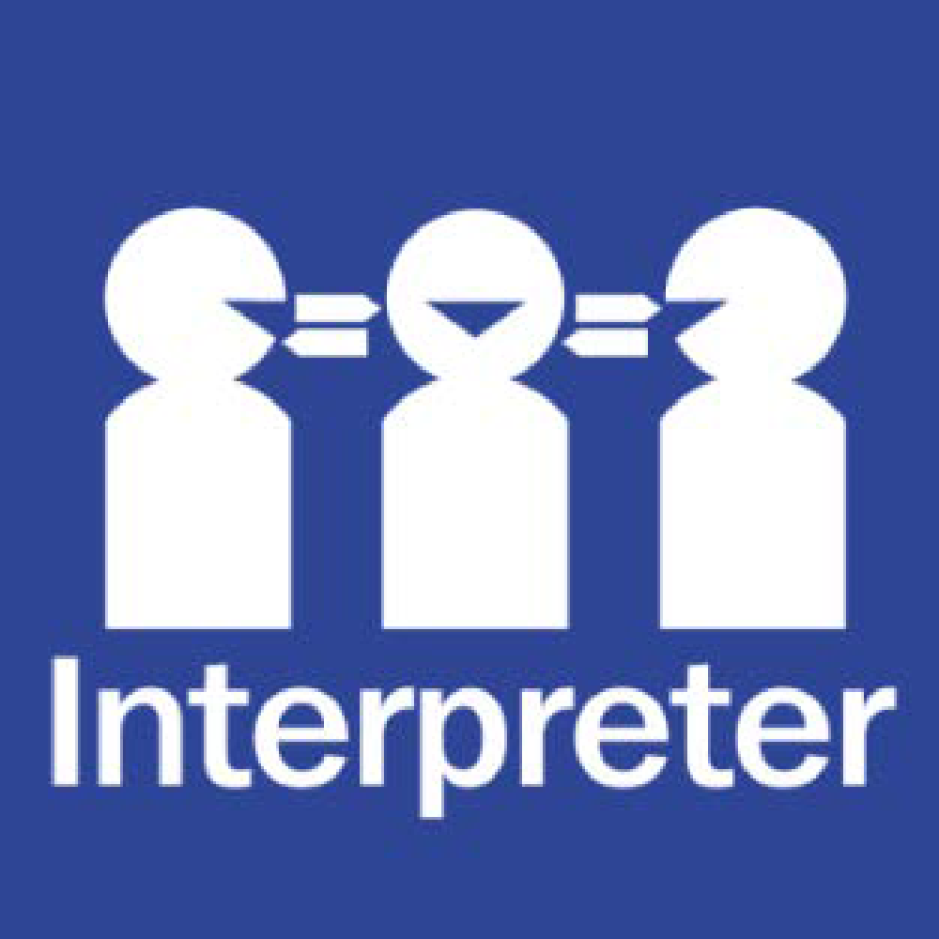

If you need help to understand the information in this policy please contact the main office on 93543343

**PURPOSE**

To explain to our school community the rules and procedures we have in place in relation to dogs attending our school grounds.

**SCOPE**

This policy only applies to pet and stray dogs on school grounds. For policy information on wellbeing and engagement animals, refer to the department’s [Wellbeing and Engagement Animals policy](https://www2.education.vic.gov.au/pal/animals-wellbeing-engagement/policy) on PAL.

**POLICY**

**Definitions**

A **pet dog** relates to any dog that is privately owned in the community for companionship reasons, rather than as a support function that requires specific skills or training.

A **stray dog** is any dog that is not accompanied by their owner.

**Assistance / Wellbeing Dogs**- are those permitted for teaching or therapy reasons by trained instructors of staff at the school.

**Pet dogs**

Pascoe Vale North Primary School is not a public place, and our Principal has the authority to permit or decline entry to school grounds and impose conditions of entry.

**Dogs prohibited**

Whilst Example School understands that many families in our school community keep dogs as pets, to ensure that our school remains a safe and inclusive place for everyone, pet dogs are not permitted on school grounds under any circumstances.

Our school community is diverse, and may include people that are allergic or uncomfortable around dogs. We are also conscious of the health hazards that may be posed by dogs. We ask that families please leave their pet dogs at home or safely tether them outside school grounds when attending our school or school events.

**Stray dogs**

Unaccompanied or stray dogs sighted at our school should be reported immediately to Merribek Council. School staff will contact municipal authorities and/or Victoria police for assistance in managing and removing a stray dog from school grounds, and ensure staff and students remain safe at school.

**Assistance dogs/ Wellbeing Dogs**

Pascoe Vale North Primary School understands its obligations under the Disability Discrimination Act 1992(Cth) the Equal Opportunity Act 2010(Vic) and will make reasonable adjustments for members of our school community with a disability who require an ‘assistance animal’ to help alleviate the effects of their disability. Assistance animals are permitted to attend our school with their handler. Our school principal can lawfully ask a person to produce evidence that an animal:

* Is trained specifically to assist a person to alleviate the effects of a disability ( eg seeing eye dog)
* Meets standards of hygiene and behaviour appropriate for a school environment.

We understand that in some circumstances, students may require an assistance animal to attend school to help them to participate in their educational program. Pascoe Vale North Primary School will consider a request made by a student with a disability to allow an assistance animal to attend school with them on a case-by-case basis. The school may also allow a therapy dog to be considered as part of a Wellbeing strategy for students.

If you would like to discuss this further, please contact the Principal.

**COMMUNICATION**

This policy will be communicated to our school community in the following ways:

* Available publicly on our school’s website
* Policy in COMPASS in documentation section for parent access
* Reminders to families about the NO Dog Policy on compass notifications
* Included in staff induction processes
* Reminders in our school newsletter
* Hard copy available from school administration upon request

**RELATED POLICIES AND RESOURCES**

* *Duty of Care* and *Visitors* policies can be located on our school website. <http://www.pvnps.vic.edu.au/policies.html>
* [Wellbeing and Engagement Animals on PAL](https://www2.education.vic.gov.au/pal/animals-wellbeing-engagement/policy)

**POLICY REVIEW AND APPROVAL**

|  |  |
| --- | --- |
| Policy last reviewed | February 2025 |
| Consultation | School Council meeting 17th February 2025 |
| Approved by | Principal |
| Next scheduled review date | February 2028 |