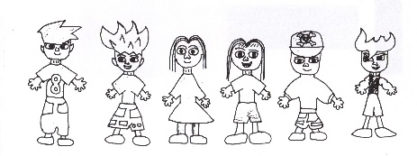
TERM 3 Parent Teacher Day
BOOKING FORM
Tuesday 17th September 2024
WHEELERS HILL PRIMARY SCHOOL
OUTSIDE SCHOOL HOURS CARE
12.50pm – 6pm

Tuesday 17th September – Parent Teacher Interview Day
Extended After School care Session 12.50 – 6pm Cost $40 per child

We will be running an extended After School Care session to support working families during the parent teacher interview afternoon
If you chose to collect your child from school at 12.50pm (and Notify OSHC below) you will not be charged for the normal after school care fee for that day. Cancellations MUST be made the week before to have fees deleted

Please tick below if you need the longer session or if you would like to cancel your ASC session at no charge

Children will need to bring their own lunch and we will provide afternoon tea

Children must be enrolled with OSHC before making a booking

TERM 3 Parent Teacher Day – Please tick which one you need

Child’s Name | Tuesday 17th September Extended ASC session  $40 per child | Cancel my ASC session on Tuesday 17th September  No Charge

Contact Phone Numbers on the Day

Name: ______________________________________ Phone: ___________________

Name: ______________________________________ Phone: ___________________

Signature of Parent: _________________________________ Date: __________________

