CLASSIC BLUEBERRY MUFFINS

(makes 12)

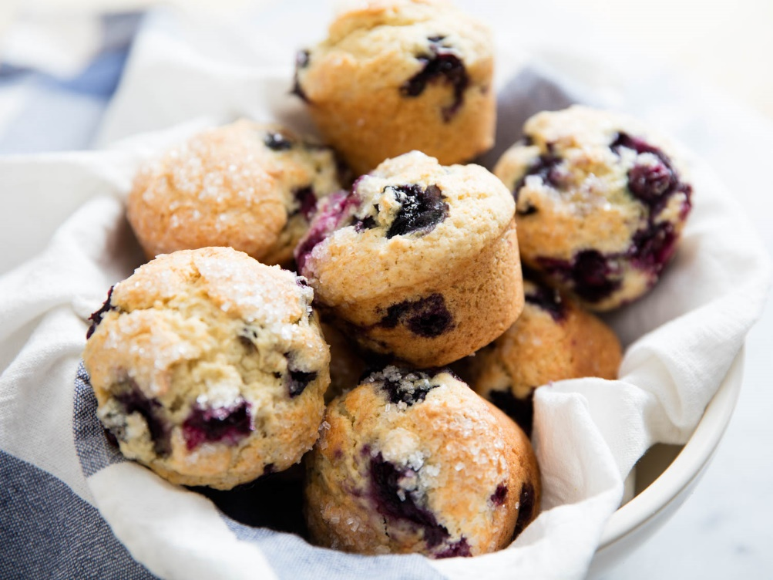
INGREDIENTS
- 2 ½ cups SR Flour
- 1 teaspoon Baking Powder
- 1/3 cup Sugar
- 2 Eggs, lightly beaten
- 1 cup Buttermilk or Milk
- 60g Butter, melted
- 125g Blueberries
- 2 Tablespoons Coffee Sugar Crystals or Demerara Sugar

METHOD
- Preheat oven to 200°C. Grease a 12-hole muffin pan.
- Sift SR flour and baking powder together into a bowl, add sugar and mix to combine.
- Combine eggs, buttermilk or milk and butter.
- Add egg mixture and blueberries to dry ingredients and mix until just combined.
- Spoon mixture into muffin cups. Sprinkle with coffee sugar crystals and bake for 20 – 30 minutes or until muffins are cooked when tested with a skewer.
- Stand in pan for 5 minutes.
- Transfer to a wire rack to cool.

