Section 1 for Students and Families

Career News: The Big Picture

Our New World
These infographics are fun. McCrindle interprets data to give us insights. It is fun seeing the influences that are impacting on our world.

McCrindle also give ideas about what the world of work will be like for Gen Alpha. They talk about:
- Growing up digital
- The COVID-19 generation
- Globally connected and influenced
- How the grandparents’ generation is impacting.
You can check out the infographics HERE.

Unemployment bounces up to 4.1% in January
According to the ABS people who were not employed decide to return to work in January each year. This has caused a bounce in unemployment figures for the past three years. In 2024 our unemployment figure rose to 4.1% BUT many of those unemployed people expected to get jobs in the next 4 weeks.
There was also a drop in the number of hours worked as people went on summer holidays.
Bjorn Jarvis, ABS head of labour statistics, said: “Since October 2023, the annual growth rate in hours worked has slowed considerably, down to 0.7 per cent in January 2024, and well below the annual employment growth of 2.6 per cent.”

WA to change the way ATAR is calculated (from 2026)
The score bonuses given to West Australian students studying some of the more difficult ATAR subjects will no longer be applied from the 2026 school year, in an effort to increase fairness for all year 12s hoping to gain entry to university.
The Tertiary Entrance Aggregate score is used to calculate a students’ ATAR results, and an automatic bonus of 10 per cent is applied to mathematics methods, mathematics specialist, and a student’s highest-scoring language other than English, or LOTE.
Currently, students who study these ATAR courses can receive a maximum aggregate score of 430 which is made up of 100 points for each of their four top subjects, plus up to three bonuses just for choosing the course.
Students who don’t study those subjects have a maximum possible score of only 400. This is particularly problematic for students at schools which may not even offer these subjects.
Tertiary Institutions Service Centre chief-executive Andrew Crevald said WA was the only Australian state that granted a bonus of this type for an ATAR course.
You can read the reasoning behind this decision to cut the bonus system HERE. (Thanks for the link Clare Slodecki)

Job advertisements decrease in January
According to Jobs and Skills Australia, job advertisements decreased by 2.0 in January 2024. Despite this, vacancy numbers remain at record levels.
Go to this chart online to get interactive results.
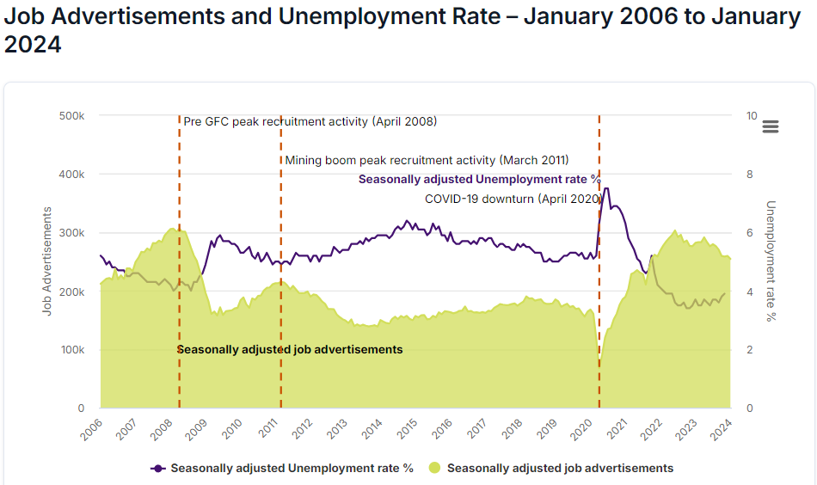
Summary
It seems as if the economy may be softening enough to lead to some interest rate relief in the near future but the economy is still so strong that people seeking jobs are well placed to find a job that suits their needs.

100 Fastest Growing Global Skills for 2024
Udemy has identified 100 Fastest – Growing Global Skills for 2024. They are a tech teaching company so they focus on tech skills.
Some of the skills identified by Udemy are application specific, like 1. ChatGPT and 3. Google Cloud skills. When a new, better product comes along, experts in those companies will be able to quickly learn the new product and move forward in their careers.
Others are more long term, like 9. DevSecOps which is about IT security, and that has been an issue since the internet started connecting data.
Skill in Demand | Discussion
- Open AI’s ChatGPT | If you haven’t played with ChatGPT, get yourself a free account and start playing around with it. It is an artificial intelligence platform that is the biggest change in IT since the internet reached us.
- Environmental, Social and Governance skills. | This is about frameworks.  A law degree, policy development experience or knowledge of enterprise architecture would help in creating and enforcing frameworks that give us order and safety.
- Google Cloud Professional Cloud DevOps Engineer | Many companies use Google Cloud Computing to scale their operations and take advantage of global resources. If you know how to use these Google systems, you will be seen as a serious techie.
- Behavioral economics | These people put together economics and psychology to anticipate how people will behave.
- Advertising strategy | This isn’t new but keeping up with emerging advertising strategies will be challenging. Donald Trump is an expert at this.
- Certification and software test-taking preparation | This sounds like teaching and ensuring the credibility of the test taking systems.
- Microsoft Azure Synapse Analytics  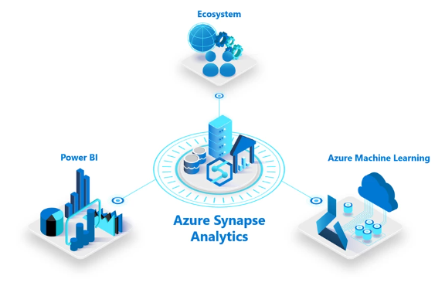 | This is about managing big data. The World Economic Forum has been identifying this data analytic skills as a priority for some time.  Being able to crunch data continues to be an in demand skills and the Microsoft system is leading.
- Autodesk 3ds Max | In 2023 the Managing Director of North Metro TAFE told career practitioners that their gaming courses were leading to jobs in design and project visualisation. This skill is about creating 3D models.
- DevSecOps | This skill deals with the ongoing challenge of security across organisations and platforms. I anticipate that skills to develop security systems will continue to be ibn high demand.
- Software design | Go to TAFE. Get in on the ground floor in an entry level computer class and keep learning for the rest of your career.
To see the full 100 top skills you can download the eBook HERE.

Special Report Career Connect Conference

February 2024

Riding the Tiger of Change Conference Highlights
Each year the Career Development Association of Australia and Notre Dame University put together a career conference to kick start the academic year. This year the theme was Riding the Tiger of Change.
Although Notre Dame hosts the event, all the universities come along to give a quick overview of their key innovations for the year. TISC is always there giving updates on what’s new and what to expect.
We also had speakers from the resources industry and agriculture, and one talking about pathways through TAFE to defence careers.
We always have the economic outlook. This year it was given by Luke Le Breton from the Department of Training and Workforce Development who managed to put the stats into a context that career educators loved.
Key Impressions:
- Unis are competing for school students and there are more opportunities for senior students to start uni courses while at school
- Fewer students are taking an ATAR pathway to uni
- Those students who do take an ATAR pathway to uni do better
- WA has the lowest per centage of the entire population that do ATAR (NOT the lowest per centage of Year 12s who do ATAR).
- Worker shortages are across all levels and all industries in WA, from unskilled to highly skilled.
- 2023 senior students were more informed about what pathways are available to them and what extra information they need.
- There are jobs for unskilled through to highly skilled workers, including a significant demand for electricians.

Notre Dame

FEES: Notre Dame fees are THE SAME as those of public universities.
UniPath
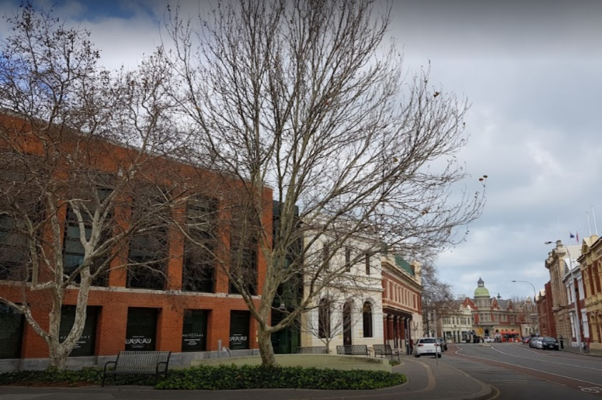
UniPath is a 12-week pathway program that, upon successful completion, will guarantee you direct entry into many undergraduate degree programs at Notre Dame.
You can start your UniPath program while still at school.
You get to study on campus one day a week, be in tutorials with other university students and enhance your study skills and academic writing in preparation for your university degree. You will learn the ways of the university, attend first year lectures, meet students from diverse disciplines and make new friends.
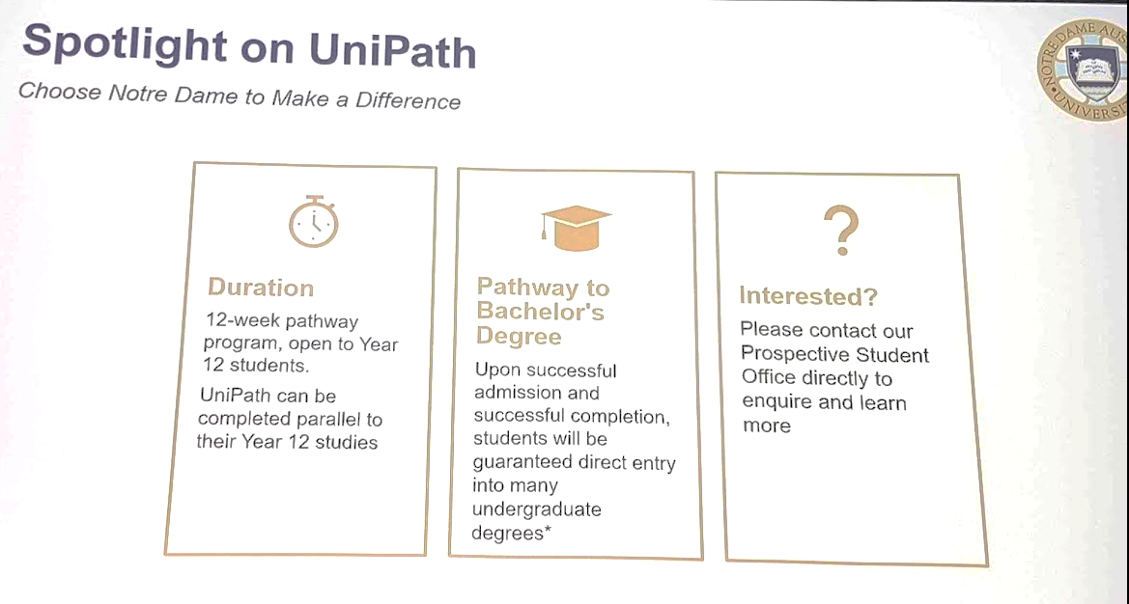
For details go HERE.
Medicine Assured Pathway from Bachelor of Biomedical Science starting 2025
This pathway to medicine is targeted to school leavers who are aspiring doctors. Students apply in year 12 for a Biomedical Science degree with:
- An outstanding ATAR score.
- Successful completion of UCAT
- Final selection through the Multiple Mini Interview
Notre Dame will be conducting application for medicine information sessions in 2024 which are yet to be scheduled.
You can view information session from September last year HERE.
You can find information about the Priority Pathway, General entry pathway and Indigenous entry pathway HERE.
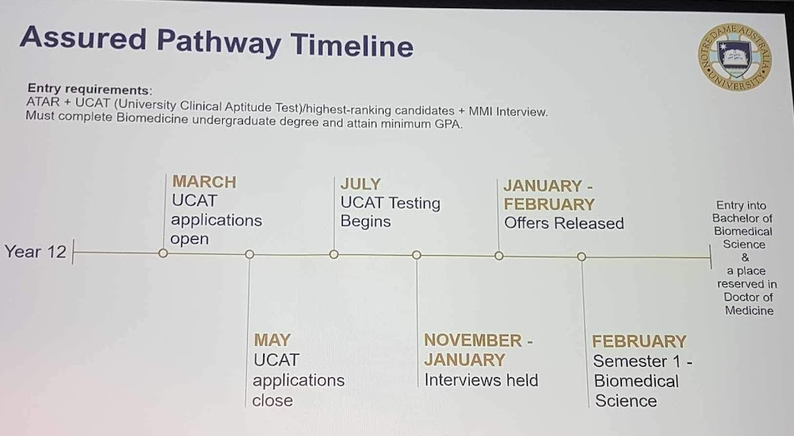

Become a doctor at the Kimberley Remote Medical School
The Kimberley Centre for Remote Medical Training opens in 2025 and will provide up to 20 students per year with the opportunity to complete their medical training on country, close to home and family and other forms of pastoral support.
The school will target Aboriginal students from the Kimberley, people already living in the Kimberley and other groups under-represented in the medical profession.
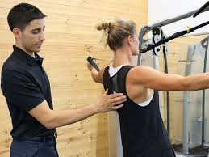
Bachelor of Exercise and Sport Science
We heard how the Bachelor of Exercise and Sport Science is a specialty at Notre Dame with industry practicums and internship placements during the course.
Exercise Science – Physiology was mentioned as a specialization of Notre Dame.

New Course - Bachelor of Occupational Therapy (Honours)
This course is a 4 year decree program that will be available in 2024.
Bachelor of Physiotherapy
This is a four year program. You can take a two year accelerated Masters program from the Bachelor of Exercise and Sport Science or the Bachelor of Biomedical Science.
Graduate Diploma of Paramedicine
This is a one year course, which is a popular qualification for those studying nursing.
This course is recognised by St John’s Ambulance.
Bachelor of Psychology
Notre Dame has responded to the shortage of psychologists by delivering a 3-year Bachelor of Arts Psychology degree. This is recognised by the Australian Psychology Accreditation Council.
Notre Dame also offers a:
- 1 year honours program
- 1-year masters program
Computer Science at Notre Dame
The Bachelor of Computer Science at Notre Dame has introduced a significant ethics component in response to the issues delivered by AI and deep fakes.
There is a Semester 2, 2024 intake for this course.

Curtin University
Portfolio Pathway Toolkit
Portfolio Pathways to university are gaining popularity.
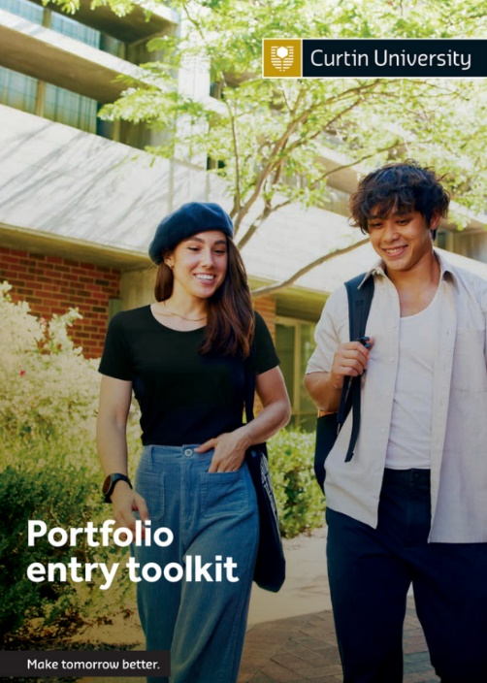
To support those wishing to apply for uni via a portfolio pathway, Curtin is developing a Portfolio Pathway Toolkit. You can find it HERE.

NEW: Bachelor of Innovation + Bachelor of Law double degree
This combination of Law and Innovation will probably appeal to school leavers. Curtin is excited about this course, and we will hear more about it at future events.
You can find information HERE.

NEW: Commerce + Fashion Marketing double degree
This is another combination that will probably appeal to school leavers who are interested in a career in fashion marketing, but realistic about how few opportunities would be available in that field in WA. The addition of a commerce major will help graduates to become more employable.

Medical Radiation Science
New pre-requisites.
The Medical Radiation Science course pre-requisites now allow:
- Physics ATAR
- Mathematics Applications ATAR or Mathematics: Methods or Specialist ATAR or equivalent.

Graduate Diploma of Education
In line with State government education policy, Curtin has reintroduced the Graduate Diploma in Education. This was a traditional pathway to secondary teaching in the past. Students undertake a degree in their chosen field of study (English, science, etc) then they undertake a one year post graduate diploma.
Schools are introducing more comprehensive support programs for graduate teachers which are designed to reduce the workload and stress experienced by new teachers

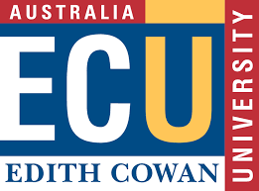
ECU
This is new - Sonography
50 students enrolled into the Bachelor of Preclinical Foundations of Imaging Science, these students will then go on to complete the Graduate Diploma of Medical Sonography to become Accredited Medical Sonographers.
Experience ECU
ECU will be offering six Experience ECU Day’s during the school holidays in 2024 and these are aimed at Year 9’s and 10’s. For more information about these events please reach out to Ginetta Papaluca Team Leader, Student Ambassador Program g.papaluca@ecu.edu.au.

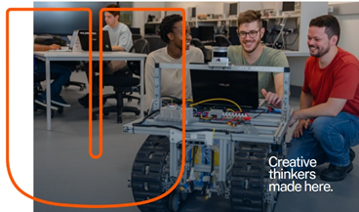
Bachelor of Engineering (Robotics and Autonomous Systems) Honours
ECU continues to put a lot of resources into keeping West Australian engineering skills up to date. The Bachelor of Engineering (Robotics and Autonomous Systems) Honours program starts with a general first year of engineering before specializing.

Later in the day we heard from a Resources Industry representative how robotics is being used underground and across the resources sector.

ECU Portsmouth Partnership
In 2022 ECU formed a partnership with Portsmouth University in England, that enabled students from either university to study on both campuses and get a dual degree.
The first cohort from England came to ECU last year and this year the first West Australian contingent is going to Portsmouth. You can check it out HERE.

Teacher Education Qualifications
ECU identified their education qualifications as:
- The Post Graduate Diploma (1 year after a degree)
- Bachelor of Education courses in Early Childhood, Primary and Secondary teaching. (4 years)
- Master of Education in Early Childhood, Primary and Secondary Teaching.
Find details HERE.

Murdoch University

Murdoch Partnership with Ag Department
The Ag Department is now called the Department of Primary Industries and Regional Development.
That Department is going to co-locate from Kensington to the Murdoch University site.
The plan is for all universities to be able to use the new buildings and labs for biosecurity, research and teaching purposes.
Murdoch has always delivered veterinary science and is a leader in conservation, so it is well placed to grow into this new role.
Biosecurity research will be a priority at the new facility which is due to open in 2027.

Murdoch Future Student Team has grown.
Murdoch has increased the number of people in its future student team and can now do school incursions or manage excursions to Murdoch campus for years 7 – 12.

Ngala Kwop Biddi Brighter Future Scholarships
Each Western Australian Secondary School will be invited to nominate one of their graduating Year 12 students, who by their leadership and activity has effected positive change in their School or community, related to one of the three strategic themes.
- Sustainability
- Equity, diversity and inclusion
- First Nations
The scholarship is valued at $12,000. Find out more HERE.

Murdoch Access Engineering Scholarship
The Murdoch University Access Engineering Scholarship seeks to widen participation and support students from underrepresented groups in a field of study that is becoming increasingly important and impactful for a sustainable future.
Value $12,000

Indigenous Engineering Pathway Scholarship
Murdoch University Indigenous Engineering Pathway Scholarship is for Aboriginal and Torres Strait Islander students seeking to access engineering study or careers via the Bachelor of Engineering Technology.
Value $9,000 – $12,000

UWA
Last year UWA broke ranks with its traditional pathways and started recognising life experiences as a pathway into some of its courses.
Now UWA has introduced micro credentials as a potential pathway into undergraduate degrees.
Check out Admission entry pathways HERE.
- UWA is finding that ATAR students do better at uni, but the new pathways are gaining traction.
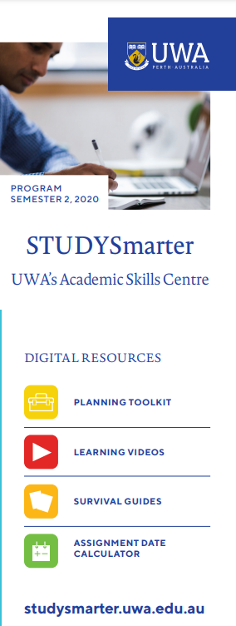
Studysmarter.uwa.edu.au
In an effort to support students to succeed, UWA has established the StudySmarter app.

UWA+ Starter Credentials
These micro credentials are designed to meet secondary students' flexibility requirements, UWA+ Starter micro-credentials focus on providing secondary students with the opportunity to study subjects online or in mixed mode with the school.
Students can gain credit towards selected bachelor’s degrees by completing 3 micro-credentials.
UWA has SCSA recognition for 3 micro-credentials and is applying for recognition for more.
_____________________________________________
Alternate Pathway to Nursing
ECU, Notre Dame and Murdoch are all offering alternative pathways to nursing. Contact the university of your choice for details.

Enabling Programs
If you undertake an enabling program which is not graded, do not expect all universities to accept it as an entry pathway.
Flexi Track High is now graded.

Conference Highlights TISC
TISC manages applications for universities across Western Australia.
ATAR and non-ATAR pathway students apply for their preferred course at their preferred university via TISC and the magic of algorithms sorts it out and makes students an offer.
Only WA Academy of Performing Arts students apply directly to WAAPA for a position.

97% of students who applied through TISC got offers to uni this year. 95% of year 12s got offers.
Invite TISC to School
TISC staff are happy to come to schools to talk to teachers, students and families.
They will do Teams meetings for remote schools.
TISC Videos show you how
TISC has 12 videos to help you to understand applying for uni, including

- The ATAR
- Calculating the ATAR
- Entry requirements
- Entry requirements VET
- Moderation
- Scaling

If you want to demonstrate or practice applying through TISC. you can register as a Year 11 student and do a trial run.

Early Offers
- Universities have been asked to hold off on early offers until Term 3 as so many students get an offer, then want to change their mind.
- Most early offers are conditional upon applicants meeting requirements
- From July to December early offers will be sent out once per month.
- About half of all applications are in by the end of July.
- 30 September continues to be the final date for TISC applications.

Put in the right evidence
Students applying for non-ATAR pathways frequently do not get offers because they DO NOT PUT IN THE RIGHT EVIDENCE.
If you are still doing a Certificate IV qualification, or some other pathway program at time when you apply, that must be declared on your application so that TISC knows to follow up.
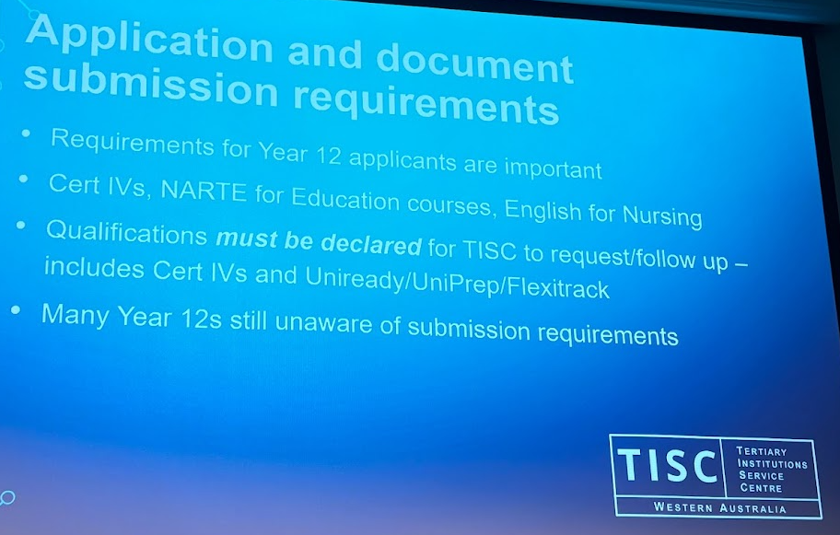

Educational Access Scheme – for when things go wrong
If your life went to the dogs throughout years 11 and 12 and you didn’t have a fair chance to do your best in your ATAR, you can put in an application for special consideration which may help you to get entry to your preferred course.
In 2023 there were 902 applications but only 439 of those provided the required documents!
The Educational Access Scheme does not override English competency or pre-requisite requirements.
Western Australia has the lowest ATAR Participation in Australia
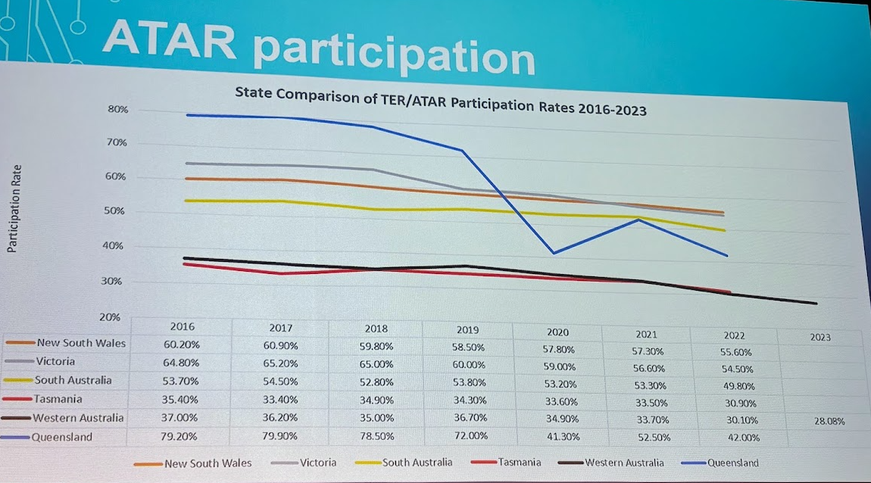
In 2023 only 28.08% of West Australians applied for uni through an ATAR pathway.
Fees, charges and schedule
- There is a flat application fee of $92. TISC is looking at introducing equity discounts.
- Applications open 1 May.
- Early offers will start coming through from Week 1, Term 3.
- Courses with early closing dates are not expected to change. (Medicine etc 30 September, Veterinary Science 30 November).

Conference Highlights - Industry Speakers
Resources Industry
Amanda Hamilton from the Resources Industry Training Council showed us how electricians, metal fitters, machinists and plant operators are in demand now and will be in demand as clean energy occupations come online.
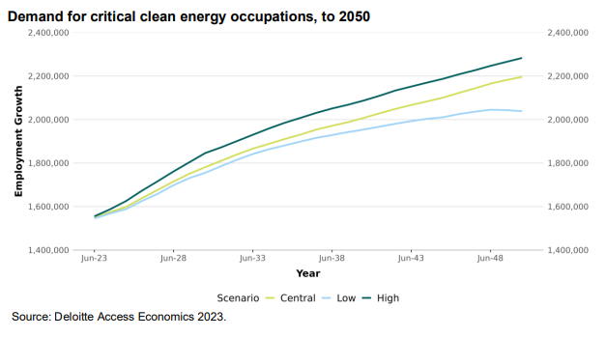
Australia is likely to need 32,000 more electricians in the next seven years.
The key mining occupations in demand are:
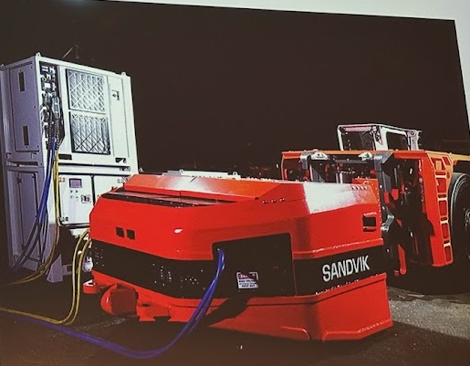
- Professional mining engineers, general engineers, metallurgists, geologists, surveyors, underground surveyors
- Cert III trades including electricians, heavy diesel fitters, auto electricians, mechanical fitters, boiler makers, welders and chefs.
- Skills Level 4/5 include drillers, belt splicers, shot firers and truck drivers.
The resource industry is critical of training for its industry, saying instructors don’t have enough industry experience, and there is not enough emphasis on practical skills.
It was acknowledged that mining companies poach trainers from colleges leaving significant gaps in the capacity of the training provider to meet the mining companies’ skills demands.
The shift in resources to electronic vehicles is towards electric powered robot vehicles.
Electricity powered engines do not need standard diesel mechanic skills.
Agriculture Industry
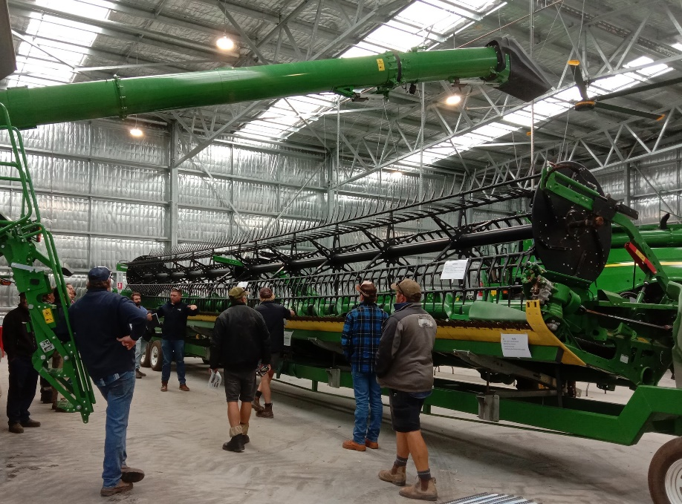
Brad Forrester from Farm Machinery & Industry Association showed us how the agriculture industry is moving to a business model like Microsoft’s with farmers paying for up to date software programs.
There is a new Agricultural Machinery training centre at Muresk (near Northam) which is designed to prepare workers for operating huge, high tech agricultural machinery.
They do Cert III Agricultural Mechanical Technology.
$3500 Toolkit
Before they start students get a toolbox with tools worth $3500 which includes a laptop.

These videos show how technology is integrated to manual farm operations. They are short and they will change how you think about working in agriculture.

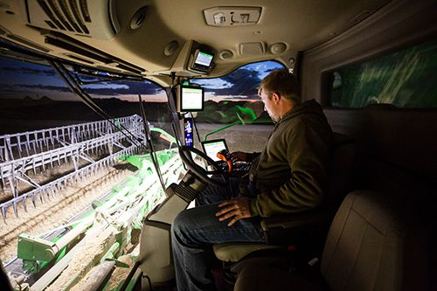
2019 Latest Video

2013 video – still looks pretty advanced

Nihal Rai South Metro TAFE – Defence Industry Collaboration Award winner
South Metro TAFE and the Defence Industry have collaborated to deliver the Defence Industry Pathway Program designed as a “gap year” program from which students might will develop transferrable skills which could lead them a defence job or into another industry like resources or agriculture.
The 12-month 'taster' program was designed to provide graduates with a broad understanding of the maritime defence industry through work placements focusing on career pathway options within the industry.

Scholarships
The Women in Defence Scholarship applications are open. Apply HERE.
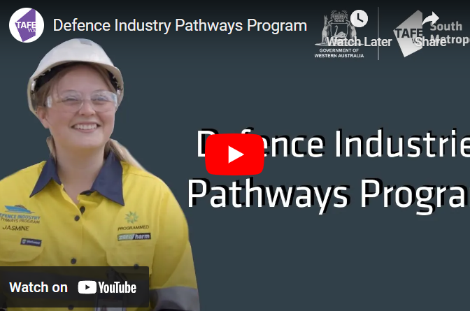
You can read about the Defence Industry Pathways Program HERE.

Economic Outlook
Luke Le Breton from, DTWD blew us away by communicating his knowledge of economics in a way that will inform our career advice decisions.
Highlights:
- More West Australians participate in the workforce than people in other states.
- Youth disengagement in WA kicked up towards the end of last year.

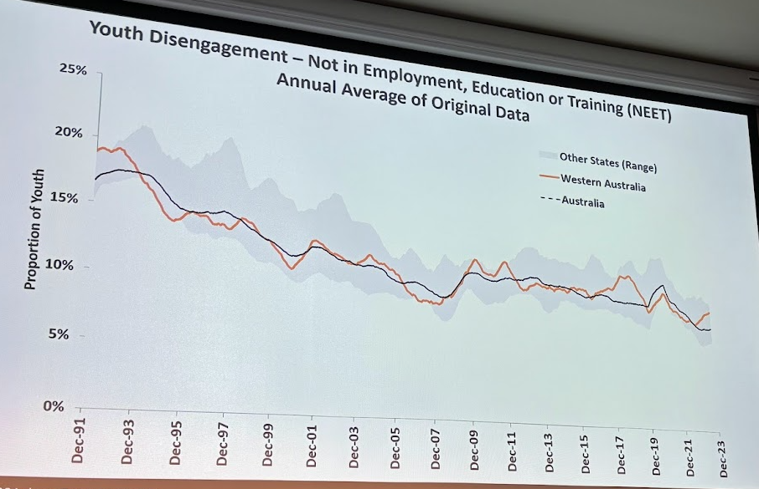
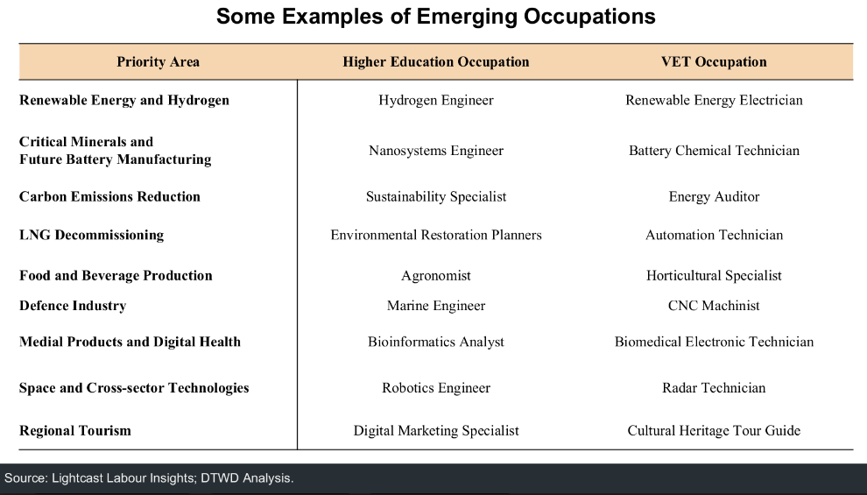

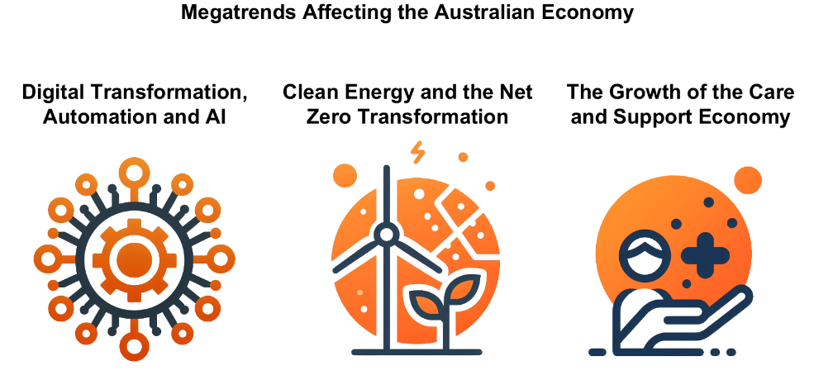
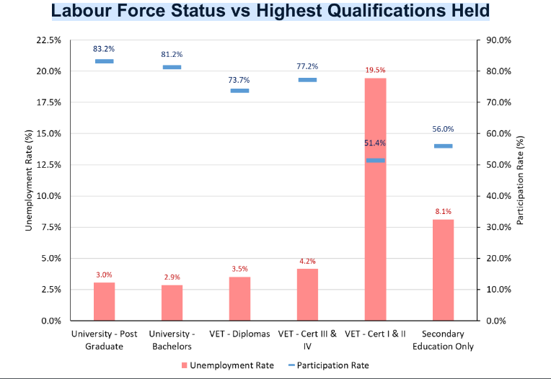
His slides are great. If you want a set, please email me.
That’s a Wrap
Another great Career Connect conference to kick start the year.
Great to see so many of you there.
Thanks to Notre Dame and all of the speakers.

Career Opportunities

9 March Saturday City of Canning Job Expo
The City of Canning is working to support careers and employment opportunities for people in the south of Perth.
There are over 30 stalls with businesses actively hiring, training providers and career advisors from the Jobs and Skills Centres who will help you to put your resume together, brush up your interview skills and find job opportunities.
Students can ask potential employers for advice on what jobs the industry provides and what skills are needed to win a job. Find details HERE.
City of Canning Civic & Administration Centre 10am – 2pm Saturday 9th

Defence Force Work Experience
Defence Work Experience Program provides young Australians interested in Defence as a future career, the opportunity to sample life in Defence and learn more about the Australian Defence Force (ADF) and the Australian Public Service (APS).
The Defence Work Experience Program is pleased to advise that Defence is offering opportunities for work experience activities. As placements are planned and confirmed, they will be advertised through the “Placements” tab. We encourage you to check our website regularly.
Naval Gazing: Navy Careers Experience - April Job Ref - WEP/00499/24
- Navy
- HMAS Stirling
- 8 - 10 April 2024
Closing Date: 25-Feb-2024
Day in the life of a Soldier: Irwin Barracks - May Job Ref - WEP/00474/24
- Army
- Irwin Barracks
- 16 May 2024
Closing Date: 31-Mar-2024
An Aerial View: Air Force Careers Day RAAF Base Pearce - May Job Ref - WEP/00726/24
- Air Force
- RAAF Base Pearce
- 21 May 2024
Closing Date: 14-Apr-2024
Day in the life of a Soldier: Irwin Barracks - June Job Ref - WEP/00478/24
- Army
- Irwin Barracks
- 27 June 2024
Closing Date: 12-May-2024
Naval Gazing: Navy Careers Experience - July Job Ref - WEP/00502/24
- Navy
- HMAS Stirling
- 1 - 3 July 2024
Closing Date: 19-May-2024
Day in the life of a Soldier: Irwin Barracks - August Job Ref - WEP/00481/24
- Army
- Irwin Barracks
- 15 August 2024
Closing Date: 07-Jul-2024
An Aerial View: Air Force Careers Day RAAF Base Pearce - August Job Ref - WEP/00730/24
- Air Force
- RAAF Base Pearce
- 20 August 2024
Closing Date: 07-Jul-2024
Day in the life of a Soldier: Irwin Barracks - September Job Ref - WEP/00485/24
- Army
- Irwin Barracks
- 12 September 2024
Closing Date: 28-Jul-2024
Naval Gazing: Navy Careers Experience - September/October Job Ref - WEP/00503/24
- Navy
- HMAS Stirling
- 30 September - 2 October 2024
Closing Date: 18-Aug-2024
Naval Gazing: Navy Careers Experience - November Job Ref - WEP/00507/24
- Navy
- HMAS Stirling
- 4 - 6 November 2024
29-Sep-2024
An Aerial View: Air Force Careers Day RAAF Base Pearce - November Job Ref - WEP/00738/24
- Air Force
- RAAF Base Pearce
- 12 November 2024
Closing Date: 06-Oct-2024
Day in the life of a Soldier: Irwin Barracks - November Job Ref - WEP/00496/24
- Army
- Irwin Barracks
- 14 November 2024
Closing Date: 27-Oct-2024

MyFuture for Parents and Carers
MyFuture is a national one-stop-shop for parents and carers who are looking for career resources to help their student. If you are not sure where to start, set up a MyFuture account and start exploring.
MyFuture is collated through collaborations with all Australian governments, so it isn’t trying to sell you anything and you have a fair chance of any personal data you put in staying private.
I’m a big fan.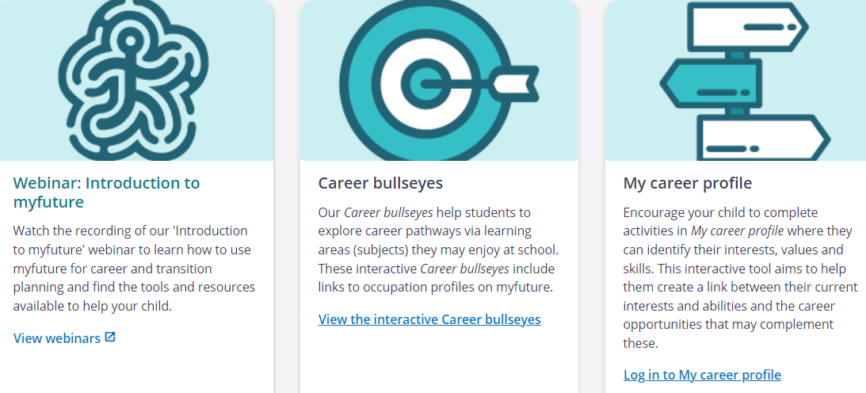

Local Opportunities in Ellenbrook
The Ellenbrook Youth Centre is running programs for 12 – 18 year olds. Programs include:
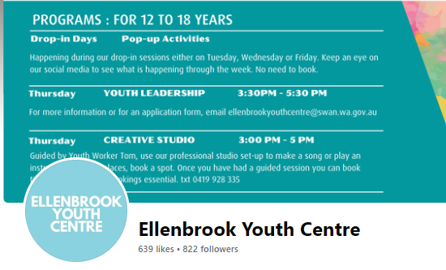
- Youth leadership
- Job Skills. Fundamentals
- Start a business, with Bloom
- Creative Studio
For information go HERE.

University Events

University Open Day Calendar 2024
17 March |  | UWA Open Day
23 March |  | Murdoch University
24 March |  | Curtin Open Day
5 May |  | Notre Dame
14 April Joondalup  21 April South West  28 April Mt Lawley | Edith Cowan

University News

University Open Days start in March
Because students can apply for a place at university in 2025 from about April, universities now hold open days early in the year, and they now run more events throughout the year to help prospective students to make informed decisions.
- You can apply for a place within a course at university and change your mind.
- There is no advantage to applying for a place in a course early.

A Guide to Open Days for Year 12 Students
- Go with a buddy
- Spend 3 – 4 hours there
- Do campus tours, go to talks go to practical classes that are available.

10/10 Students who KNOW what they want to do next year.
At the Open Day:
- Explore subjects & pathways available for your preferred degree.
- Explore teaching methodology – make sure you have face to face classes so that you get to know future colleagues and employers.
- Do they have industry placements later in the course?
- What scholarships and financial support are available.
- Find what study support is available – student mentors, free “learn to study” classes, referencing and writing classes, pastoral care.
- What is the biggest barrier to success experienced by current students?
- Arrange to see a professional career advisor to discuss your thoughts.
Check out this information.

7/10 Students who are fairly sure about what they want to do.
- Go online BEFORE the Open Day and check out the handbooks relating to the courses that interest you.
- Narrow down to a maximum of 4 courses to check out.
- Follow the same steps as those above. You may need more than one meeting with a professional career advisor. They are usually free and can save you a year of your life and $10,000 worth of mistakes.
4/10 Might want to uni
- Check First in Family to Go to Uni
- Talk to a career advisor – at school, at a uni or at a Jobs and Skills Centre. They are free and they may save you a year of your life and $10,000 (WHICH YOU HAVE TO PAY EVEN IF YOU DROP OUT OF UNI AFTER A YEAR).
- Check Gap Year Opportunities. (I will update this later in the year as 2025 opportunities are published.)
- Follow tips for 7/10 Students who are fairly sure about what they want to do.
To read quick tips and advice on how to make the most of your day go HERE.
Applications for places at universities in WA in 2025 open on 1 May.
There is no advantage to winning your chosen place by applying early.
Year 11 – A Step by Step Guide to Open Days I
Year 11 results are taken into account if you apply for an early offer. By knowing what university, you want to go to and what course you want to take, you can focus on achieving the required ATAR and prerequisites.
Big Tip: Plan to go with a friend. If they know the sorts of things you are looking for, they will ask questions that you may not think of and give you good feedback.
To read the Step by Step Guide go HERE.
Year 10 – Ready, Steady, Go to University Open Days
Before you make your Year 10 subject selection, go to university open days to find out what courses you are interested, what ATAR score you need and what prerequisite and recommended courses you should take.

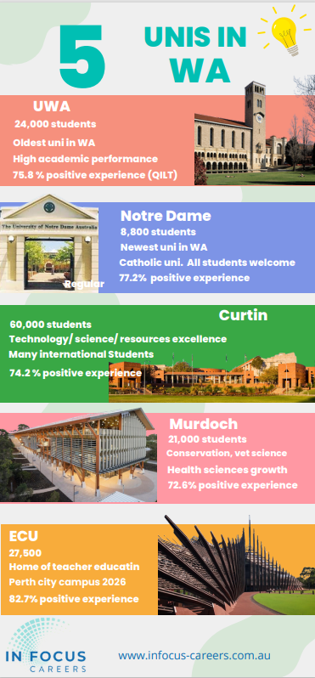
5 WA Unis Infographic
Get a quick overview of the 5 unis in WA through this infographic.

Training News

23 February Applications close for the Defence Industry Pathway Program
Applications are now open for the Defence Industry Pathways Program (DIPP).
DIPP is a 12-month traineeship offering hands-on training and experience within various areas of the defence industry and graduating with a 52904WA Certificate III in Defence Industry Pathways.
Apply now and find out more HERE

1 March 2024 Training Award Applications Open
Applications for 2024 Training Awards open on 1 March.
School students are traditionally interested in the School-based Apprentice of the Year.
This award is for students undertaking a Certificate II or above through a school based apprenticeship or traineeship.
There are a range of award categories. You can check them out HERE.

8 March International Women’s Day AND World Plumbing Day Tradeshow
I think the plumbing industry has realised that their skills shortages could be solved by employing more women.
THAT’s why they have put their World Plumbing Day Tradeshow on International Women’s Day!!
6.30 am – 9.00 am. Galvins Plumbing Supplies Head Office, 3/5 Sundercombe Street in Osborne Park

Record VET Enrolments in 2024
There have been a record number of applications to study fee-free courses in 2024 - a 29 per cent increase on applications compared to this time last year. There has also been a 25 per cent increase in applications for TAFE courses overall.
Health and care sector qualifications made up seven out of the top ten fee-free full qualifications, with the strongest enrolment growth in 2023, compared to the previous year.
Direct Support Skills Set North Metro TAFE
You can read about the courses with the biggest increases HERE.

2024 Apprenticeship Priority List Released

Sound Technicians and Graphic Pre-Press Trades Workers are among 19 new occupations added to the national Australian Apprenticeship Priority List for 2024.

For more information on the Australian Apprenticeships Priority List go HERE.

Apprenticeship Support Australia
Apprenticeship Support Australia is an Australian Apprenticeship Support Network (AASN), contracted deliver skills development advice and solutions to businesses and job-seekers across Australia. We offer employers holistic business-wide training advice and can assist in recommending suitable qualifications, advice on how to access Government funding for training, help with matching and recruitment of new staff, as well as ongoing coaching, mentoring and support of apprentices and trainees.
Link : Apprenticeship Support Australia - WA (cciwa.com)

Top Fee-Free TAFE Courses 2023
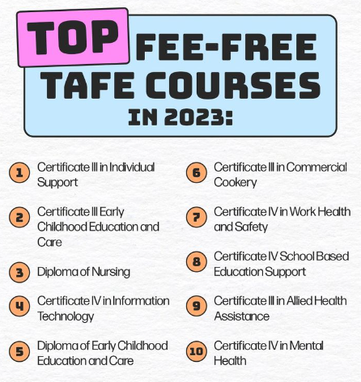

Senior School Opportunities

31 March 2024: Applications Close for Rotary Youth Exchange 2025
Rotary Youth Exchange students spend 12 months in a foreign country with board and accommodation provided by host families.
Students:
- make lifelong friends,
- expand their world views and
- have a brilliant time.
Students must be between the ages of 15 and 18 on the 1 January of the year of their exchange.
Contact Rotary Youth Exchange Western Australia for details on how to apply.

3 April Murdoch Year 11 & 12 Exploration Day
This FREE event will allow you to explore all Murdoch has to offer.
Immerse yourself on our campus and meet our friendly staff and current students, while taking part in interactive workshops specific to your area of interest and explore our unique facilities!
Registrations are essential. You can register HERE.

Thinking of Law? Thinking of a Gap Year?

Projects Abroad has launched Law & Human Rights in Tanzania designed for teens aged 15 to 18. This project offers a unique opportunity to enter the world of justice and make a difference in the vibrant city of Arusha.

Alongside local lawyers, you’ll work on real legal cases, empowering women to defend their rights. You’ll also campaign for critical issues such as illiteracy and domestic violence.

Living with fellow teenagers, you’ll prepare presentations, conduct interviews, and attend court hearings. This provides unbeatable hands-on experience while actively contributing to human rights in Tanzania.
Find out more HERE.

IDEAcademy opens campus in Peel
IDEAcademy is a vocational pathway through senior school. It focuses on innovation and student centric learning and students seem to love it. It has been growing it’s Perth base and has opened a co-learning hub in the Peel Food Innovation Precinct.
At the end of your time, you will have a portfolio of nationally recognised credentials. Your portfolio becomes your ticket to university, further education, training, and employment.
Check out the IDEAcademy website for more info about their alternative approach to education for students 15+. Go HERE.

Year 12 Opportunities

5 March University Clinical Aptitude Test 2024 Registrations Open
There are now three pathways into medicine in WA that require you to do the UCAT test.

- medicine at Curtin or
- into the UWA Assured Pathway to Medicine and Dentistry
- Notre Dame Assured Pathway

To be offered a place in any of these three pathways you need:
- amazing ATAR scores,
- a great UCAT score and
- have an interview or do the CASPER test.
The UCAT testing begins on 1 July and runs through to 9 August.
You can register here,
You can see key dates HERE.
Practice Tests
There are many hints and practice tests on the UCAT page.
Check AI for tips
I asked ChatGPT “what could I do to improve my UCAT score” and it gave 6 good suggestions which I think would improve my result.
Paying for UCAT preparation courses
I get bombarded with ads from companies that want me to promote their UCAT preparation courses. I have been to information sessions at UWA and at Churchlands High School where we were advised that the tests on the UCAT site are more than adequate and not to bother with the paid preparation courses.

Regional candidates for medicine
Curtin University provides significant support to RRR students who want to apply for medicine. If you live in a regional area check So you want to be in a doctor, but you live in the bush.

Resources for High School Students about transitioning to uni
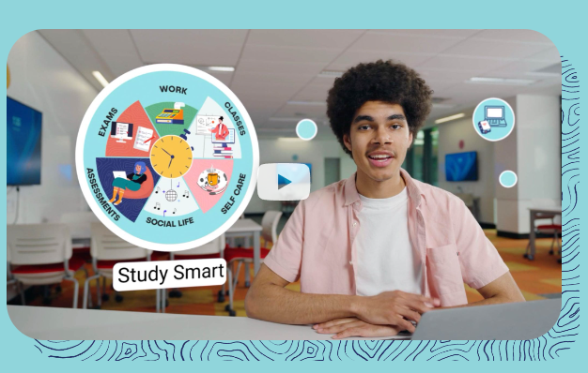
This Uni Ready toolkit was designed by students in NSW. It is designed to assist students with their transition from school to university.
Get insider tips, study strategies, and peer support to help you navigate the leap from high school to university.
* Uncover the differences between high school and uni learning.
* Master 'Study Smart' techniques for effective time management.
* Navigate texts and assessments like a pro.
* Develop critical thinking skills crucial for success in any field.
* Find academic support and your go-to people for advice.
The Uni Ready toolkit is a free resource created by the Access, Equity, and Inclusion team at UNSW in partnership with the University of Sydney and the University of Newcastle, supported by funding from the NSW Government.
Read more here.

Year 11 Opportunities
Fogarty Foundation Scholarships
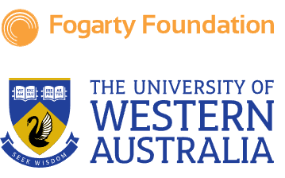
To be competitive for a prestigious Fogarty Foundation Scholarship, your resume from Year 11 needs to be impressive.
Winning one of these scholarships will give you a strong start in your careers. They are worth $10,000 per year and they come with considerable mentoring and expert support.
It is worth checking out what you need to do to be competitive.
Check them out HERE.

Register now for Curtin Girls + Engineering Tomorrow
Runs Terms 2 & 3.
Register now for Girls Engineering Tomorrow
It is an outreach initiative that aims to support and inspire girls and those whose gender is under-represented in STEM. The initiative offers a range of programs and events to support students at different stages of their educational journey, showcasing opportunities in engineering.
The program will offer an opportunity to:
- Receive study support.
- Meet inspiring women in engineering.
- Connect with our university GET Student Mentors
- Participate in a range of engineering-themed activities and workshops.
- Learn about engineering courses and careers.
Register HERE

Middle School Opportunities

Girls + Engineering Tomorrow Forum @ Curtin (Years 9 & 10)
A forum for Year 9 and 10 girls and their teachers to explore engineering through hands-on workshops, information on engineering pathways, and a Q&A with engineering role models.
Register now for this one-day forum in Term 4 for Year 9 and 10 girls and their teachers to explore the world of engineering. Find information HERE.

Girls in 7 – 9 Curtin STEM Workshops – Express Interest Now
Inspire STEM is a program combining engaging hands-on workshops and mentoring to introduce students to the world of STEM. Students will explore a range of STEM areas, hear from experts and learn about STEM study and career pathways.
This program is free, and sessions are held after school in Terms 2 & 3 at Curtin University, Bentley.
You can register your interest HERE.

Year 9 Career Taster Program
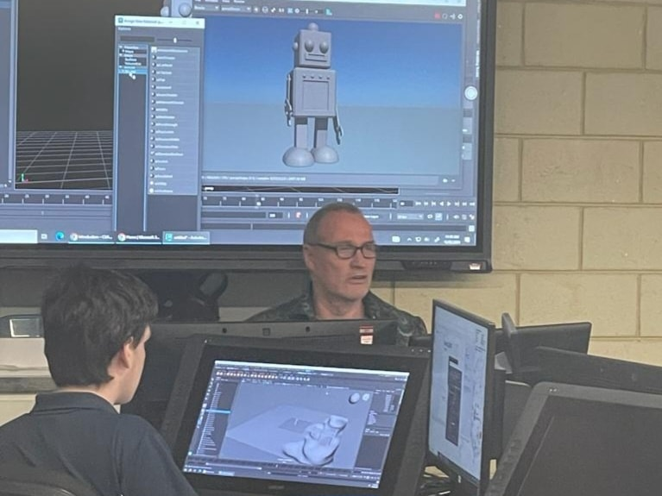
The Year 9 Career Taster Program (CTP) provides an exciting opportunity to challenge students' thinking, spark their ‘career curiosity’ and make connections between education and post-school opportunities.
Clarkston Community High School CTP experience saw students participating in an Animation workshop at NM TAFE where they designed and created 2D moving objects using industry software.
NM TAFE Facebook News

Year 7 - 9 Opportunities

8 March Innovators Tea Party for girls in Years 7 – 9
Hear a panel of women who work in Science, Technology, Engineering and Maths fields talk about opportunities and career paths in their industries.
It’s on 8 March 6.30 – 8pm at Hillview Intercultural Community Centre Bentley. Register HERE.

Year 7 Opportunities

Join a CoderDojo
A Dojo is a free, volunteer-led, community-based computer club for young people. Anyone aged 7 to 17 can visit a Dojo and learn to code, build a website, or create an app or game. Dojos are a space for kids and teens to explore technology in an informal, creative, safe and social environment.
We promote a focus on youth mentoring, and on peer and self-led learning. There are 63 CoderDojos across Western Australia. Find your nearest one HERE.

Aboriginal Career Opportunities

Yalmay Yunupiŋu Senior Australian of the Year –

Game changer advocate for Aboriginal employment
Yalmay Yunupiŋu is Senior Australian of The Year.
I worked as career educator in Arnhem Land and Ms Yunupiŋu was always available to advocate for employment conditions for Yolgnu people.
She advocated for us non Yolgnu people to learn key Yolgnu phrases and culture. We learned a lot about appropriate jobs and employment practices for Indigenous Australians thanks to her advice.
We have listened to her wisdom and the world is a better place because of her work. It is wonderful to see her work recognised Australia wide.
You can read about Yalmay Yunupinu HERE.
(See the MyFuture webinar on 13 March for more on culturally appropriate education and employment.)

People with Disability News

School of Special Education Needs – Medical and Mental Health
If your child is off school for a long time for medical or mental health issues, you can get support through the School of Special Education Needs (SSEN).
SSEN provides expert help to families when times get tough.
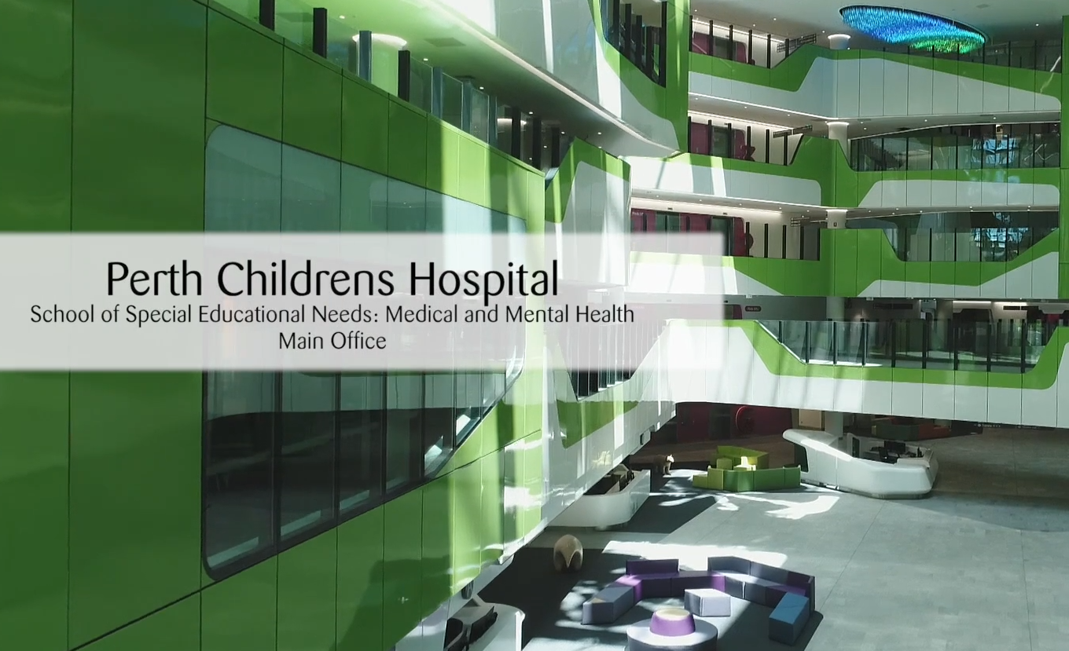
You can watch the SSEN video and check out their services HERE.
MMH is one of seven Specialist Schools run through the Department of Education, with the others being:
- SIDE- the School of Isolated and Distance Education provides distance and online learning to students who cannot attend classes in a regular school.
- Instrumental Music - the instrumental music program run in schools through Instrumental Music School Services.
If your child is selected, this outstanding program will take your child’s love of music to the next level.
Alternative Learning Settings - alternative learning facilities and targeted support programs are provided for students who have been excluded from a public school or who are at risk of exclusion due to violent and/or aggressive behaviour.
- Behaviour & Engagement, This support is provided I schools for students with extreme, complex and challenging behaviours.
- Disability - The School of Special Education Needs: Disability provides schools with support to ensure students with disability can access learning on the same basis as their peers.
- Sensory.- Support for children with hearing loss, vision impairment and dual sensory loss

International Student News

18 April International Student Expo 2024
Are you:
- A high school student who wants to know more about university programs and pathways?
- A Vocational or University student who wishes to transfer to another course?
- A final-year student who aims to study further and receive up to 50% scholarships?
- A temporary visa holder who seeks advice on visa options or Permanent Residency?
- A graduate who wants to explore career opportunities?
What can you find at the Study Expo?
- Over 20 Prestigious Universities, TAFEs and Private Colleges
- Free and Personalised Visa/PR Advice**
- Explore Great Tips to Land a Job
- Application Fee Waived*
- Up to 50% Scholarship Available*
18 April, 12 noon to 6pm Double Tree by Hilton, Northbridge
Get tickets HERE.

