Parking Around the School and
Kiss and Drop Zone Regulations
No Stopping –
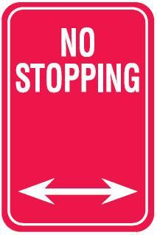

A driver must not stop on a length of road or in an area to which a No Stopping sign applies. Between the times mentioned, motorist who park between the no stopping signs will be issued with a traffic infringement notice totalling $311.00 and two demerit points. This includes stopping and dropping off/picking up your children in these zones. You cannot stop in these zones for any reason (except for a medical emergency)

Bus Zone –

A driver must not stop in a bus zone between the mentioned times.
The dropping off and picking up of children in these zones during the mentioned time is prohibited. A fine of $311.00 and two demerit points apply.

No Parking – This rule applies to our Kiss and Drop zone between the hours of 8:00-9:30am and 2:30-4:00pm

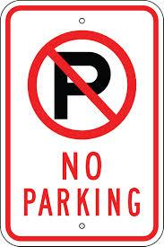

A driver of a vehicle must not stop on a length of road or in an area to which a No Parking sign applies unless the driver is;
- dropping off, or picking up passengers or goods
- does not leave the vehicle unattended (vehicle unattended means that the driver can leave the vehicle however the driver cannot be any more than 3 metres from the closest point of the vehicle)
- completes the dropping off or picking up of passengers or goods, and drives on as soon as possible (generally in a 2 minute time frame)
The No Parking rule is simple. Between the time mentioned, drivers cannot leave their vehicles in these zones and walk into the school to collect their children. If you park in these zones between the times listed, you must remain in or near your vehicle (within 3 metres). Motorists detected breaching these road rule signs will be issued with a traffic infringement notice totalling $311.00 and two demerit points.

Safety and good manners in Kiss and Drop….
- Students should exit their vehicle on the left-hand side closest to the curb
- Students can enter or exit their vehicle in any parking bay along the kiss and drop zone – you do not need to be in the front parking bay for your child to hop out
- If there are gaps in the parking bays you are able to go around parked vehicles and use those vacant parking bays
- Move out of the left lane/parking bays when your child has hoped out or in so others can come into the parking bays
- Please be mindful that the line of cars can stretch down Moore St towards NECOM and they are lining up – try not to push in!

