**Jackson School Announcements**

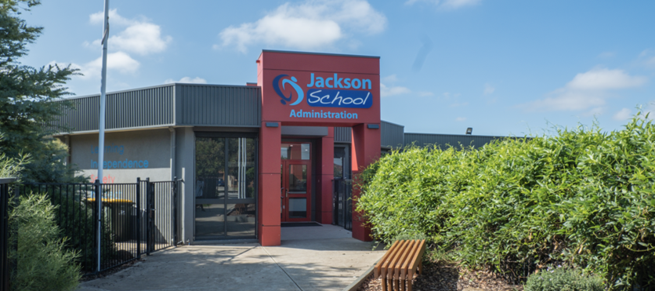

Sometimes at school we have announcements.

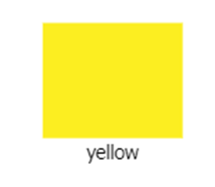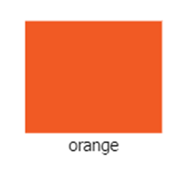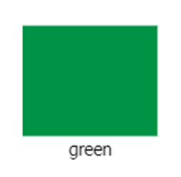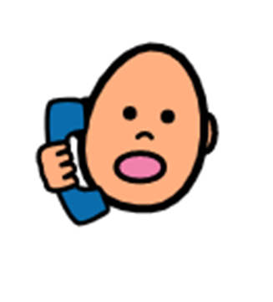

When I hear a green, yellow, or **orange,** announcement this means someone in the school needs help.

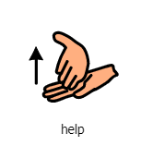

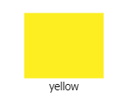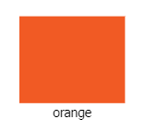

An orange announcement and an **orange lockdown** are different.

When I hear an orange announcement, I don’t have to stop what I’m doing and can leave my classroom. Everyone is safe.

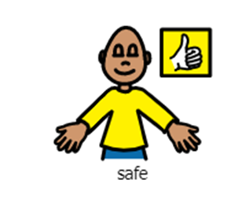

When there is an **orange lockdown** our principal or teacher will make a special announcement.

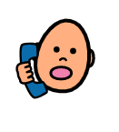

When I hear an **orange lockdown** this means I need to stay in my classroom to be safe.

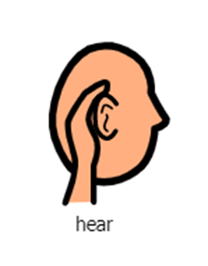

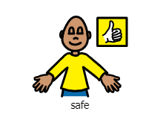

If I am playing outside when I hear an **orange lockdown** a teacher will take me back to a classroom.

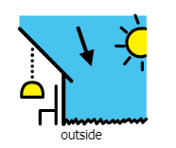

My job is to keep my body calm and listen to instructions from my teacher.

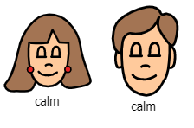

A lockdown means a student needs help from lots of different people.

It helps keep everyone at the school safe.

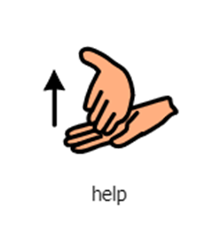

Sometimes lockdowns go for a long time it is okay to feel frustrated you are in the classroom.

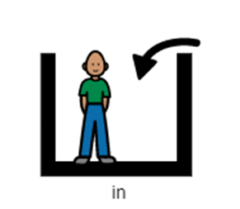

You are safe in the classroom with your teacher.

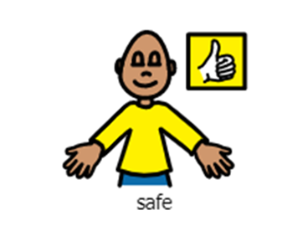

When the lockdown is finished the principal or teacher will make a special announcement **“All Clear”.**

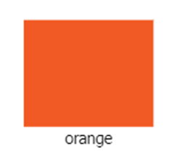

We can leave our classrooms and go back to our regular routine.

