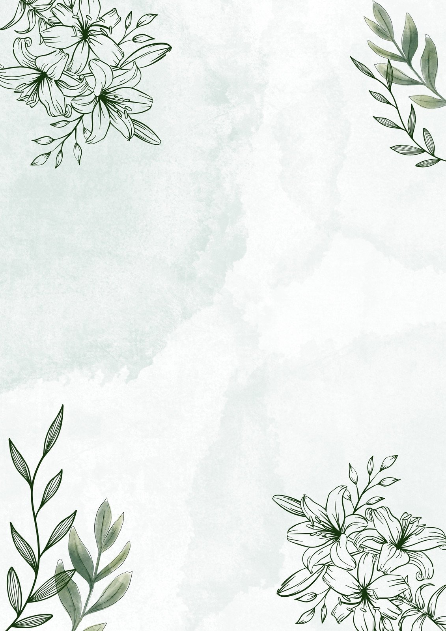
I am Poem by Ivy
I am adventurous, wild and brave.
I wonder what next is going to be like.
I hear River screaming.
I see myself transform into my older self.
I want to be Proud of River.
I am adventurous, wild and brave.

I pretend I can speak another language.
I feel nervous about next year.
I touch people’s hearts.
I worry about most animals going extinct.
I cry when I see a dead animal on the road.
I am adventurous, wild and brave.

I understand some of the math.
I speak what I think is right.
I dream of ducklings helping each other.
I try my best in Math.
I hope one day I will succeed.
I am adventurous, wild and brave.

