Career News

The Big Day In careers in IT show
Each year the Australian Computer Society hosts a road show that goes around Australia trying to attract students into careers in computing.
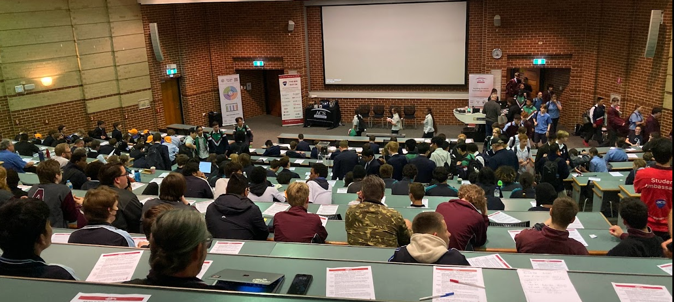
This year The Big Day In was on at Curtin.

My main takeaways were:
Many of the speakers had started in careers in other industries before going into IT.


- Jennifer Rule was poached by Iluka Resources from lecturing in the Fashion and Design department at South Metro TAFE.

She said that she had practically none of the essential criteria on the job description but said her transferrable skills were perfect and she landed the job.

- There were three guys who had won cadetships in the Bankwest Technology Graduate Program and only one, Bharath Sukesh, had gone straight from school, where he loved maths and straight sciences, into a Bachelor of Engineering where he specialised in Computer Science.

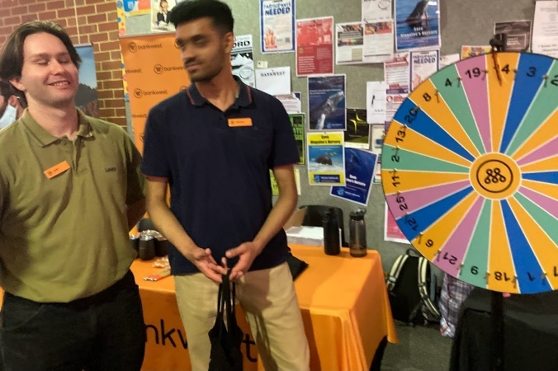
Of the other two, Dylan Travers started off his career doing architecture before going into software engineering, and Ryan Thuys started doing fashion and design before moving into social media and finally software engineering.

Pathways from School into IT

- The Australian Signals Directorate used to be spy central. It offers the Australian Government Digital Apprentice Program and if you worked there, your training would be first class as you can’t really afford to make mistakes in this line of work. You can find a great career quiz that indicates what sort of IT would suit your abilities. See Puzzles and Challenges HERE.

- There was some mention of how to gain credit points to a uni degree from VET courses.

There are currently few IF ANY work experience placements for school students. If you want to find out about the IT industry while still at school:
- Get part time jobs working in IT. Working in a retail or computer repair shop or designing web pages for your junior sport club will give you knowledge that will teach you more about the industry and may help you to secure a course place or cadetship.
- GROK Academy is FREE for Australian schools. Students can use it to learn basic coding skills.
- Women in Technology WA provides ongoing mentoring, events and support.
- Keep an eye out for the next Innovators Tea Party event which will be advertised in this newsletter.
- The CoderDojos are going strong in WA and there are lots of robotics events each month and RoboCup runs each year.
- School students wanting to go into IT should plan to enter an IT competition in 2024.

Parents Helping Parents - My Kids Career
The Australian Parents Council has created MyKidsCareer to help parents to support their students.


University Opportunities

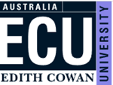
20 September Computing and Security Science Information Evening

Our Computing and Security programs include a broad choice of major subjects and cover dynamic areas such a computer science, cyber security, information technology, counter terrorism, security, intelligence, and software engineering.

6 – 7.30 pm. Joondalup Campus Register HERE.

25 September 2023 ATAR Revision Sessions

ECU will be delivering the ATAR revision sessions both on-campus, and online for our regional and remote students.
Sessions run between Monday 25 September and Friday 29 September 2023
 | Monday 25 September | Tuesday 26 September | Wednesday 27 September | Thursday 28 September | Friday 29 September
9.00am – 1.00pm | Computer Science | Maths Methods | Human Biology | English | Physics
2.00pm – 6.00pm |  | Biology | Maths Applications | Maths Specialist | Chemistry

Online: Register for online www.trybooking.com/CHTPZ
On Campus: Register for on campus www.trybooking.com/CHTPB


30 September Medicine: Final date to apply for Curtin Medical School
The final date to apply for the Bachelor of Medicine, Bachelor of Surgery will be Saturday 30 September. All students wantint to apply for Semester 1, 2024 Medicine intake must submit an application through Tisk by this date.
Indicative ATAR: 95 Minimum
Prerequisites: Chemistry ATAR
Tests required: UCAT ANZ and CASPER
For more information contact, students can email Curtin Medical School

2 October Curtin accommodation applications open
Applications for UniLodge and St Catherine's College (Curtin Perth) are set to open on Monday 2 October, while applications for Agricola (Curtin Kalgoorlie) open on Monday 9 October.
Accommodation support is available to aid your students as they make these important decisions.
Students can explore campus accommodation, or for more information, contact the Curtin Perth Reservations team, or Agricola student accommodation team for Kalgoorlie.

October 11 Engineering and Technology Showcase
Tour facilities, talk to teaching staff and students and discover ECU’s great Engineering and Technology opportunities.
Register HERE.

24 October Social Work Information Session Online

If you're interested in learning more about ECU's Social Work course please join us for our online Information Session, where you will hear from both the Future Students Team and Social Work Academics.
6 – 7.30pm Register and get the link HERE.

15 November Future Student Information Expo

Our Information Expo will introduce you to our wide range of courses and the excellent support services you can expect as a student. We'll cover course admission pathways, how to apply, fees and scholarships and flexible study options like online or part-time. Bring family or friends and explore the campus and our great facilities.
6 – 7.30pm Joondalup Campus. Find details HERE.

30 November Curtin Portfolio Applications

Year 12 students must submit all supporting documentation for their portfolio applications by 30 November 2023 to be considered for the Main Round offers. Any documentation uploaded after this date will most likely be assessed for Second Round offers in January. learn more about Portfolio entry.

Curtin Connect year 12 assistance

Curtin Connect will be open and available throughout the December holiday period to provide year 12 students with course advice or assistance with their TISC application. They will be open Monday - Friday from 8.30am - 4.30pm (Tuesday from 9.30am) but will be closed on regular public holidays.

TISC University Applications for 2024

TISC application deadlines
- 30 September Medicine, Surgery, Dental, Pharmacy, Podiatric Medicine
Find details HERE.
- 17 November: Curtin Nursing Conversion
Find details HERE
- 30 November Murdoch Veterinary Science.
Find details HERE.
- 18 December Closing date to apply for main round offers.

For more information Important Dates for 2023 go HERE.

December 22: Main round offers will be available online and emailed.

Good Univesities Guide 2023/24
These rankings are for university undergraduate courses in Western Australia across a range of measures. There have been some significant changes over the past year.

You can find the Good Universities Guide rankings HERE.

Overall Experience

 |  |  |  | 
82.7% | 77.2% | 75.8% | 74.2% | 72.6%
Social Equity – The proportion of students from low socioeconomic or disadvantaged backgrounds
 |  |  |  | 
22% | 17% | 16% | 11% | 9%
Staff Qualifications – proportion of staff with masters or doctoral degrees.

82% | 76% | 73% | 68% | 51%
Student Demand – high achieving students choosing to study at each university.

Low 6  Medium 66  High 28 | Low 10  Medium 71  High 19 | Low 14  Medium 80  High 6 | Low 25  Medium 73  High 2 | NA
Student: Teacher Ratio

20:1 | 20:1 | 30:1 | 25:1 | 24:1
First Generation – Students whose parents’ education is known and did not exceed Year 12
40% | 35% | 29% | 29% | 23%
Learner Engagement – felt they belonged and participated in university life.
64.5% | 58.6% | 55.7% | 50.1% | 48.3%
Learning Resources – Students who were satisfied with the learning resources provided.
88.7% | 85.6% | 83.5% | 79.5% | 77.1%
Skills Development – Students who were satisfied with the skills they developed.
87.1% | 86.8% | 79.6% | 78.7 | 76.2%
Student Support
80.2% | 73.9% | 73.2% | 72.6% | 69/7%
Teaching Quality
85.2% | 84.1% | 81.9% | 79% | 78.4%
Graduate Salary
$62,000 | $53,200 | $49,200 | $48,400 | $35,500
Full time employment
78.2% | 73.7% | 65.5% | 62.8% | 61.4%

- ECU is still the West Australian university given top ranking by undergraduate students. It is ranked third in Australia after Avondale, a small Seventh Day Adventist university in NSW which ranked first, and Bond University, on the Gold Coast with just 4,000 students which ranked second.


These results are in some cases EXACTLY the same or substantially similar to those provided by the ComparED results that were gathered through Quality Indicators of Learning and Teaching last year.

Training

TAFE Applications opened on September 1 Close 3 November
Applications for TAFE courses for 2024 open on September 1 and close on 3 November
See Key Dates HERE. Go HERE and fill out your application.

2024 TAFE Applications Open

Close 3 November for competitive courses
 | North Metropolitan TAFE
 | South Metropolitan TAFE
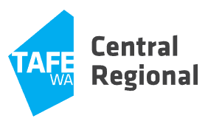 | Central Regional TAFE
 | North Regional TAFE
 | South Regional TAFE
F or more information, download the TAFE admissions guide for entry to full time courses for entry to full time courses.

Cyber Security Microsoft Traineeships
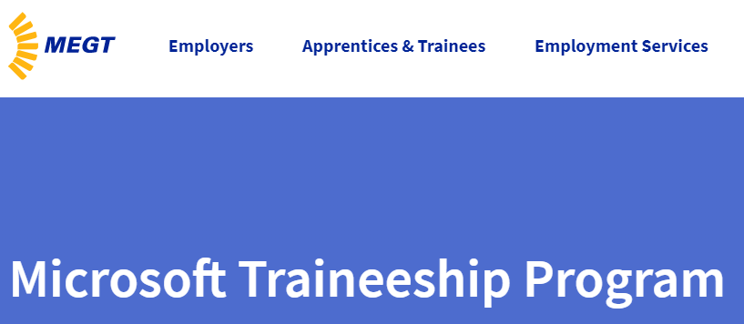
If you are interested in starting an IT Traineeship, MEGT has Microsoft Traineeships advertised HERE.

Apprenticeship Guide from CCIWA
CCIWA is currently working on the new issue of the Apprenticeship Guide. Georgie Mitchell from CCIWA has asked that you remember that the current issue has a lot of opportunities that are CURRENTLY OPEN.

Check Apprenticeship & Traineeship Intake Guide - Apprenticeship Support Australia - WA (cciwa.com)

Georgie also pointed out these resources:

Students/Jobseekers
The link to view the free jobseeker/candidate services Gateway and Recruitment Team offer: Apprentice / Trainee - Apprenticeship Support Australia - WA (cciwa.com)
The team offer over the phone and in person career consultations focused on but not limited to
- Apprenticeship/Traineeship Pathway advice
- Job readiness assessments
- CV advice
- Interview Preparation
can be booked via Careers & Recruitment (office365.com)

Senior School Opportunities

FIRST Robotics Masterclass Series | September - October 2023
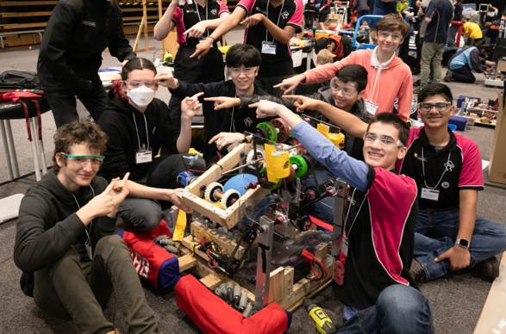
The FIRST Robotics Masterclass is a 9-day experience to learn about engineering, 3D Modelling, programming and team management. It runs at our Bentley campus, (mostly) on weekends during late September and October.
University student mentors from Curtin’s FRC Team 4788 will provide an inspiring, inclusive and informative environment for high school students to improve their abilities to work in a FIRST Robotics Competition (FRC).
After completing this masterclass, participants will have the option to join Curtin Team 4788 in the official 2024 FRC season, which includes a trip to Sydney for the Asia-Pacific Regionals in March, and a crack at the International finals in Houston in April.
DATES: 29, 30 Sep; 1,6,7,8,14,21,22 October
Watch video: www.youtube.com/watch?v=UvU8SDmH-LA

Registrations open soon, express your interest HERE

Never applied for a job? Get resume temmplates here
It’s tricky to write an application if you have never had a job. The Victorian government provides templates to follow at Youth Central which make your applications look good.
Check out the tips and guides HERE.

Pathways to VET for those without their WACE or OLNA

There are several alternative pathways to TAFE for school students who do not achieve an OLNA:
- Vocational pathway (VET in schools): students can achieve an OLNA or a Certificate I, II or III to gain entry to a TAFE course.
- TAFE Admissions testing: school students may be eligible to register for TAFE Admissions testing if they have not sat the OLNA at school within the six months preceding TAFE Admissions testing and if they have not exhausted their maximum six attempts at the OLNA while of compulsory school age.
- Alternative assessment:
  - Students can enrol at any Certificate I level, as there are no entry and
  - Students can enrol into one of the foundation skills and equity courses.
For more information, TAFE admissions guide for entry to full time courses

Bloom invitation to young changemakers
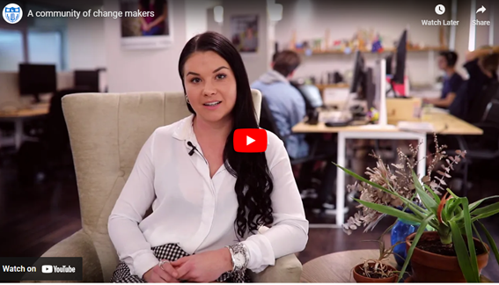
Bloom supports youth innovation and entrepreneurship by providing friendships, working spaces and upskilling for young people at both the St Catherine’s UWA and Curtin sites.
If you are at school, or about to leave, you might find your group of likeminded changmakers at Bloom. Watch the video HERE. Check Bloom out HERE. Email Lisa Longman lisa@bloom.org.au

Year 12 Opportunities

Police Force Careers at Royal SHow
If you are going to the Royal Show, you can talk to recruitment staff about careers in the West Australian police service.
They will be available from 23 – 30 September. Check details HERE.

7 October WA Police force Careers Expo
You can check out the WA Police Academy and discover a variety of careers in the WA Police Service on the 7 October.
Check details HERE.
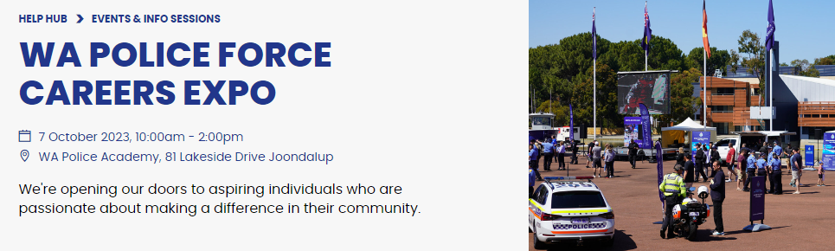

15 October Applications for AgCAREERSTART close
Do you know a young person whose interested in a farming career?
AgCAREERSTART is a unique gap-year program

Applications for 2024 are open to 17-25 year olds, previous agricultural work experience is welcome but not required.

Main Payments for Uni and VET Students
If you’re studying, training or doing an Australian Apprenticeship, you may get 1 of 4 main payments.
Youth Allowance for students and apprentices | Financial help for students and apprentices aged 24 or younger and either:  - studying full time  - doing a full time Australian Apprenticeship.
ABSTUDY | Aboriginal and Torres Strait Islander students and Australian Apprentices.
Education Entry Payment | A yearly payment you get when you start study and get certain income support from us.
Student Start-up Loan | A loan you can get up to twice a year if you’re an eligible higher education student.
Rent Assistance. | You may be eligible for Rent Assistance if you are getting ABSTUDY Living Allowance, Austudy or Youth Allowance

Westpac Young Technologists Scholarship
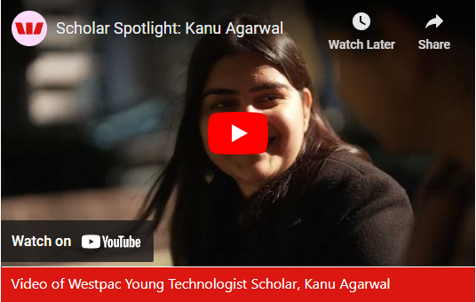
The Westpac Young Technologists Scholarship is for talented high school graduates looking to strengthen their expertise in technology to create new opportunities in the world of STEM.

The Westpac Young Technologist Scholarship is valued at $20,000 and includes funding to the scholar of $5,000 per year for three years ($15,000 total) and the Disruptive Leaders Program, valued at $5,000.
Check it out HERE.

Holiday Job Opportunity


Peddle looks like lots of fun and a great way to make money over summer as you meet new people.

Year 11 Opportunities

6 November Applications close Curtin Focus on Mining tour
January 2024

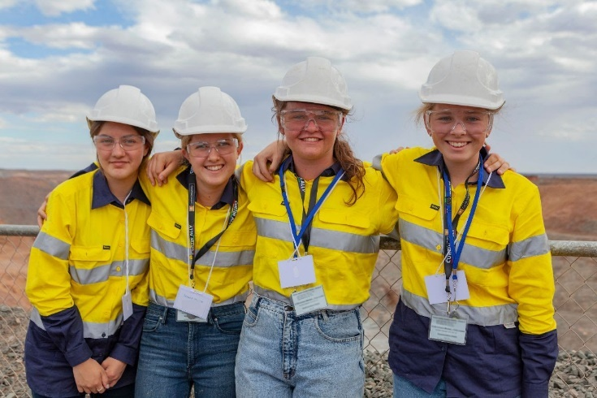
Twenty four Year 11 and 12 STEM students will be heading to Kalgoorlie during the January holidays to find out about emerging STEM careers in WA's evolving mining sector. The students will be hosted at Curtin's WA School of Mines with trips to Goldfield operational sites throughout the week.
Applications close 6 November.
More about Focus on Mining

13 October Fairway UWA 2024 Applications Close
UWA’s Fairway program provides support to students from Broadway Schools who want to go to university. Check out the advantages that this free program can give.

It starts in the school holidays with a residential camp at UWA and continues through online engagement throughout the year. It is not onerous for participants.

Students apply for the program in Year 11 and participate in Year 12.
Check it out HERE.

Applications close 5pm AWST, Friday 13 October 2023.
Year 10 Opportunities

Universities Admission Guide for Year 10s
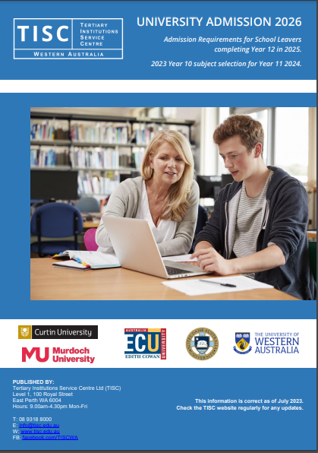
Parents, teachers and career practitioners will be using the TISC Guide 2026 to make sure you are taking subjects in the right categories.
It includes information about prerequisites for each university course.

If you would like to check the Guide you can download a free copy HERE.

Year 9 & 10 Opportunities

8 – 15 Year Olds

Robo Academy using Lego September & October
Book in now to Curtin's two-day introduction to robotics programs. Suitable for children aged 8-15 years old, the sessions cater for beginner and intermediate students, and let them explore their creativity using Lego-based programmable 'bots.
Choose a date that suits:
23 & 24 September | 10am-3pm | Beginner and Intermediate
30 September & 1 October | 10am-3pm | Beginner and Intermediate
TICKETS | Robo Academy | Engage (curtin.edu.au)

27 September Experience ECU – School Holiday Program for Year 9 & 10

This program is for Year 9 and 10 students who will be able to experience what it’s like to study at Edith Cowan University in the September school holidays.

During the day, they will explore our campus, meet our academics, ask questions to our current students, find out about our courses and learn about our entry pathways.

They will be experiencing what ECU has to offer – from our real-world facilities to campus life, while also attending a variety of workshops
Please ensure to register as places are limited. Register HERE.


27 OR 28 September A day in the life of a Murdoch Uni Student for Year 9 & 10


If you are currently in Year 9 or 10, A Day in the Life of a Murdoch University Student is the perfect opportunity for you to explore your interests and where these might lead you.
Find out more HERE.

Girls Engineering Forum | 24 November 2023

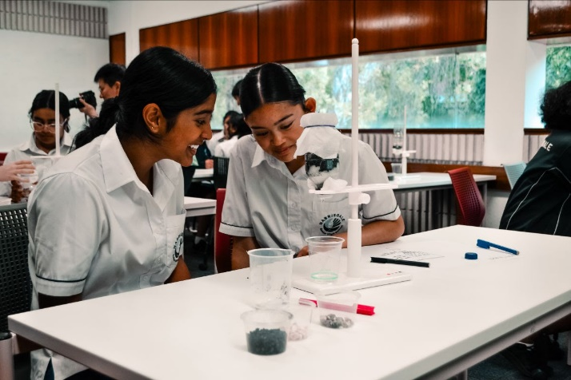
Year 9 & 10 students and their teachers are invited to attend the Girls+ Engineering Tomorrow Forum. This FREE opportunity connects girls with a passion for STEM and showcases engineering through a 1-day experience at Curtin.
Over the day, students will participate in engaging workshops, meet university and industry role models, and hear from our Women in Engineering Panel as they explore the diverse and exciting pathways available in engineering.

Register HERE.

Primary School Opportunities

26 – 30 September Awesome Festival – school holiday program


A career in the creative arts could be the best career pathway for many children. Learn to play the ukelele, make a video, learn to create comic strips.
The festival is aimed at young children.

Find details HERE.

8 – 15 Year Olds

September & October Robo Academy using Lego
Book in now to Curtin's two-day introduction to robotics programs. Suitable for children aged 8-15 years old, the sessions cater for beginner and intermediate students, and let them explore their creativity using Lego-based programmable 'bots.
Choose a date that suits:
23 & 24 September | 10am-3pm | Beginner and Intermediate
30 September & 1 October | 10am-3pm | Beginner and Intermediate
TICKETS | Robo Academy | Engage (curtin.edu.au)

3 – 6 October Barking Gecko School Holiday Workshop Subiaco

Across these four-day workshop intensives, participants will explore their limitless imaginations creating characters, developing devising and storytelling skills before sharing their creations and explorations with family and friends on their final day.
Metro School Holiday Workshops | Subiaco
Venue: Subiaco Arts Centre
Dates: Tuesday 3 - Friday 6 October (inclusive)
Times: 9:30am - 3:30pm daily
Ages: 8 - 12 Years
For further information, please email: learning@barkinggecko.com.au

Defence Opportunities

1 October Applications close for Navy Work Experience
Naval Gazing Navy Careers Experience - November Job Ref - WEP/09396/22  - 13 - 15 November  - HMAS Stirling  - Navy  Information Pack Word Document Information Pack PDF Document | - Start New Application  - Access Existing Application  - Preview Application Form  - Email A Friend

1 October Applications close Air Force Careers Day
An Aerial View: Air Force Careers Day (14 November 2022) Job Ref - WEP/01117/23  - 14th November 2023  - RAAF Base Pearce Great Northern Highway, Bullsbrook WA 6084  - Air Force  Information Pack Word Document Information Pack PDF Document | - Start New Application  - Access Existing Application  - Preview Application Form  - Email A Friend

15 October Applications close for A day in the life
Day in the life of a Soldier - WEP - (23rd November 2023) Job Ref - WEP/02601/23  - 23rd November 2023  - Irwin Barracks  - Army  Information Pack Word Document Information Pack PDF Document | - Start New Application  - Access Existing Application  - Preview Application Form  - Email A Friend

31 October ADF Scholarships Close
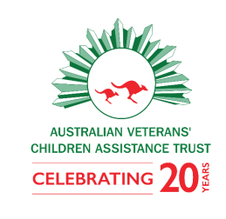
Children and grandchildren of veterans are eligible for scholarships to support their study at unis, TAFEs and other training providers. Applications for scholarships close on 31 October.

All bursaries and sponsored scholarships are for tertiary education and are $4000-$6000 per year, for up to three years.
https://avcat.org.au/scholarships/
Applications opened 18 August and close 31 October.

Read more about preparing your application in our Application Guide.

RRR Opportunities

9 October Applications close for regional traineeship grants
- Regional Traineeship Program assisting communities to employ and upskill local workers, supported by the Cook Government
- Grants of up to $38,000 available now to support vocational education in the regions.

Grants of up to $38,000 are available to WA Community Resource Centre (CRC) Network members and select regional Local Government Authorities (LGA) to assist with the cost of employing a trainee.
The one-off payment will support vocational training to develop a trainee's skills and knowledge to help meet the needs of local businesses and industry.
For information go HERE.

17 October South West Teacher Educatoin
Are you thinking of pursuing a career in Teacher Education? If so, our information evening is perfect for you!
6.00 – 7.30 South West Campus Find details HERE.

14 November South West Information Evening
If you want to study at ECU South West, attend our Information Session to find out more.
ECU South West is Western Australia's largest university campus outside the metropolitan area. The campus features a wide range of contemporary facilities to enhance student and staff experiences. These include state-of-the-art teaching facilities and commercial outlets providing key services; most services on-campus are also open to the wider community.
6 – 7.30PM Register HERE.

Assistance for Isolated Children Scheme
A group of payments for parents and carers of children who can't go to a local government school because of geographical isolation, disability or special needs.
Read the full conditions under who can get it.
Get help if you’re moving to study
Fares Allowance helps with travel costs between your permanent home and place of tertiary study if you get certain payments from us.
Relocation Scholarship is a once a year payment if you get Youth Allowance or ABSTUDY. You must also move to or from a regional or remote area for higher education study.
Get help with living costs
You might also get payments or assistance to help with your living costs.
Rent Assistance is an automatic payment if you pay rent and get certain payments from us.

Aboriginal and Torres Strait Islander

Koomba Birdal 2024 at NM TAFE campus
Midland has worked with Aboriginal advisors to identify 4 entry level courses for Aboriginal and Torres Strait Islander students:
- Rail Infrastructure (Cert II)
- Light Vehicle Mechanic (pre apprenticeship)
- Business Administration (Cert III)
- Salon Assistant and Retail Cosmetics (Dual Qualification Cert II)
PPE or uniforms are provided to students.
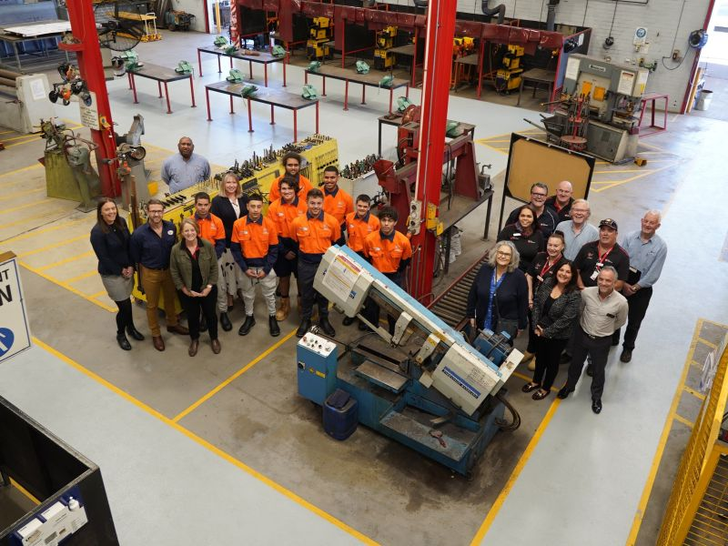
Information about these courses will be posted HERE. Or email A.J.lowe@nmtafe.wa.edu.au

Australian Aboriginal Mining Academy


The Australian Aboriginal Mining Academy was established in 2019 to facilitate the creation of meaningful job opportunities in the resources sector for Aboriginal and Torres Strait Islander people through the provision of education and training.
Aboriginal Mining Academy

14 – 19 January 2024 National Indigenous Business Summer School – Broome
The University of Notre Dame Australia's School of Law and Business invites you to apply for the 2024 National Indigenous Business Summer School program (NIBSSWA).
If you’re an Aboriginal or Torres Strait Islander student going into Year 11 or 12 in 2024, and you’re ready to challenge yourself and explore new opportunities, NIBSSWA is for you!
When: 14-19 January 2024 Questions: Email nibsswa24@nd.edu.au

A Career in Health could be closer than you think. First Nations Health Scholarships

The Puggy Hunter Memorial Scholarship Scheme (PHMSS) is designed to encourage and assist undergraduate students in health-related disciplines to complete their studies and join the health workforce. The scheme provides scholarships for Aboriginal and/or Torres Strait Islander people studying an entry level health course.
Find details HERE.

Students with Disability

Services at ECU
Student Equity, Diversity and Disability Service is a free, confidential service for students with a disability and/or medical condition, either permanent or temporary and can help make uni life a better experience.

