FareShare rescues surplus food and cooks free, nutritious meals for people doing it tough.
FareShare cooks more than 6,000 free meals a day for charities such as soup vans, homeless shelters, women’s refuges and community food banks.

Food Drive
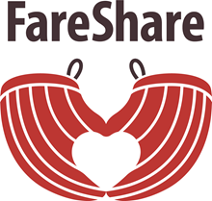

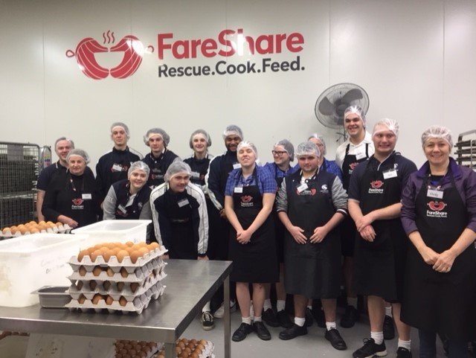
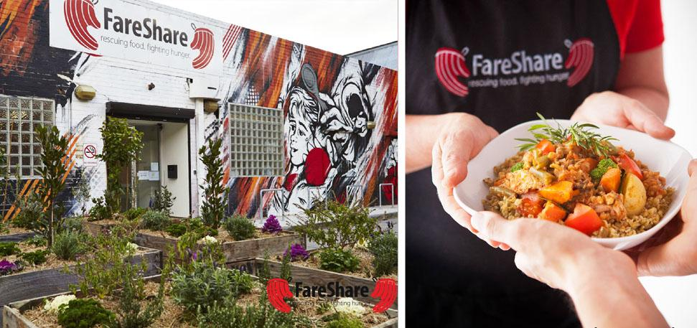

16th September – 11th October
How you can help: donate canned tomatoes, pasta and plain flour.
Collection box located in the Admin Office and the Hub for donations.
Thank you for your support!

