Service Name: Barwon Heads | Week Beginning: 17th to 21st October 2022 (Term 4. WEEK 3)
Community Involvement/ Service planned for the week:
- Following the schools’ Mental Health & well-being topic which is Persistence. Being persistent means working hard to finish what we set out to achieve and not giving up.
- Doing the compost and completing the task of putting the chickens in their chicken coop.
- Using recycle material from the school
- Asking parents for toys, old mobiles, keyboards, and books donations.
Projects to be undertaken or planned:
- Edible garden. The plants that we plant need a big container. Children will be encouraged to put them in different containers and plant more edible plants.
- Creating with children simple cooking recipes.
Team Goals for this Week:
- Educators and children will agree on the Junior Leadership program.
- Encourage and support children to maintain our little garden by watering the plants.
Theme or Main Focus for this Week’s Planner: Mythology Week!
Learning Outcomes:
- 1.1 Children confidently explore and engage with social and physical environments through relationships and play
- 2.2 Children respond to diversity with respect. Children listen to others’ ideas and respect different ways of being and doing
- 3.1 Children use moral reasoning to solve problems
- 4.1 Children persevere even when they find a task difficult and experience the satisfaction of achievement
- 5.3 Children collaborate with others, express ideas and make meaning using a range of media and communication technologies
School Holiday Program
We have an amazing School Holiday program coming up. Like all our holiday programs, we have an awesome time with the children, full of fun packed experiences that I am sure they will always remember. Please complete your booking forms as soon as possible and if you have any questions, come and speak to one of the staff at our program who will be happy to help.
Big Childcare Philosophy
Big Childcare is a leader in the out of school hour’s industry. Our team is professional, experienced, nurturing and committed to providing a supportive and transparent environment for families where their feedback and support is highly valued. We provide exceptional quality out of school hours care for school aged children which meets the health, safety and wellbeing needs of the children and families in the community. We believe in making our programs engaging, diverse, physically active and fun, where children’s learning can be scaffolded, so they can reach their full potential. Through these experiences’ children will develop a range of life long skills including building on their social and emotional capacity. Children are valued and respected as individual are central to our programs. The programs we offer are developed in conjunction with educators, schools the community, children and families. They are critically reflected upon and evaluated to ensure we are providing positive experiences that are age appropriate and extend every child.
We encourage all children and parents to provide us with feedback on the running of our service
All children are given the freedom to choose and change the activities they participate in

 | Monday | Tuesday | Wednesday | Thursday | Friday
Before Care  Creative Experiences | Creative Experiences  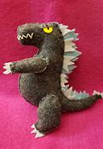  Paper Dragon/Godzilla Plates  Children will make their own dragon using glue, staples, wood sticks, paper plates, and texters. They will be encouraged to be persistent in this task.  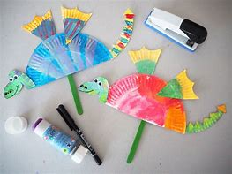  L/O: 1.1 and 4.1  NQS: 1.2.1  Current Interest of:  5.09.22 Will, Eli, Tarm, Oscar, | Creative Experiences  DIY Mermaid  Children will use their imagination to create mermaids or fishes that are part of the Mythology. They will use cardboard, scissors and colorful paper.  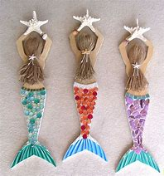  L/O: 1.1 and 4.1  NQS: 1.2.1  Current Interest of:  4.10.11 Jack  6.09.22 Billie, Maddison and Emma | Creative Experiences  Cooking “Fire” spaghetti Bolognese  Children will help to prepare spaghetti Bolognese, and while doing it, we will talk about some mythology creatures related to fire such a Phoenix and Tartarus.  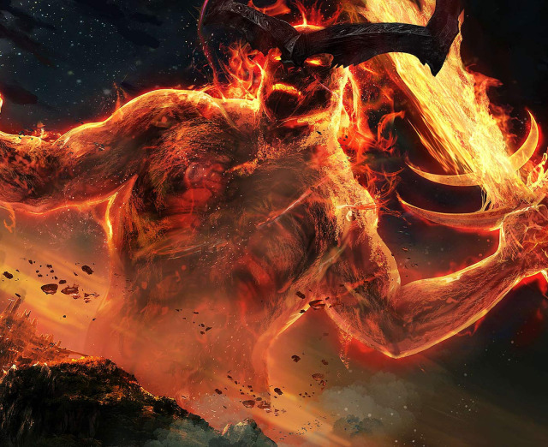  L/O: 4.1  NQS: 1.1.2, 2.13  Current Interest of  12.10.22 Bodhi | Creative Experiences  Egyptian Cats  It is believed that cats were placed on this earth to protect the Pharaohs and its people from deadly snakes, scorpions and evil. The children will be creating their own egyptian cat with its famous gold jewellery)  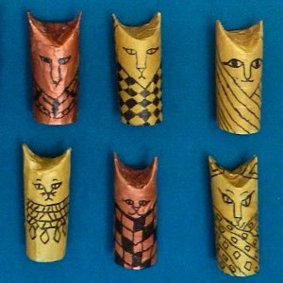  L/O: 4.1  NQS: 1.1.2  4.10.11 Maddison, Emm, Georgia | Creative Experiences  The rainbow snake  After washing the video of the rainbow serpent, children will create their own rainbow serpent.  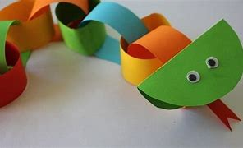  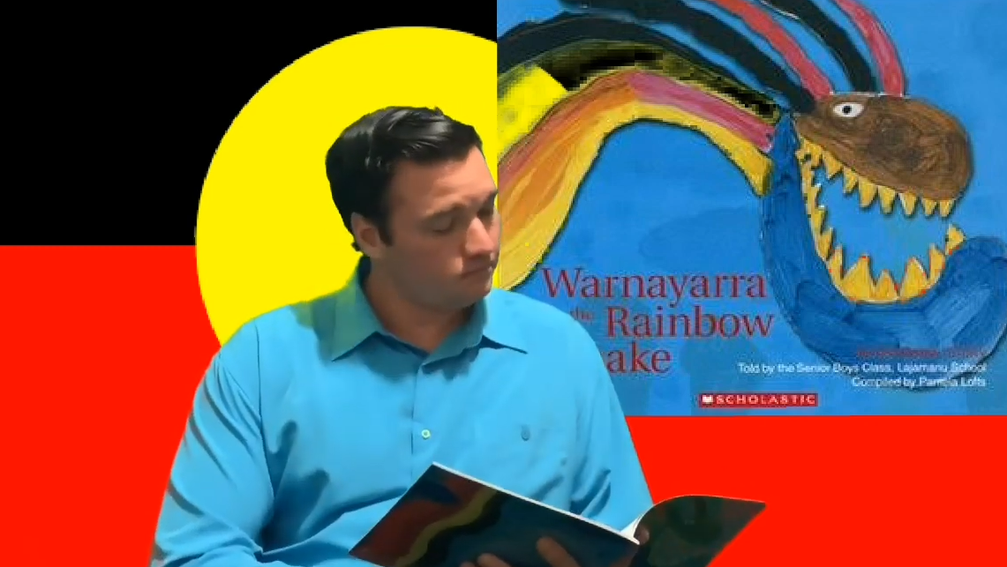  L/O:5.3  NQS:1.1.2  Current Interest of:  Educator

Before Care  Physical Experiences | Physical Experiences  Where is Wally?  Children will develop persistence by finding 8 Wally in the classroom.  L/O: 4.1  NQS: 2.1.3  Current interest of  1/09/22 Jimmy | Physical Experiences  Just Dance Disney Party Under the Sea  Children will have a dance party under the sea.  Under The Sea - Dance by Cat Yeo for Kids - YouTube  L/O: 4.1 and 5.3 NQS: 2.1.3  6.09.22 Billie, Maddison and Emma | Physical Experiences  ABC ANIMAL BALL GAME  Children will pass the ball but before to do it, they need to call out an animal that starts with a selected letter.  L/O: 3.2 and 4.1  NQS: 2.1.3  Current interest of 4.10.22 Jack. | Physical Experiences  DANCE “WALK LIKE A EGYPT”  Follow the dance moves on the TV. Let’s see who can dance the best!  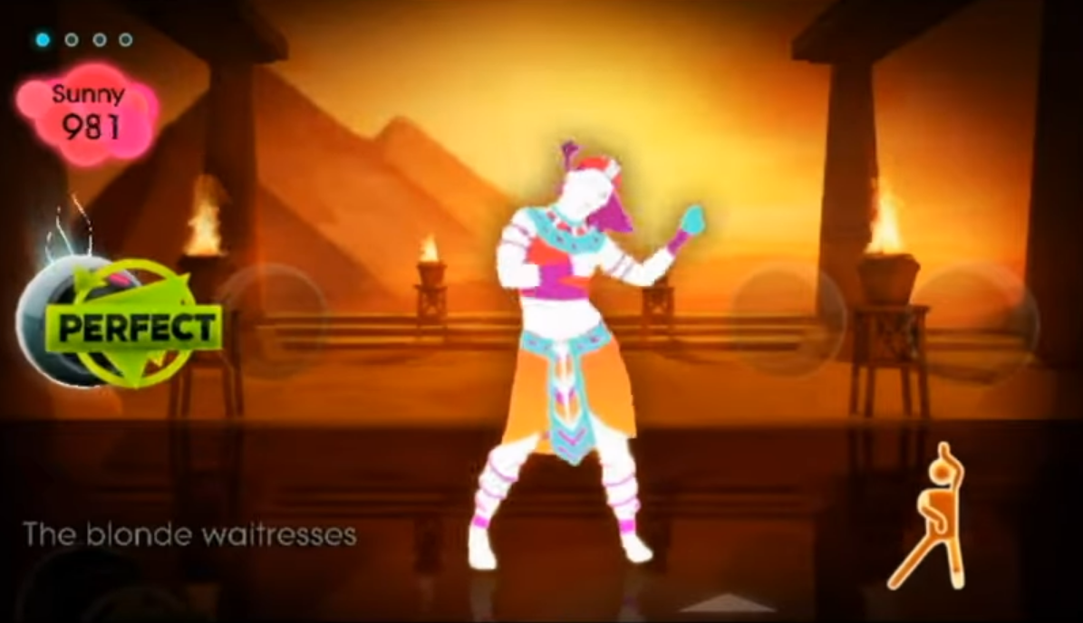  https://youtu.be/iacS9EnsepM  L/O: 3.2  NQS: 2.1.3  Current Interest of:  Educator | Physical Experiences  Musical BALL  Just like passing the parcel however we are using a ball. If the music stops whilst you are holding the ball, you are out of the game  L/O: 3.2  NQS: 2.1.1  Current Interest of:  Educator
Before Care Intentional Teaching or Discussion | Topic: Persistence  Tell me a time were you have been persistence in a task and what did you feel when you finish that task.  Delivered by: Azucena  Tell me about a question that you would like to be ask.  Delivered by: Azucena  (*13.09.22 Will’s idea) | Topic: Persistence  Tell me a time were you have been persistence in a task and what did you feel when you finish that task.  Delivered by: Azucena  Tell me about a question that you would like to be ask.  Delivered by: Azucena  (*13.09.22 Will’s idea) | Topic: Persistence  Tell me a time were you have been persistence in a task and what did you feel when you finish that task.  Delivered by: Azucena  Tell me about a question that you would like to be ask.  Delivered by: Azucena  (*13.09.22 Will’s idea)  Delivered by: Azucena | Topic: Persistence  Tell me a time were you have been persistence in a task and what did you feel when you finish that task.  Delivered by: Azucena  Tell me about a question that you would like to be ask.  Delivered by: Azucena  (*13.09.22 Will’s idea)  Delivered by: Azucena | Topic: Persistence  Tell me a time were you have been persistence in a task and what did you feel when you finish that task.  Delivered by: Azucena  Tell me about a question that you would like to be ask.  Delivered by: Azucena  (*13.09.22 Will’s idea)  Delivered by: Azucena
 | Monday | Tuesday | Wednesday | Thursday | Friday
After Care  Creative Experiences | Creative Experiences  Paper Dragon/Godzilla Plates  Children will make their own dragon using glue, stleppers, wood sticks, paper plates and texters. They will be encouraged to be persistent in this task.  L/O: 1.1 and 4.1  NQS: 1.2.1  Current Interest of:  5.09.22 Will, Eli, Tarm, Oscar  13.9.22 Emma | Creative Experiences  Shaving cream ZEUS/Tlaloc experiment  Children will discover who Zeus and Tlaloc were in Greek and Mexican mythology respectively, then they will do a rain cloud experiment using a jar with shaving cream and food colouring.  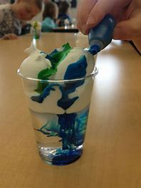  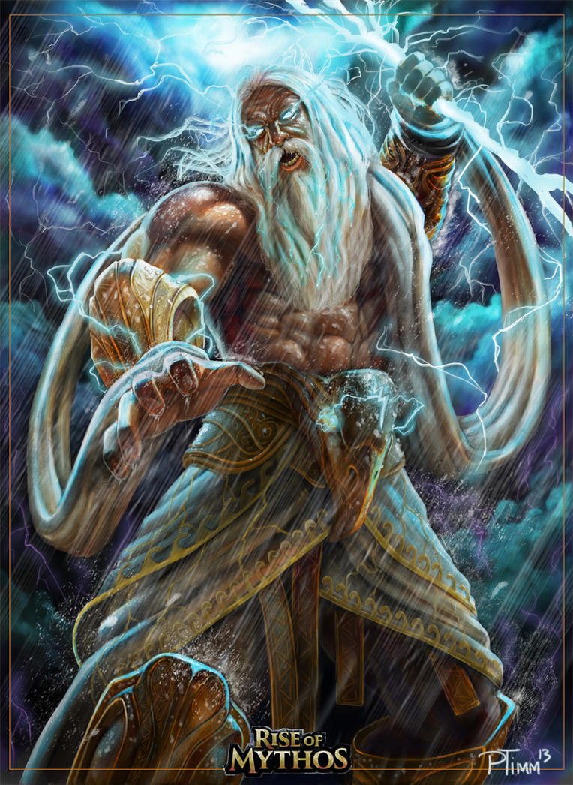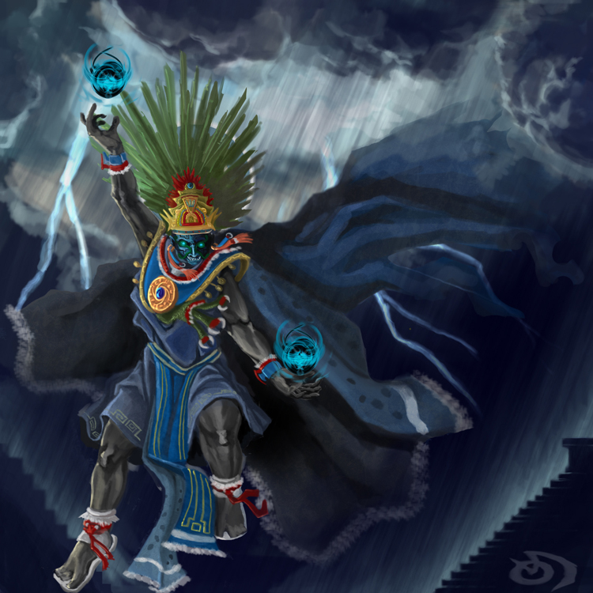  L/O: 2.2 and 4.1  NQS: 1.2.1  Current Interest of:  3.10.22 Demi, Oscar, Emma, Eli | Creative Experience  Mythical animals  Children will create their own mythological creatures by combining different animals.  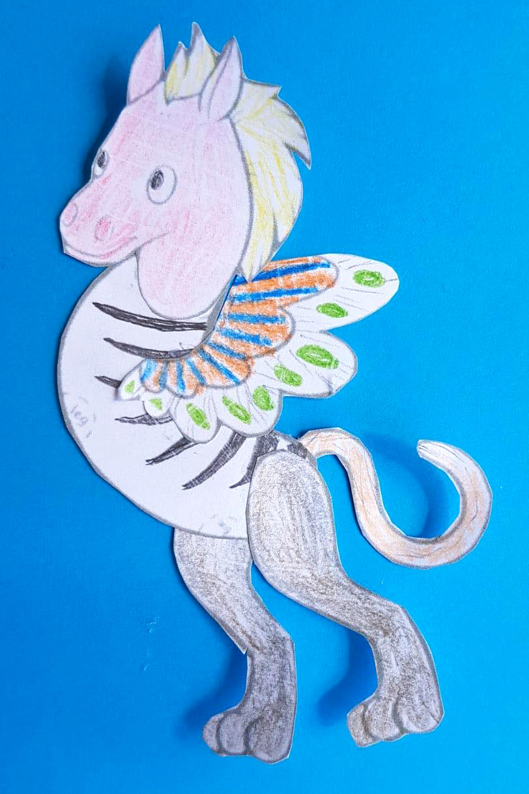  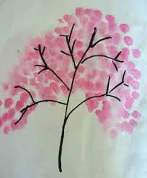  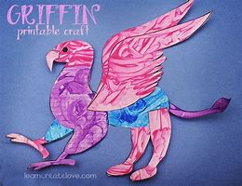  L/O: 2.2 and 4.1  NQS: 1.2.1  Current Interest of:  7/09/22. Painting and colouring. Emma and Charlotte and Alfie. | Creative Experiences  Kitsune Painting  The Japanese believed that foxes had magical powers and could tranform into humans whenever they wanted to help or trick people. The children will be painting their own unique Kitsune with its noticeable red markings.  L/O: 1.1, 4.4  NQS: 1.2.1  Current Interest of:  4.10.22  Maddison and Georgia | Creative Experiences  The rainbow snake  After washing the video of the rainbow serpent, children will create their own rainbow serpent.  L/O:5.3  NQS:1.1.2  Current Interest of:  Educator
After Care  Physical Experiences | Physical Experiences  DANCE “Believer” by Imagine Dragons  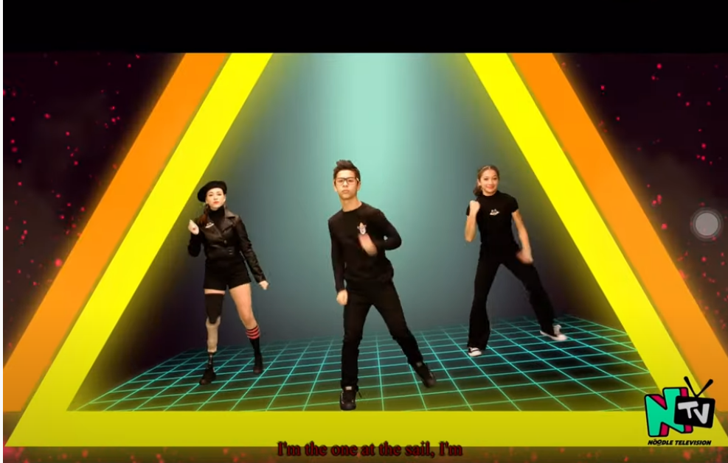  Believer - Noodle Television - YouTube  Visual Diary CURRICULUM DAY: 7/10/22 Will, Edie, Penny, Dotty | Physical Experiences  RAIN GODS salad  Children will play fruit salad but instead of fruits, they will call out the name of Zeus and Tlaloc.  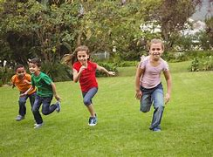  L/O: 2.2  NQS: 2.1.3  Current interest of  4.10.22 Oscar, Tarm, Georgia, Will | Physical Experiences  LAVA Tiggy MONSTER  Children will select someone to do it then they will run but when they hear the floor is lava they must find somewhere to climb in, the “it” could not climb but still can catch them.  L/O: 3.2  NQS: 2.1.3  Current interest of  10/03/22  Oscar | Physical Experiences  DANCE “WALK LIKE A EGYPT”  Follow the dance moves on the TV. Let’s see who can dance the best!  https://youtu.be/iacS9EnsepM  L/O: 3.2  NQS: 2.1.3  Current Interest of:  Educator | Physical Experiences  Line tiggy  LINE TIGGY  Make sure to stay on the lines and don’t get tagged.  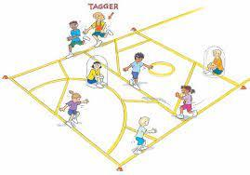  L/O: 3.2 NQS: 1.2.1  Current Interest of: 4.10.22 Georgia  5.10.22 Will, Aled, Griffith
After Care Intentional Teaching or Discussion | Topic: Persistence  Tell me about a difficult task or situation that you faced and what did you do to overcome it?  Delivered by: Azucena  Tell me about a question that you would like to be ask.  Delivered by: Azucena  (*13.09.22 Will’s idea) | Topic: Persistence  Tell me about a difficult task or situation that you faced and what did you do to overcome it?  Delivered by: Azucena  Tell me about a question that you would like to be ask.  Delivered by: Azucena  (*13.09.22 Will’s idea) | Topic: Persistence  Tell me about a difficult task or situation that you faced and what did you do to overcome it?  Delivered by: Azucena  Tell me about a question that you would like to be ask.  Delivered by: Azucena  (*13.09.22 Will’s idea) | Topic: Persistence  Tell me about a difficult task or situation that you faced and what did you do to overcome it?  Delivered by: Azucena  Tell me about a question that you would like to be ask.  Delivered by: Azucena  (*13.09.22 Will’s idea) | Topic: Persistence  Tell me about a difficult task or situation that you faced and what did you do to overcome it?  Delivered by: Azucena  Tell me about a question that you would like to be ask.  Delivered by: Azucena  (*13.09.22 Will’s idea)

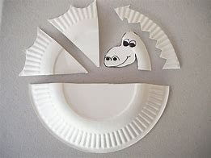

Zeus was the king of the Olympian gods and the supreme deity in Greek religion. Often referred to as the Father, as the god of thunder and the 'cloud-gatherer', he controlled the weather, offered signs and omens and generally dispensed justice, guaranteeing order amongst both the gods and humanity from his seat high on Mt. Olympus.

Tláloc (pron. Tla-loc) is one of the most important and formidable gods in the Aztec pantheon. He was considered the god of rain, water, lightning and agriculture. Tlaloc was seen as both a benevolent god providing life-giving rain but also as an unforgiving and destructive deity when he sent storms and drought.

Thor: Ragnarok Concept Art by Aleksi Briclot
In Greek mythology, Tartarus was a primordial deity, just like Chaos and Gaia, Mother Earth. Tartarus was the infernal regions of ancient Greek mythology, the deepest region of the world, the lower of the two parts of the underworld, where the gods locked up their enemies. Tartarus is also described as a deep abyss used as a dungeon of torment and suffering for the wicked and as the prison for the Titans.
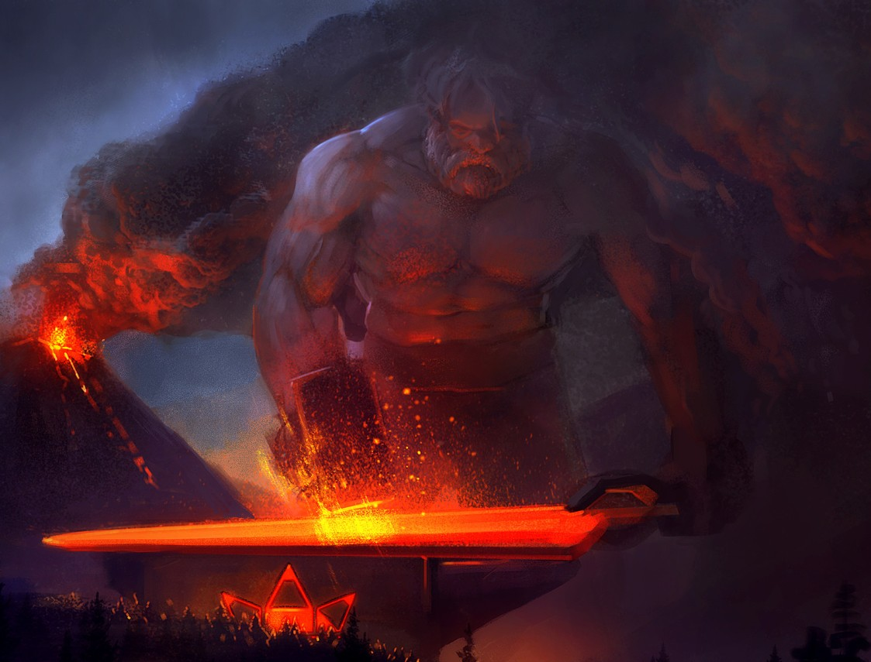
The phoenix is an immortal bird associated with Greek mythology (with analogs in many cultures) that cyclically regenerates or is otherwise born again. Associated with the sun, a phoenix obtains new life by rising from the ashes of its predecessor.

