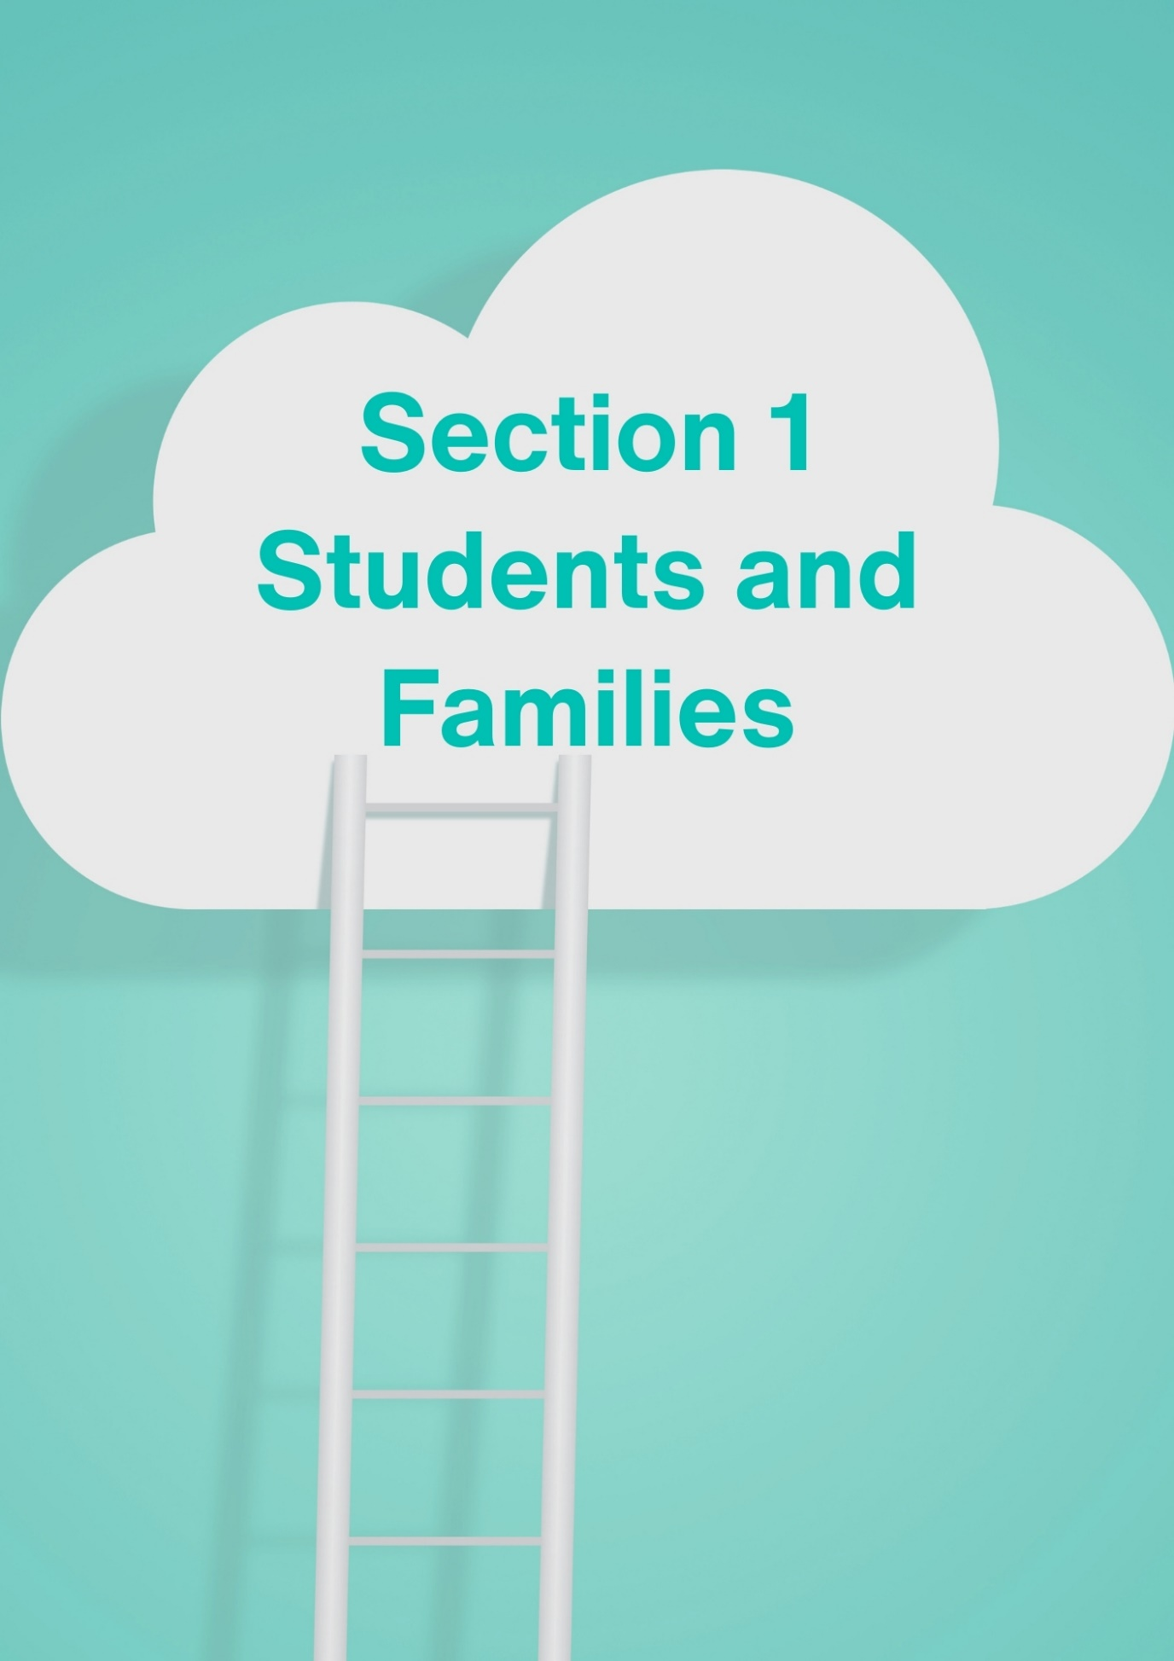

Section 1 for Students and Families

Career Events

25 May ECU Massed Sax Festival - Sax Day One
For saxophone students (with at least 2 years of playing experience) in Years 7 – 12
Day One: Clinics, Competitions, Concerts, Masterclasses
Enjoy specialised jazz and classical sax workshops plus ensemble clinics to help you get the most out of your playing, learn tips for injury prevention, and enter the inaugural WAAPA Sax competitions for high school sax players (Years 7-12) and sax composers (Years 11-12).
Place: WAAPA ECU Mt Lawley
Time: 11.00am - 5.00pm
Cost: Free
Massed Sax Festival - Sax Day One

26 May ECU Massed Sax Festival - Sax Day Two
Age: For saxophone students (with at least 2 years of playing experience) in high school years 7 – 12

This second full day of incredible music-making kicks off with the now-famous Massed Sax Orchestra, followed by inspirational workshops, trade exhibitions and free concerts, and culminates in a Sunday evening extravaganza for family and friends. Open to anyone who has been playing the saxophone for more than two years. Enjoy the biggest sax event of its kind in WA.

Place: WAAPA ECU Mt Lawley
Time: 11.00am - 5.00pm
Cost: Free
Day Two: Massed Sax Orchestra, Workshops, Concerts

27 May Career Conversations Information for Families Bentley 6:30 PM - 8:00 PM
This Education Department free event is for parents, students and community in your local area and Registration opens at 6:00 pm for a 6:30 pm start. Refreshments provided.

LOCATION
Bentley Technology Park - Global Streaming Room
The Hub, 2 Brodie-Hall Drive, Bentley WA 6102
Register HERE.

9 June ECU Percussion Pandemonium
Age: For classical percussionists in high school years 9 - 12
A free afternoon of fun, music, drums and supercharged percussion! Led by Tim White, Genevieve Wilkins and Defying Gravity, WAAPA’s percussionists work with you in fun hands-on workshops exploring ensemble playing, percussion technique, rhythm games, improvisation and world music. The day concludes with a performance for parents at 4.00pm.

Place: WAAPA ECU Mt Lawley

Time: 1.00pm - 5.00pm
Cost: Free
Percussion Pandemonium

12 June Rockingham Jobs Fair
If you live down the coast from Fremantle, get along to the Rockingham Jobs Fair.
Discover local employers looking to recruit new employees and apprentices, government departments, education providers and businesses.
Gary Holland Community Centre 10am – 3 pm
Find details at Rockingham Jobs Fair

Career News

At last, jobs in aged care become financially worthwhile!

Aged care workers win up to 28.5% wage rise
Aged care workers have won their years-long Fair Work case for a wage rise of up to 28.5% for the entire sector.
This makes work in the aged care sector considerably more financially acceptable.
Health Services Union national president Gerard Hayes, whose union had sought 25 per cent total increases for all employees, said the “life changing” increases for direct carers would result in average pay rates rising from $23.10 to $32.52 an hour.
Find details HERE

LinkedIn Global: Most In-Demand Jobs Right Now
Demand for deli clerks across all of LinkedIn more than doubled during the first quarter of 2024, measured by the share of paid job posts on LinkedIn.

People Facing Roles
Four of the top 10 jobs with the fastest-growing demand are explicitly in-person roles, with two in the food service space (deli clerk, barista) and two in healthcare (optometrist, hospice nurse).
Sales managers, sales specialists and IT skills continue to be in high demand.
Read the LinkedIn report HERE.

The Latest Labour Force Data February 2024

Unemployment remains low
School leavers can be confident about there being demand for workers in almost any career they choose.
The world is their oyster according to these stats.
Unemployment remained low throughout February although underemployment rate remained at 6.6%.
The Australian Bureau of Statistics have released the Labour Force Data for February 2024

Jobs and Skills Australia: Recruitment Insights
Labour Market Steady
City based employers are having less difficulty recruiting staff, but regional employers are experiencing more trouble recruiting.
- Employers in the Construction industry are the least likely to have difficulty recruiting for apprentices.
- Occupations with lower recruitment difficulty rates included those in the Electrotechnology and Telecommunications Trades Workers group.
Read the latest report HERE.

Employed People work in jobs where their qualification is not relevant Australian Bureau of Statistics
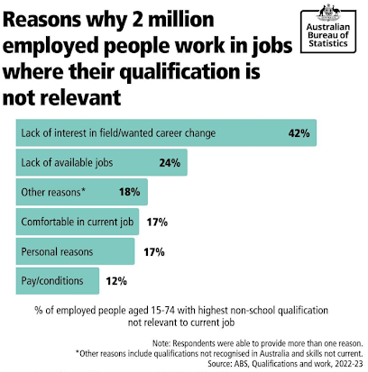
This seems shocking. It isn’t just Blockbuster Video store staff who have moved on.

It is clear that we need to keep learning on the job so that our skills don’t become redundant, and we need to pump up core skills, like leadership and being nice (empathy) so that people like working with us.

See details HERE.

Seek Australia’s Top 5 Fastest Growing Salaries
Which industries and roles have seen the fastest salary growth on SEEK?
SEEK has put together a list of Australian industries and jobs that have experienced the biggest salary increases.
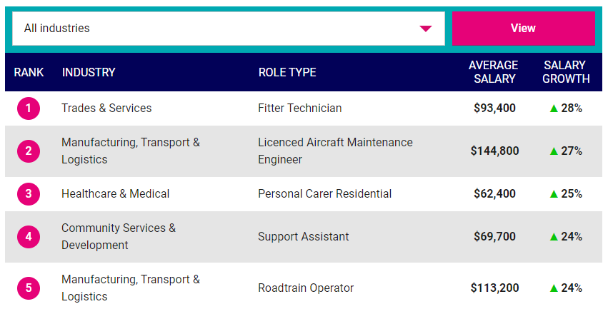
SEEK has the 20 fastest growing from all industries AND you can check out each industry to see where the salaries are going up.
Check it out HERE.

Get a MyFuture Account
There are many career information sites. All of them provide some great information. Start by getting a MyFuture account.
I think it is the best careers website in Australia:
- It’s a government site so they aren’t trying to sell you anything.
- Your private information will be protected by government.
- You get your own private account where you can save your information.
- All states and territories contribute to the information.

You can set up your account HERE.

University Events

4 June Murdoch Mandurah Campus Open Night
Join us at Murdoch University's Mandurah Campus and discover your future career in Nursing and our enabling pathways into university bachelor’s degrees.
Talk to Murdoch staff about the different pathway options available at our Rockingham and Mandurah campuses.
Gain hands-on experience as we take you on a tour though the state-of-the-art facilities including our Simulation Lab.
Find more information and register HERE.

6 June ECU Engineering Showcase for Year 11 & 12’s
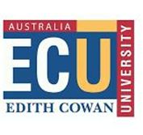
Discover why engineering is such a great profession and how ECU can provide you with an excellent start to a highly rewarding career.
Hear from current students and alumni speakers about their experiences at ECU and the transition into exciting industry roles.
Joondalup Campus 5pm Register HERE.

University News

Early Offers not made until 2 September
All WA universities will open applications for 2025 on 1 May.
The first offers will not be made until 2 September. This is a significant change which brings our procedures into line with other States and Territories.
More information can be found HERE.

University Early Offers for 2025 Applications Open 1 May

Curtin Early Offers
- If your predicted ATAR is five points above the ATAR score required for your selected course, you’ll receive an early offer that secures your place in semester 1, 2025. Your offer won’t be dependent on your final year 12 ATAR score.
- You’ll still need to complete WACE and meet the English and subject requirements for your course.
- If your predicted ATAR is less than five points above the ATAR score required for your course, you’ll still receive an early offer for a place at Curtin.
- You’ll need to achieve a final ATAR that meets course entry requirements, and meet WACE, English and subjects’ requirements for the course.
Apply through TISC from 1 May and choose Curtin as your first preference.
Key Contact How to Apply to Curtin Contact 1300 222 888
Book an appointment HERE.

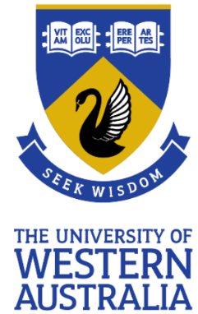
UWA Early Offers
- Applicants must have a minimum predicted ATAR of 80 (Broadway ATAR of 78) and meet the entry requirements for their nominated course to receive an offer.
- Register for updates HERE.

Key Contact Phone 131 UWA (131 892)
8.30am–5.00pm (AWST), Monday to Friday
Book an appointment HERE.
Notre Dame Early Offers
- When evaluating your eligibility, we consider your involvement in extracurricular activities, community service and other non-academic accomplishments.
- Early offers do not apply to Bachelor of Biomedical Science or the Bachelor of Advanced Biomedical Science pathway to the Doctor of Medicine programs.
Key Contact Phone: (08) 9433 0555
Email: future@nd.edu.au
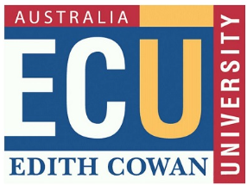
ECU Early Offers
- If you're in Year 12 and have a predicted ATAR, or you're completing a Certificate IV or a recognised university enabling course that leads to undergraduate study, you can apply for an early offer for an ECU course.
- We'll use your most recent school results to calculate a predicted ATAR and if this meets the requirement for your nominated course, you'll receive a conditional early offer of a place. This will be subject to you achieving WACE and meeting the English requirements and any other prerequisites for your course (where relevant.
- If you're studying a Certificate IV or enabling course, or if your predicted ATAR doesn't quite meet the minimum entry requirements for your course, you'll still be eligible for an early offer that’s conditional on you meeting all entry requirements for your preferred course. That means achieving the required ATAR with your final results or completing your Certificate IV or enabling course. You'll also need to achieve WACE and meet the English requirements and any other prerequisites for your course.
Key Contact
- Ask us
- Enquiries
- 134 328
Murdoch University
- Year 12 students graduating in 2024 and planning to study at university in Semester 1, 2025, can apply through the Tertiary Institutions Service Centre (TISC) from May 2024 until January 2025.
- If your teen is applying for an early offer to study a course at Murdoch, they have until December to apply.
Key Contacts
Opening hours:
Mon – Fri, 8am – 6pm
Make an enquiry 1300 687 3624
Book an appointment

2025 Undergraduate Course Guides are Out
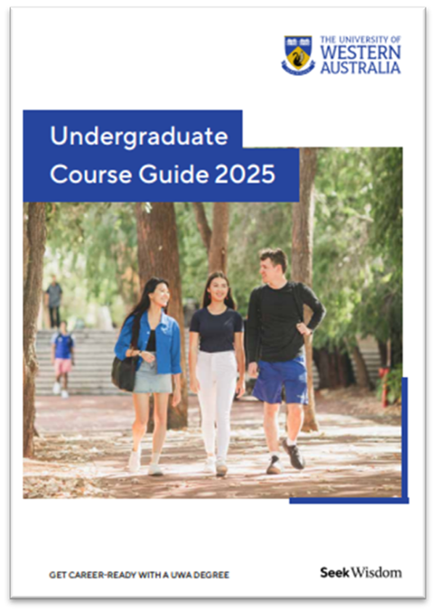

UWA Undergraduate Course Guide
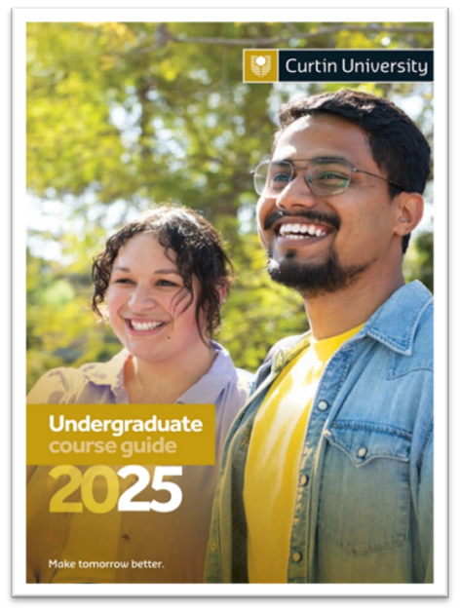

Curtin Undergraduate Course Guide
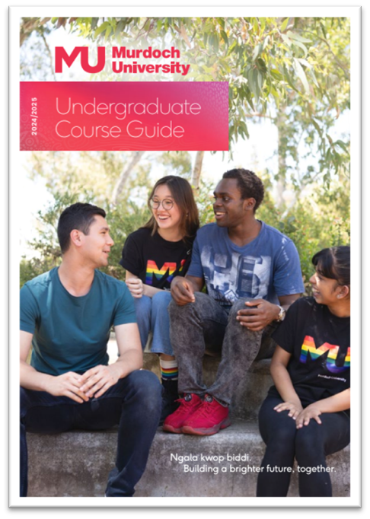

Murdoch Undergraduate Course Guide

ECU Undergraduate Course Guide

Training News

17 May UCAT registrations close for medicine places 2025
If you are applying for medicine for 2025 at:
- Curtin, or
- for an assured pathway into medicine at UWA
you need to undertake the UCAT ANZ compulsory entry requirement

BOOKINGS CLOSE | Friday 17 May 2024 at 11:59pm AEST
Late bookings close | Friday 31 May 2024 at 11:59pm AEST
Final booking deadline | Wednesday 5 June 2024 at 11:59pm AEST
Testing period | 1 July - 9 August 2024
The test is conducted between 3 July and 11 August 2023

- You can register and find preparation tests HERE.
- Find out about reduced test fees HERE
- There are banks of practice tests HERE

All candidates need to prepare by understanding these test tools.

Women in Defence Industry Scholarship
The 2021 Women in Defence Industry scholarship program is offering 20 scholarships, for $5,000 each in training at South Metropolitan TAFE, for women who would like to kickstart a career in WA's defence industry. And it's open for all ages - school leavers through to mature aged!
This is an amazing opportunity to get two full qualifications (in only six months!) plus a genuine head start on your new career.

Full details are at https://www.jobsandskills.wa.gov.au/defence... -

Construction Industry Pre Apprenticeships
There is a housing shortage crisis in Western Australia. We are importing people with building skills from overseas as we struggle to get homes built.
If you are in Year 11 or 12 a Pre-Apprenticeship is a great way to get a head start in the industry, Employers are keen to employ keen pre apprentices into apprenticeships.
Image from ABC News April 2024
Find information about pre apprenticeships HERE.

Drivers Licence Training Support Program from Construction Training Fund
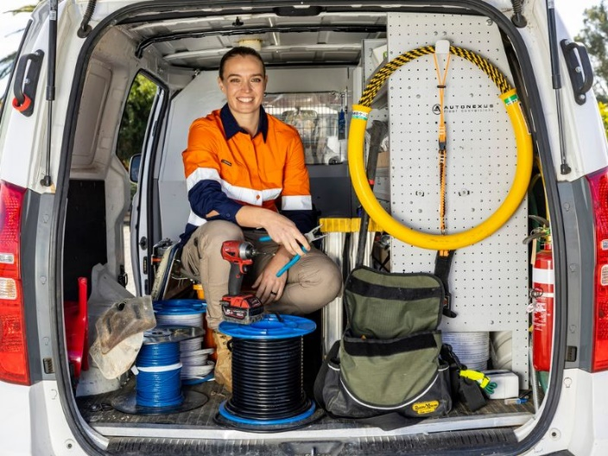
The initiative is open to Year 11 and 12 students to supplement their pre-apprenticeship training. The CTF Scholarship Program will assist young people to develop awareness and skills in road safety and vehicle management.
The Program is currently offered to Construction Training Fund Scholarship Program students to supplement their pre-apprenticeship training.
Year 11 students are required to complete their first semester before they can apply via CTF.
For more information go HERE. ita@ctf.wa.gov.au or call (08) 9244 0100

Irrigation Technology Experts Needed
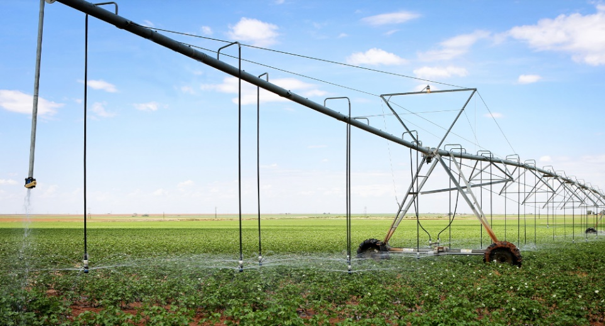
As we live through the hottest and driest year on record, there has never been a more important time than now to focus on driving water and energy efficient practices to ensure food security.
This exciting and rewarding industry is crucial to sustainable food and fibre production, as well as ensuring our communities have open spaces to enjoy.
Relevant qualification: Certificate III in Irrigation Technology
Visit: Irrigation Australia https://www.irrigationaustralia.com.au

Build writing skills in VET colleges
Don’t let lack of writing skills stop you getting a qualification.
Training colleges have lots of support available either while you are studying a traineeship or apprenticeship, or BEFORE you even start in a mainstream course.
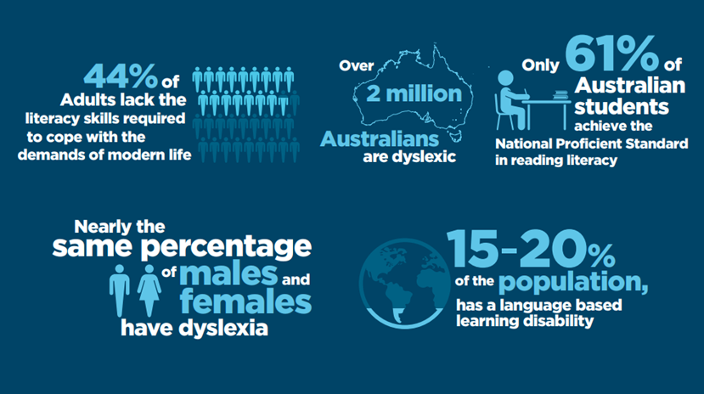
Education HQ Reading Difficulties: an Australia-wide Problem
There are also volunteers, who are often former teachers, who help migrants and non-migrants to build their literacy skills.
If you need to build your reading and writing skills contact your local Jobs and Skills Centre for help.

Community Skills Fastest Growing
Last year Health Care and Social Assistance qualifications made up seven of the top ten fee-free full qualifications in terms of growth in enrolments, with the most significant growth in numbers in the Certificate III in Early Childhood Education and Care.
Allied Health, experienced a 61% increase and Mental Health a 30% increase.

Senior School Opportunities

25 May Innovators’ Tea Party – STEM Speed Networking Career Event
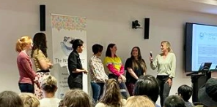
This is a unique opportunity for students to meet with inspiring female role models working in Science, Technology, Engineering & Maths. Designed for students in years 10-12, you will speak 1-1 with a number of different Women in STEM. Mentors speak to students about their career journey and what day-to-day life is like working in their field.

Session | Session Time | Theme
1 | 9:45am-12:00pm | Technology, Engineering, and Data
2 | 12:15pm-2:30pm | All STEM fields -jobs including mining engineer, agricultural researcher, medical physicist and more

Fields covered: Medical Physicist and Medical Student, Chemical Science, Technology Engineer, Agricultural Science, Mining engineer and Oil Gas and Energy Engineer, Geology
Find details HERE.

Screen Careers – Set Educated
The Set Educated course lays the groundwork for a successful career within the Australian screen industry. It is a practical course that covers the fundamentals required to navigate a career behind the scenes, including health and safety protocols and set etiquette.
This e-learning course is entirely free and conveniently accessible at any time through our website.
You can access the course HERE

Career Resources for Young People Aged 15–24 and for Parents and Guardians
The National Careers Institute has released its 2024 suite of career resources for school leavers. There is a:
- School Leavers Information Kit (SLIK) – information for students on what’s next; from higher education and training options to financial assistance or getting a job.
- Parents and guardians guide (PGG) – support for parents and guardians in starting important conversations at home.
Resources HERE

Defence Force Work Experience
Defence Work Experience Program provides young Australians interested in Defence as a future career, the opportunity to sample life in Defence and learn more about the Australian Defence Force (ADF) and the Australian Public Service (APS).
The Defence Work Experience Program is pleased to advise that Defence is offering opportunities for work experience activities.
We encourage you to check our website regularly.

New Projects Abroad Gap Year Opportunities for December and January
Projects Abroad organises international volunteer opportunities for school breaks and gap years.
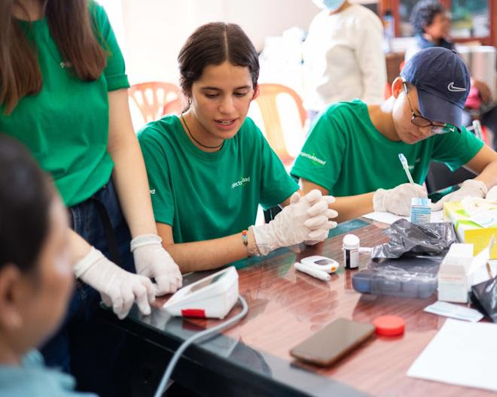
They are currently organising programs for the summer break.
If you are:
- 15 – 18
- Want 24/7 safety
- Want to maximise your time abroad as you meet teenagers from around the world
Check out the opportunities HERE

Year 12 Opportunities

31 May Fogarty Foundation Scholarship Applications Close
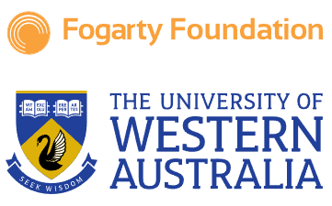
The UWA Fogarty Scholarships are the premier scholarships in WA. The scholarship is intended for students who show significant academic potential, together with leadership ability and other outstanding achievements throughout Year 11 and 12.
Find information and application forms HERE.

2 July Year 12 ATAR Economics Conference
Get ready for Curtin’s annual ATAR economics conference designed to help you to revise and prepare for success! Curtin is bringing together industry leaders to share their expert insights and knowledge with you.
The conference will cover strategies for success, balance of payments, trade issues and foreign investment, tactics for section 2 of the exam, and how to master those tricky multiple-choice questions. Alongside captivating speakers and interactive workshops, your ticket includes morning tea, snacks, merchandise, and car parking.
Find details HERE.
Register now for a day of learning, networking and growth.

Year 12 SCSA Information Handbook 2024 Part 1
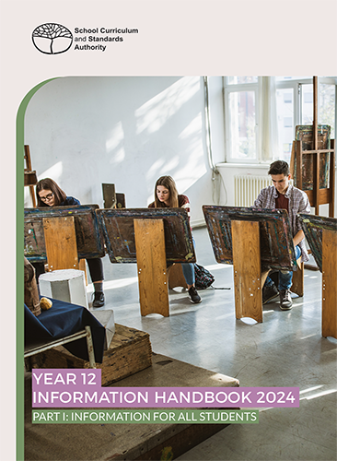
The Year 12 handbook is provided in two parts, with Part I for all Year 12 students, including information about:
- key dates that are important for you this year •
- what is involved in the WASSA and the WACE •
- the student portal and the WACE Checker •
- equivalences and how they can count towards your WACE •
- school-based assessment and how it works
- examinations (the focus of Part II, available in July) • general advice on life as a Year 12 student.
Download the Handbook HERE.

Defence Force Gap Year
If you are not sure what you want to do next year, check out the Defence Force Gap Year program.
- You get paid.
- You have somewhere to live.
- You learn new skills.
- You travel and you meet new people.
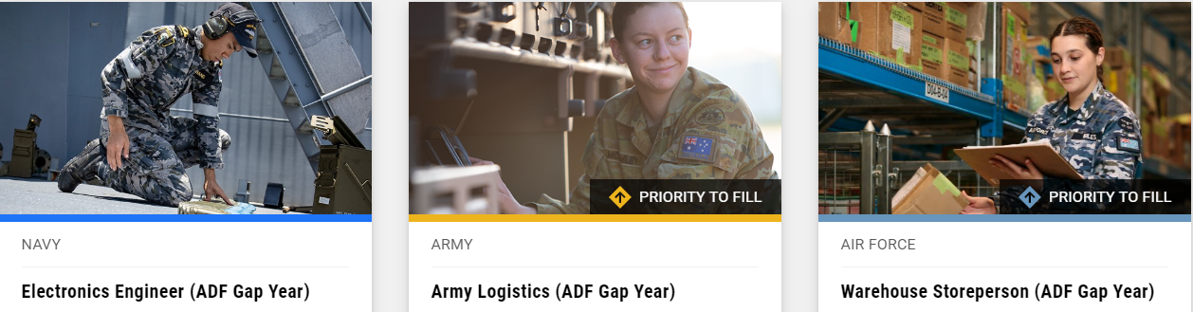
There are 22 career paths to choose from. Check them out HERE

Things to do in May
- SCSA Handbook: Check the SCSA Handbook with a career advisor, form teacher, year coordinator or other responsible educator to ensure you are on the right track.
- Pace Yourself: Burn out is a big risk in Year 12. You don’t want to burn out before you have finished your exams. Do this to achieve ATAR success in December
- Uni. If you want to go to uni, make an appointment with a university career advisor and talk about courses, individual subjects, ATAR revision programs, current student leaders and any support that they give to school students. Give yourself every chance to succeed – ATAR Revision Programs for Senior Students by enrolling in mid-year revision programs.
- VET: If you want to explore VET programs go to a Jobs and Skills Centre and talk about courses, apprenticeships, and traineeships, credits from certificates into degrees (computing and nursing VET courses provide good credits into most degree courses).
- Gap Year: Check out some exciting gap year opportunities for school leavers in 2025 available HERE.

Year 11 Opportunities

Things to do in May

Year 11
- If you want to go to uni and didn’t get great results in Term 1, ask each teacher for help. Check out this post for goal setting and study tips. .
- Check out opportunities to broaden your world through university camps, information sessions and classes for school students.
- Don’t get stuck at school if you hate it. There’s a better path for you. Check out what other paths are available HERE.

Year 10 Opportunities

Year 10 Subject Selection
Many Year 10 students will be doing subject selections for Year 11 and 12 during Term 2.
If you have no idea what you want to do when you leave school, you can start to explore ideas by doing some Hear Your Dreams Aptitude Tests. 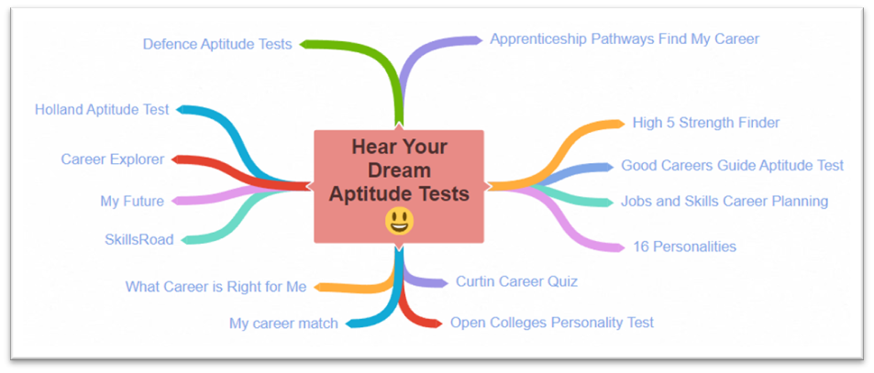

2027 University Admissions
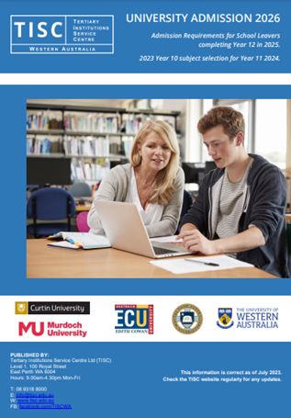
The Tertiary Information Service Centre (TISC) is still collating information about pre requisites for 2027 from all five universities in Western Australia.
You can find 2026 University Admissions information HERE.

Pre requisites V Desirable subjects
- Only pre-requisites are essential as part of the application process
- Some courses recommend Desirable subjects which:
  - May make you more competitive when you apply for a place
  - Will help you to build knowledge that will help you to succeed at university.
Check the 2026 Admissions information:
- Identify the university or universities you might choose to study at.
- Identify potential courses to study at the university of your choice for both Pre requisites and for Desirable subjects.

The 2027 Handbook will be out soon.

Middle School Opportunities

Things to do in May

Broaden Your Horizons
If you feel you have potential to do more than you are doing at school you can Start exploring your world through some of these suggestions.
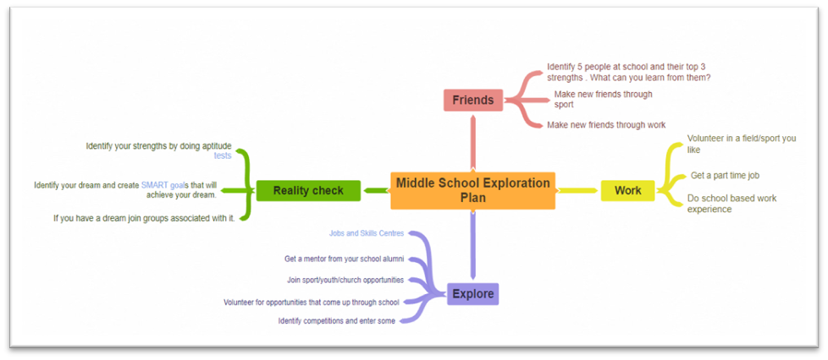
- Explore these volunteering opportunities
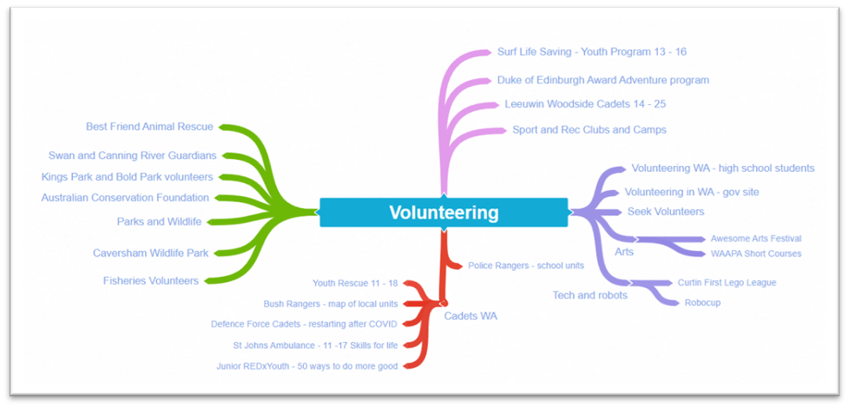

Primary School

Fremantle College Year 5 Curiosity Club
The Fremantle College Curiosity Club is an after-school extension program for Year 5 students, offering studies in:
- Curiosity Club Specialist Marine
- Curiosity Club Specialist ICT
Applications can be made at: https://fremantlecollege.wa.edu.au/curiosity-club-information-sessions/

Regional Opportunities

So, you want to be a doctor, but you live in the bush
Curtin University provides significant support to RRR students who want to apply for medicine. If you live in a regional area check So you want to be in a doctor, but you live in the bush.
Your Career Resources for School Leavers
Check out the Support for regional, rural and remote young people guide.
- Are you moving away from home?
- Pathways
- Explore different journeys for school leavers
- Additional resources

Aboriginal and Torres Strait Islander Opportunities

Career Resources for School Leavers
Check out the Aboriginal and Torres Strait Islander guide. on tailored programs and services available to First Nations young people to support them for life after school.

3000 jobs are to be created in RRR areas.
The new Remote Jobs and Economic Development program to create 3,000 jobs in remote communities starting in the second half of this year.
It will be implemented in partnership with First Nations people, build skills and experience, and deliver services that communities want.
- As part of the initiative Remote Training Hubs are to be established in remote locations over the next 3 years.
- A Junior Rangers program will be set up in 50 sites across remote Australia.
- 183 people have already enrolled in the Health Worker Traineesip Program and there is a commitment to increase the number of First Nations health workers to 500.
You can read more about the initiative HERE

Students with Disability Opportunities

Essential Personnel Employment Buddy Program
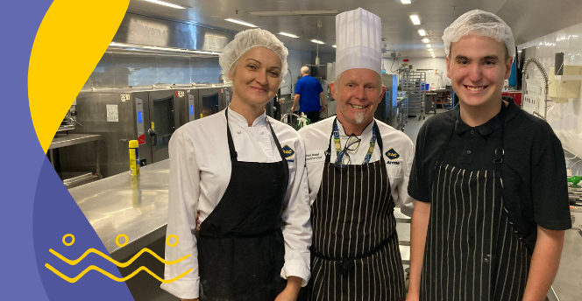
The Employment Buddy Program is a free program for young people with disability between the age of 15-24.
The program runs for 1 x day per week for 12 weeks.

Find out more HERE.

ABC Radio: Universities Accord not ambitious for students with disability
The Universities Accord final report released last week sets out a blueprint for the future of higher education in Australia. But the country's Disability Discrimination Commissioner has raised concerns with the document, claiming it fails to set ambitious targets for students living with disabilities, and uses faulty data. Listen to the ABC's Oliver Gordon's report with, Rosemary Kayess (Disability Discrimination Commissioner), Andrew Shim (Autistic university student and disability advocate) and Darlene McLennan (Manager, ADCET). Find out more about ABC Radio: Universities Accord not ambitious for students with disability
For more general information about education and training for students with disability subscribe HERE.

Career Resources for School Leavers
Check Support for young people with disability – information regarding a range of programs and resources available for young people with disability to support them for their life after school.

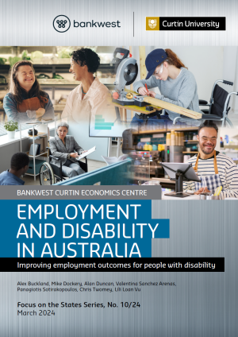
Improving employment outcomes for people with disability
The Bankwest Curtin Economics Centre has released an Employment and Disability in Australia report which reveals increasing employment of people with a disability by 10 per cent could add $16 billion to economic output yearly.
The Report details the benefits of employing people with a disability, including addressing economic advantages, allowing individuals to find meaningful work, gain job satisfaction, autonomy and promote overall wellbeing.

Read more HERE.

International Student Opportunities

Blog posts with rich WA Career Information

Resources Industry Jobs
Boys in Western Australia know they can earn big money without a degree by taking on an apprenticeship that will lead to work in the resources industry.
Female school leavers who want to work in the resources industry tend to go to university. There ARE opportunities for girls in trades, but it is hard.
Sexual harassment is an ongoing problem that has caused young women to stay away. (See women in resources trades HERE.)
I have collated information about jobs in the WA resources industry HERE.
For more information about jobs in the resources industry go HERE.

The Olympics are coming. Want a career in sport?
The Olympics are coming. The Australian team is being selected. The Matilda’s are in the top 10.
So many students play sport. So many would love a career in sports.
Being as part of a team gives you a shared purpose, a feeling of belonging and goal to strive for.
If you want to work in the sport you love, there are hundreds of opportunities.
I have collated information about sports industries careers HERE.

Exciting Gap Year Opportunities for School Leavers in 2023
Leaving school is one of the biggest changes we will ever face. Change is scary and exciting.
When you leave school, you can go to uni or TAFE, or you can explore your world and beyond by taking a Gap Year.
This post identifies Gap Year opportunities in:
- Agriculture
- Defence
- Volunteering overseas
- Studying overseas
- Working in the outback.
I have collated a lot of information about gap year opportunities HERE.

