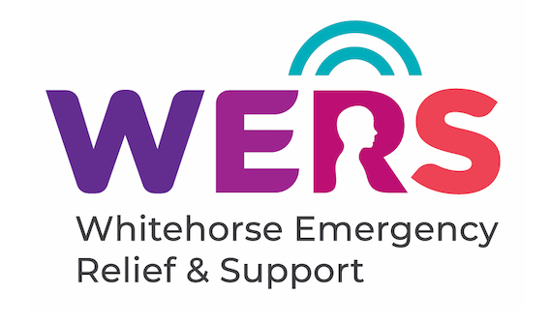
1/27 Bank St Box Hill
SUPPORTING OUR LOCAL COMMUNITY
Available to residents of the City of Whitehorse on low incomes to relieve financial stress.
Includes international students, asylum seekers and other non- Australian residents.
No appointment necessary.
To be eligible for assistance you have to show you live in the City of Whitehorse and that you are in financial distress.
Documents that help establish eligibility are: A Driver’s Licence, a recent Bank Statement,
current Centrelink Statement and a rental agreement.
- Food: Supplies of packaged, frozen and refrigerated foods, bread, fresh fruit and vegetables (when available)
- Food Vouchers for supermarket purchases
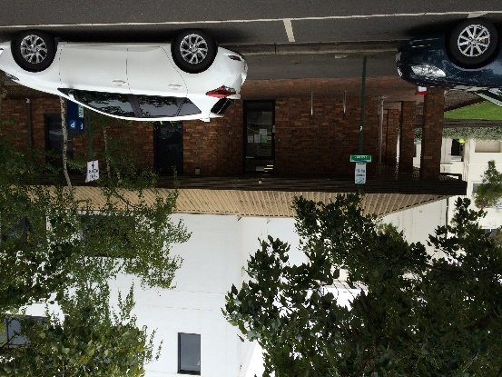
- Assist with chemist, utility and phone accounts
- Transport assistance (Petrol & Myki credits)

We can advocate on your behalf with utility and phone companies to avoid disconnections and to negotiate
affordable payment plans.
We provide information and referrals to a wide range of free local community services with the expertise to best assist individual needs including: legal advice, financial counselling, emergency housing, health, tenancy rights, no interest loans and counselling.

Tel: (03) 9191 5333
(opening hours only)
Email: help@wers.org.au
wers.org.au
OPENING HOURS
Closed public holidays

Monday 11:00am - 3:00pm Wednesday 11:00am - 3:30pm Friday 11:00am - 3:00pm

