 **LARGS BAY SCHOOL CANTEEN**

**SPECIAL LUNCH ORDER**

**NACHOS DAYS - Week 8**

Wednesday 22nd March – Rooms 3, 4, 5, 5A, 13, 14, 16, 17, 19, 20, 22, 23

Thursday 23rd March – Rooms 10, 11, 26, 27, 29, 30, 31, 32, 33

**MONEY AND ORDERS MUST BE RETURNED TO THE CANTEEN**

**BY THE MORNING OF THURSDAY 16th March**

******NO LATE ORDERS WILL BE ACCEPTED******



**NACHOS $7**

with cheese and Mexican mince

(please tick)

Sour Cream 🞏

Salsa 🞏

(above options both included in price)

Cookie included

(Please tick one)

390ml Water 🞏

Fruitbox Apple 🞏

Fruitbox Orange 🞏

Fruitbox Apple/Blackcurrant 🞏



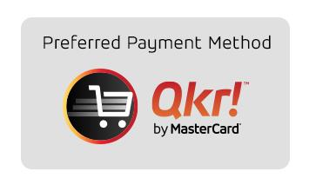

**STUDENT NAME:**________________________________________

**ROOM NO:**______________

**AMOUNT ENCLOSED:**____________________

….. ORDER USING OUR **QKR APP** OR BY RETURNING YOUR ORDER FORM WITH PAYMENT …..