

Melbourne Girls College

Instrumental Music Information Booklet

# Welcome to the Instrumental Music Program at MGC!

Our Instrumental Music Teachers:

# Voice (Contemporary and Classical) – Studio 2 PAC



Ellyce Calder (Monday, Tuesday, Thursday and Friday) [ellyce.calder@mgc.vic.edu.au](mailto:ellyce.calder@mgc.vic.edu.au)

**Voice (Contemporary) – Studio 3 PAC**



Susan De Jong (Monday and Tuesday) [susan.dejong@mgc.vic.edu.au](mailto:susan.dejong@mgc.vic.edu.au)

# Violin and Viola - Studio 1 PAC

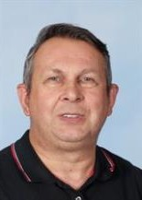

Les Gyori (Tuesdays) [lesley.gyori@mgc.vic.edu.au](mailto:lesley.gyori@mgc.vic.edu.au)



Keely Moggach (Wednesdays)

[keely.moggach@mgc.vic.edu.au](mailto:keely.moggach@mgc.vic.edu.au)

# Cello – Studio 4 PAC

Lore Burns (Mondays)

# [l.burns@mgc.vic.edu.au](mailto:l.burns@mgc.vic.edu.au)

# Piano-Studio 1

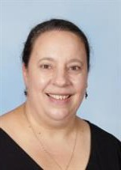

Katrina Halliday [katrina.halliday@mgc.vic.edu.au](mailto:katrina.halliday@mgc.vic.edu.au)

# Piano - Studio 1 PAC

Hayden Dun. (Mondays, Thursdays and Fridays)

Hayden.dun@mgc.vic.edu.au

# Woodwinds and Brass - Studio 7



Tony Hicks (Mondays and Wednesdays) [anthony.hicks@mgc.vic.edu.au](mailto:anthony.hicks@mgc.vic.edu.au)

# Guitar, Bass Guitar - Studio 4 PAC



Andy Clarke (Not Wednesdays) [andy.clarke@mgc.vic.edu.au](mailto:andy.clarke@mgc.vic.edu.au)

# Drum Kit & Percussion-Studio 4 PAC



Nicholas Milosevic (Thursdays) [nicholas.milosevic@mgc.vic.edu.au](mailto:nicholas.milosevic@mgc.vic.edu.au)

## Schedule of Lessons (30 minutes)

Lessons are scheduled weekly on a set day on Compass. Lessons are rotated throughout the day to ensure students are not missing substantial amounts of the same class. Students should only be absent less than half of a class on any day. Students are expected to follow up with their classroom teacher for any work missed during their music lesson.

Where possible senior students (VCE level) lessons are scheduled in the student’s spare periods.

Lessons are planned and timetabled for the full academic year and as such, there are **no refunds.**

## Missed Lessons

Students receive **32 lessons** a year, which is approximately **16 lessons per semester,** or **8 per term.**

This two-week buffer each term allows for unavoidable disruptions to the program due to excursions and sports days etc. Where possible, and with prior notice, teachers will try to reschedule a lesson if there is a clash of commitments. However, some teachers do not have any flexibility on their week due to their commitments at other schools.

**It is the student’s responsibility to attend all lessons and inform their music teacher of any potential disruptions to their lessons with 24 hour’s notice.**

**Missed lessons due to student forgetfulness will not be made up.**

Parents will receive a notification via Compass if their daughter is absent from a lesson.

Please be aware that in the lead up to performances, additional lessons and/or workshops may be scheduled and these count towards any make up lessons required.

## Assessment & Reporting

Students will be required to undertake two assessments on their instrument. The assessment periods will be held at the end of each semester. Each student receives a written progress report at the end of Term 1 & 3, and a written report at the end of Terms 2 & 4.

Students are expected to perform at their evening soiree/showcase at the end of each semester. Student also have the opportunity to complete external AMEB exams*.*

## Equipment and Materials.

All instrumental students must have

* An instrument to practice on, either owned or hired.
* A music stand (piano students excepted)
* An exercise book for notes and record of lessons
* Display folder with plastic sleeves for music

## Instrument Storage

Instruments can be stored in the instrumental studios. Students can negotiate with their teacher to use a MGC instrument if transportation is an issue. Loss or severe damage will be at the expense of the hirer.

## What to Bring to Lessons

* Music
* Instrument
* Water bottle
* Pencil
* Phone/recording device.
* Sundry items as applicable to your instrument. eg: reeds, strings, resin etc

## Home Practice Routine

Students will be taught technical exercises and pieces within their lesson time but to consolidate these new techniques it is important that a regular home practice routine is in place to support the development of their instrument.

As the old saying goes, “Practice Makes Perfect”.

We would recommend 3-4 x 20min practice sessions per week as a good starting point.

## Lesson Focus

**Term One** – Development of techniques. Consolidating previously learnt skills and developing new ones, extending their range and introducing a new genre/style of music to the repertoire.

**Term Two** – Consolidating and preparing for evening soiree.

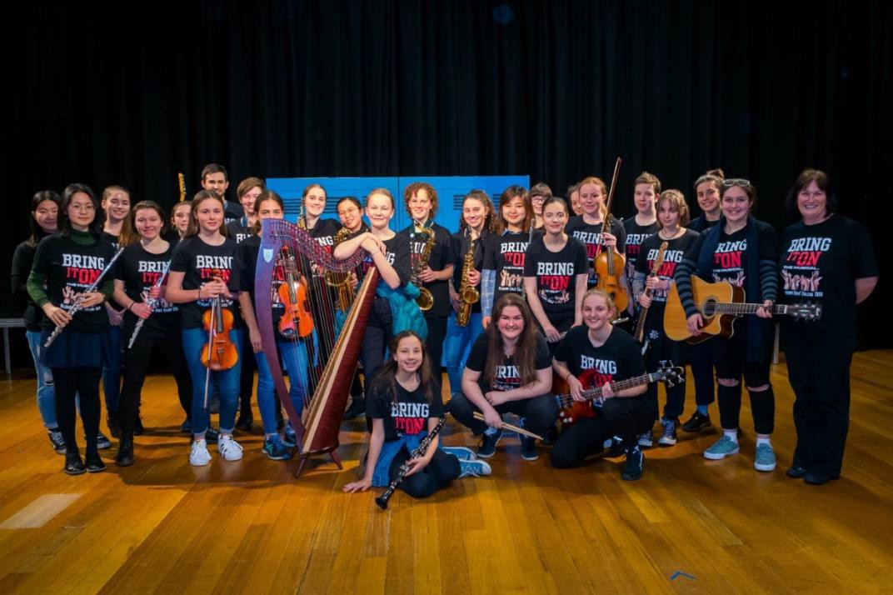**Term Three** – Further development of techniques and repertoire.

**Term Four** – Culmination of various activities to complete the year. In addition to the evening soiree, students may participate in recording sessions, prepare Christmas carols for busking in their local community, visit local Primary Schools and/or write and compose their own songs.

## Performance Opportunities

The MGC Instrumental Soirees are the main performance nights for the MGC Instrumental Program. They occur at the end of Term 2 and the beginning of Term 4. They feature all students involved in the instrumental program as well as the ensembles within the school.

We also perform at assemblies, Information Nights, Fathers’ Day Breakfast,

Presentation Night and of course, the annual Musical Production.

Our ensembles perform at Generations in Jazz and the Melbourne Schools Music Festival (MSMF)

All students enrolled in the Instrumental Music Program at MGC are encouraged to participate in a school ensemble, as this is an opportunity to practice the skills learnt in tuition and gain experience in playing in a group. Evidence has shown that students who play in an ensemble often progress faster on their chosen instrument! Students must understand that their participation in an ensemble is a yearlong commitment.

## MGC Ensembles

**MGC Orchestra:** Leader- Tony Hicks

Rehearsal Time: Wednesday 7:45am in the PAC.

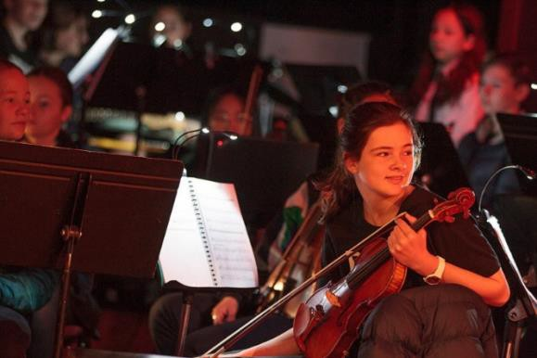The MGC Orchestra is open to all students within the school, not just those involved in lessons at MGC. The orchestra plays a range of genres including classical, contemporary popular, rock, jazz, blues as well as an emphasis on improvisation. We are always open to student suggestions for new repertoire. It is expected that students involved in lessons at MGC will actively participate in the MGC Orchestra. There are several performance opportunities throughout the year, including our school musical and/or Generations in Jazz, Music Camp, assemblies and soiree. New members are welcome throughout the year.

**String Ensemble:** Leader- Les Gyori

Rehearsal time: Tuesday 8am in the PAC.

The String Ensemble is a non-auditioned ensemble open to all string students within the school, not just those involved in lessons at MGC. They perform at our music camp, string soirees, assemblies, AMEB Online Orchestra and Presentation Night.

**Senior Strings**: Leader- Evie Scott

Rehearsal time: TBC

The Senior String Quartet is an auditioned ensemble open to string students who are interested in performing advanced repertoire in a smaller chamber setting. They perform at our music camp, assemblies, string soirees and Presentation Night.

**Junior Rock Band:** Leader- Andy Clarke

Rehearsal time: Monday lunchtimes in the PAC

The Junior Rock Band is an ensemble open to students in Years 7 – 9 within the school. They play a variety of contemporary classics and new songs and perform at our Pedal Cinema, as well as Music Camp, assemblies, Vocal Showcase evenings and Presentation Night.

**Senior Rock Band:** Leader -Andy Clarke

Rehearsal time: Friday Lunchtimes in the PAC

The Senior Rock Band is an auditioned ensemble open to students Years 9 - 12 within the school. They play a variety of contemporary classics and new songs and perform at our Pedal Cinema, as well as Music Camp, assemblies, Vocal Showcase evenings and Presentation Night.

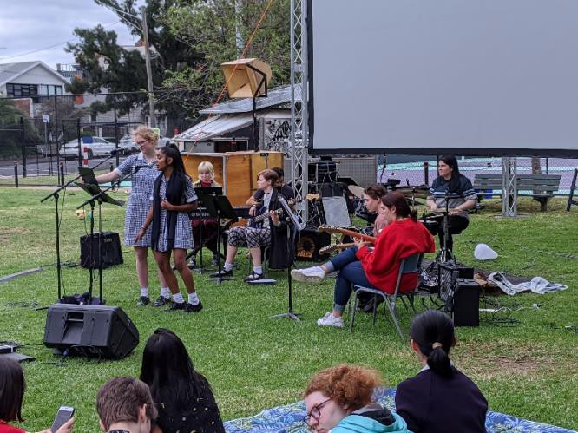

**MGC Choir:** Leader**-** Ellyce Calder

Rehearsal time: Monday lunchtimes in the Auditorium

The MGC Choir is a non-auditioned choir open to all students who are interested in singing a wide variety of genres such as pop, musical theatre and jazz tunes. They perform at assemblies, Vocal Showcase and Presentation Night. They also regularly compete in the Victorian Schools Music Festival.

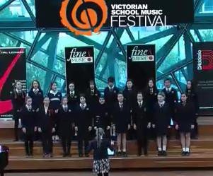

**‘Acapellago’ Acapella Choir:** Leader-Susan De Jong

Rehearsal time: Monday 9:30am and Tuesday lunchtimes in the Music Room A3

Our acapella choir is an auditioned ensemble open to all students from Year 8-

12. They represent MGC at many events, including Open Day, Information Evenings and Presentation Night and compete in the AUSACA National Acapella Championships.

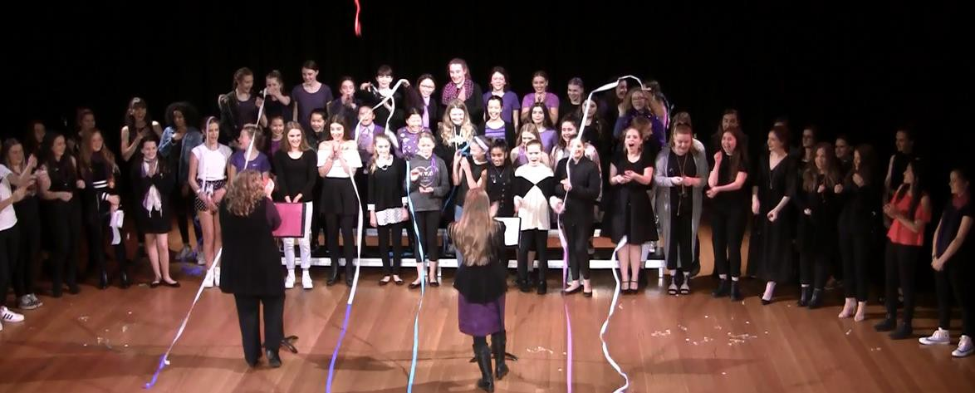

## Important Music Calendar Dates for 2023

***(Event will be created on Compass)***

**TERM 1**

Week 3 Mon 7/2 Instrumental Lessons Begin

Week 4 Fri 24/2 Pedal Power Cinema

**TERM 2**

Week 2 Fri 5/5 – Sun 7/5 Music Camp

Week 6 Fri 2/6 Vocal Showcase

Dates TBC String Soiree

Guitar and Drums Soiree

Piano Soirees

**TERM 3**

Dates TBC Victorian Schools Music Festival AUSACA Acapella Championships

Week 5 8/8-11/8 MGC Musical Production

**TERM 4**

Week 3 Thur 18/10 Vocal Showcase

Woodwind Soiree

String Soiree

Piano Soiree

Guitar and Drums Soiree

Week 8 Tue 22/11 Presentation Night

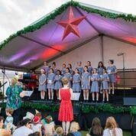

## VCE Music

Students who have developed a strong technique and performance skills should consider pursuing VCE Music. VCE Music provides the students the pathway to utilise the skills they have developed and allow them to contribute towards their final school results.

We would highly recommend students who would like to pursue VCE Music to select Music in their Year 9 and/or 10 subject selections. This will give them the best preparation for their VCE Music studies.

## What Can It All Lead to…

Many university degrees provide students with pathways to extend their performance skills if their desire is to perform and/or teach at a high level and we have successfully prepared students for auditions to pursue their ambitions at a tertiary level.

Thank you for giving your child the gift of music and we look forward to working with you as we support her on her musical journey at MGC.

Anne Corry

Instrumental Music Co-ordinator [anne.corry@mgc.vic.edu.au](mailto:anne.corry@mgc.vic.edu.au)

