Rockley & District
Community Newsletter
March 2026

Dates for Your Diary
March 2026
DATE | EVENT, TIME and VENUE  WHERE KNOWN | CONTACT
Mon to Fri | Morning Prayer 7:45am to 8:15am  St. Peter’s Anglican Church, Hill Street
Tues & Thurs | Pilates Mat Classes  10:30am School of Arts Hall | Erin  0448 408 794
Sun 1, 15, 22, 29 | Ecumenical Worship Service 9:30am  St. Patrick’s Catholic Church, Phantom St
Sat  14 | Catholic Mass 9:30am  St. Patrick’s Catholic Church, Phantom St
Sat  28 | Beer & Beats @ The Rockley Pub  3pm to 6pm Rockley Pub | Rockley Pub  6337 9415
Dates for Your Diary
April 2026
DATE | EVENT, TIME and VENUE  WHERE KNOWN | CONTACT
Mon to Fri | Morning Prayer 7:45am to 8:15am  St. Peter’s Anglican Church, Hill Street
Tues & Thurs | Pilates Mat Classes  10:30am School of Arts Hall | Erin  0448 408 794
Fri 3 to Mon 6 | Easter Weekend
Fri  3 | Stations of the Cross 3:00pm  St. Partick’s Catholic Church, Phantom St
Sun  5 | Daylight Saving Time ends  Turn clocks BACK ONE HOUR at 2:00am
Sun 5, 19, 26 | Ecumenical Worship Service 9:30am  St. Patrick’s Catholic Church, Phantom St
Sat  11 | Catholic Mass 9:30am  St. Patrick’s Catholic Church, Phantom St
Community Newsletter

Each issue of the Newsletter can be read on the Rockley Facebook page or can be emailed to those wishing to receive it electronically. An A4 copy is available to read in the Community Noticeboard in Stevens Park, Rockley. If you would like to have the Newsletters emailed to you each month, (there is no January Newsletter) please contact Jasmin at justjasmin@bigond.com
Perthville News

Would you like to receive the Perthville News each month?
Please send your email contact to perthvillenews@gmail.com to be included on the mailing list.

Universal Wellness | Chair Yoga | Meditation | Counselling is excited to be bringing Chair Yoga Classes to the Perthville Community Hall
Time: 10am to 11am Cost : $10 per person CASH ONLY on the day
Wednesdays: 4 Mar; 11 Mar; 18 Mar; 1 Apr
Bookings or questions: Please phone Nicole on 0407 249 313
MEN’s NIGHT PERTHVIILLE HALL THURSDAY 7 MAY at 6.30PM
GUEST SPEAKERS - Dr. Sean Howlett GP, Tim Miller, CSU Exercise Physiologist and Jason Smart, Presbyterian Minister
“Body, Mind and Soul”. Men only. All welcome. No booking required.
$5 entry- light supper. Enquiries John 0473 563 929
For and on behalf of Perthville Development Group Inc.

Rockley Mill & Stables Museum

The Rockley Mill and Stables Museum opens most Sundays and some Public Holidays between 11:30am and 3:30pm. Manned by local volunteers, the Museum can be opened during this time by prior appointment. Please contact Jasmin by email at justjasmin@bigpond.com to arrange an appointment.
We are always very pleased to welcome new Mill Minders. Please contact Pauline on 0432 052 265 or email Jasmin as above, for further information.

Volunteer help wanted to help document and photograph the heritage objects in the Rockley Mill & Stables Museum, including flour milling, gold mining, agriculture, costumes, the old shop goods, domestic equipment, the Toc H Society, Pioneer photographs and an 1890s girl's cricket game.
Contact Pauline Barker for details - 0432 052 265.

Rockley Waste Transfer Station
Opened and manned each Wednesday and Saturday between 2:00pm and 6:00pm during summer, it opens from 1:00pm to 5:00pm throughout winter
Ben Chifley Catchment Group News


The Ben Chifley Catchment Steering Committee Inc. was established in the mid-1990s, by several land care groups. Our aim is “Caring for our Waterways.”
The group undertakes activities that improve the quality of water in the Catchment area.
Projects include soil conservation measures and tree plantings.
If you have any projects on your property such as gully fencing, soil erosion remediation or tree planting please contact Louise, the BCCSC Secretary, on 0407 214 508.
Projects need to be inspected before approval.

Rockley Artisans Market

The next market will be held on Sunday 8th March

9:00am – 1:00pm in Stevens Park Rockley
2026 RAM dates for your diary:
14th June; 13th September and 13th December
Earthwatch with Galileo

In the ABC news: New research has found that Leptospirosis, a bacterial disease which spreads through urine and faeces of infected animals and contaminated soil, is becoming more prevalent in Australia.

More frequent storms and floods are helping the zoonotic infection spread further into Australia from the North – rats and mice could also be contributing to the spread: in 2018, one of the largest outbreaks occurred on a NSW berry farm – up to 86 workers were exposed to contaminated fruit after rats urinated on crops – and infections surged after recent mouse plagues.

Over a million cases are reported globally, and some 60,000 deaths – there is no vaccine and pneumonia – like symptoms are treated with antibiotics…

Ciao for now …
Church Services in Rockley

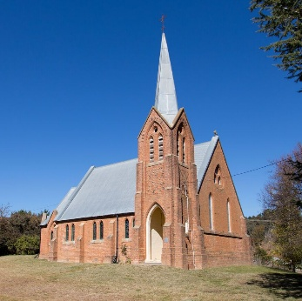
St Peter’s Anglican Church, Hill Street, have their Holy Communion Service at 10:30am on the first Sunday of each month except January and again in December, when a Christmas Service is held on the Sunday before Christmas Day. Services are presently presided by Rev Anastasia Webster-Hawes. Morning tea follows. For current copies of the weekly Bathurst Anglican Bulletin, please visit www.bathurstanglican.org.au. The office landline for All Saints Anglican Cathedral, Church Street, Bathurst is 6331 4711. The office opens Tuesday and Wednesday from 9:00am to 1:00pm or contact them via email at cathedral@bathurstanglican.org.au.

St. Patrick’s Catholic Church, Phantom Street, celebrates Mass at 9:30am on the second Saturday of each month, with the rostered priest from the Cathedral Parish of St. Michael and St. John. For current weekly Cathedral Parish bulletins, please visit https://bathurst.catholic.org.au/bathurst. Open Monday to Friday, 8:30am to 4:30pm, contact the Catholic Presbytery office, George Street, Bathurst on 6331 3066, or email The Dean, Father Francis Muhenda at dean.cathedral@cdob.org.au.

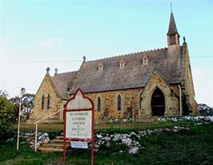
In Rockley, a small band of locals like to offer a quiet and reflective Ecumenical (all denominations) Worship service, encouraged by the Cathedral Parish, at St Patrick’s Catholic Church each Sunday 9:30am every weekend (except the second weekend of the month). All residents and visitors to Rockley are most welcomed to attend throughout the year.

St. Peter’s Anglican Church News

A new initiative to offer joyful peace and tranquility every weekday from 7:45am to approximately 8:15am, for the start of your day is being offered at St Peter’s which will be open for quiet reflection and morning prayer with daily readings. We are also hoping to introduce a monthly midweek, family breakfast, Morning Prayer, to connect to God, to help deepen your search for meaning, purpose and a sense of belonging into the community. Courses and Reflection Days and Healing services shall also be offered, to deepen understanding of God’s relationship with us. Flyers shall be distributed to advertise upcoming events. Peace be with you all.

Rockley Gardens & Art Festival

SAVE THE DATES for the RG&AF 2026

Saturday 7th and Sunday 8th November 2026

Local Artist Profile – DIANNE MANSELL

"I don't consider myself a sculptor really, not being able to think 3 dimensionally, but my latest works exist Independent of the wall and use relief textures, surfaces finishes and different materials, to create an interplay of light and colour."

That said, Dianne's work has received many awards locally for sculpture and her piece," Temporarily Off Limits", was selected as a finalist in the 2025 "Central Belonging" exhibition at Cowra Regional Gallery.

"I did have fun last year creating a more typically sculptural work from broken bottles and other forms of scrap or leftover glass - it was interesting and challenging to step outside my usual comfort zone."

Why not join Dianne and the other Rockley creatives in this year's Rockley Gardens and Art Festival in November?

The committee is looking for new artists and work in a variety of media.

Please contact Dianne on 0414 978 786 with a message if you are interested.
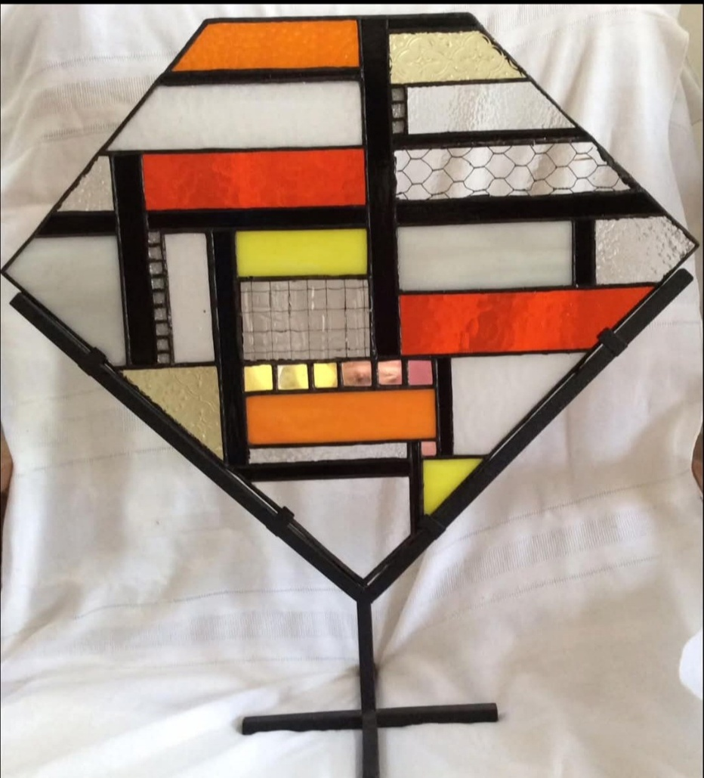

Temporarily Off Limits
- glass, mirror and metal

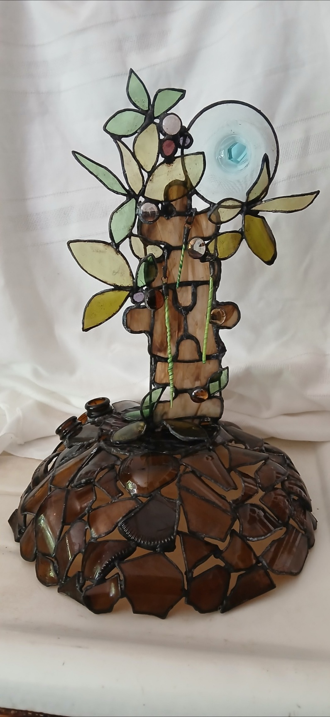

A Sapphire Moon Rises Over The Gin-Saw Tree
Recycled bottles, gin glass foot and sheet glass


Cooking Column
This month, as I and the other veggie growers have a glut of cucumbers and tomatoes, I give you a recipe for a Greek Summer Salad by Tess Mallos.
Greek Summer Salad

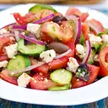
Ingredients

500g sliced tomatoes (about three large tomatoes)
2 cucumbers, peeled and sliced
4 spring onions, chopped
1 green capsicum, sliced
1 clove garlic
200g feta cheese, cut into small cubes
200g kalamata olives, seeded
Chopped parsley to sprinkle over the top

Olive oil and lemon dressing ingredients

½ cup virgin olive oil
3 Tbsps lemon juice
½ tsp salt

Freshley ground pepper to your taste
Finely chopped fresh parsley or oregano

Method
1. Rub the salad bowl with the cut garlic
2. Arrange the tomatoes, cucumbers, spring onions, green capsicum, feta and olives in the salad bowl.
3. Beat the dressing well and pour over the vegetables
4. Adjust salt and pepper to your taste
5. Garnish with parsley or oregano.

Rockley Studio & Fine Art Gallery

Rockley Studio & Fine Art Gallery is open by appointment.
Please contact Tim on 0413 037 436 for further information.

Poets Corner

Are you a poet or storyteller?
Please send your poems or short stories to justjasmin@bigpond.com

Kids Column
