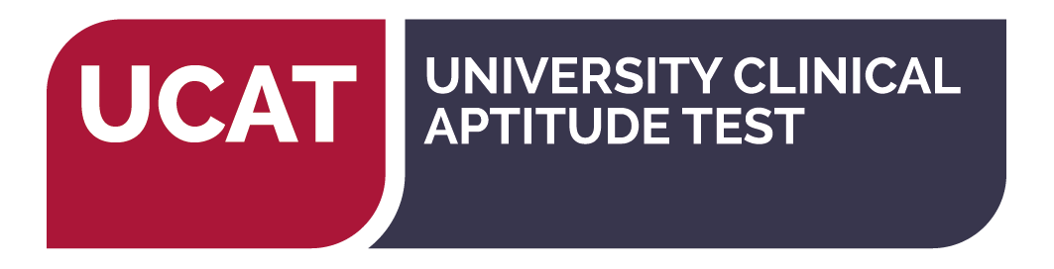

**Considering applying for Medicine at Monash in 2023?**

Direct entry into **Medicine at Monash University** requires the **UCAT - University Clinical Aptitude** **Test**. The UCAT measures applicant’s cognitive abilities in:

* ***Verbal Reasoning***
* ***Decision Making***
* ***Quantitative Reasoning***
* ***Abstract Reasoning***
* ***Situational Judgement***

Year 12 students are required to sit the test before **12th August 2022**.   
Free preparation materials are available to everyone on the Practice Tests page regardless of whether you have registered or booked your test.  
 *Note: some Pathways to medicine/dentistry/clinical sciences may not require the UCAT. International students will be required to sit a different test.* *Always check the entry requirements for each course through VTAC or the university website you intend to apply, before booking a test*.

|  |  |  |  |
| --- | --- | --- | --- |
| ***Apply*** | **Two step process using the Pearson VUE online registration system**  <https://wsr.pearsonvue.com/testtaker/signin/SignInPage/UMAT> | | |
| ***Registration Opens*** | **1st March 2022** | ***Registration Closes:*** | **17th May 2022** |
| ***Test Dates*** | **Between 1st July – 12th August 2022** | | |
| ***Where*** | **Pearson VUE Test centres throughout Australia and NZ** | | |
| ***Results*** | **Delivered to Universities in early September 2022** | | |

[ucat-anz@monash.edu](mailto:ucat-anz@monash.edu)  
 *The UCAT is also a requirement for many**Universities across* ***Australia + New Zealand:***

|  |  |  |  |  |  |  |  |
| --- | --- | --- | --- | --- | --- | --- | --- |
| **State** | **University** | **Course(s)** | | | | | |
| VIC | ***Monash University*** | Medicine | | | | | |
| SA | ***University of Adelaide*** | Medicine | Dental Surgery | | | | Oral Health |
| QLD | ***Central QLD University*** | Medical Science *(Regional medical pathway provisional entry to Uni QLD)* | | | | | |
| NSW | ***Charles Sturt University*** | Dental Science | | Medicine *(joint program in Medicine)* | | | |
| WA | ***Curtin University*** | Medicine | | | | | |
| SA | ***Flinders University*** | Clinical Sciences/Medicine | | | | | |
| QLD | ***Griffith University*** | Dental Health Science | | | | | |
| NSW | ***The University of Newcastle / New England*** | Joint Medical Program | | | | | |
| NSW | ***The University of New South Wales*** | Medicine | | | | | |
| QLD | ***The University of Queensland*** | Medicine *(provisional entry pathway)* | | | Dental Science | | |
| TAS | ***University of Tasmania*** | Medicine | | | | | |
| WA | ***The University of Western Australia*** | Medicine *(Direct* *Pathway)* | | | Dental Medicine *(Direct pathway)* | | |
| NSW | ***Western Sydney University*** | Medicine *(joint program in medicine)* | | | | | |
| NZ | ***The University of Auckland*** | Medicine | | | | | |
| NZ | ***University of Otago*** | Medicine | | | | Dentistry | |