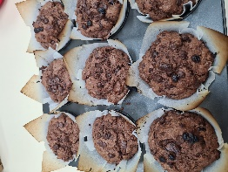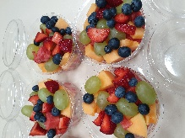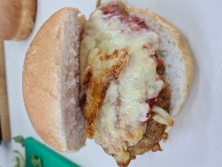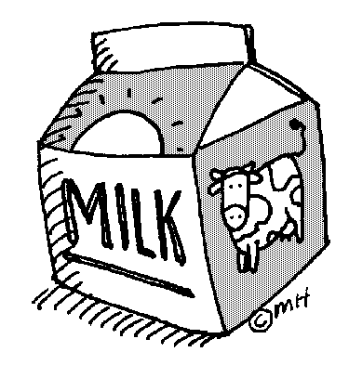

**Vegetarian**

Nachos $5

Vege Burger lettuce cheese and Mayo $5

Cheese Tomato Pizza $5

Pumpkin and Feta Pizza $5

Potato Bake CM $5

Veg Sausage Rolls CM $3

**Take Home Meals**

Lasagne made on Wednesdays, packaged on Thursdays $6 ea or 4 for $20

Potato Bake $5 ea or larger to serve 4 as part of a meal $12

**SPECIALS**

Advertised in canteen daily and on Instagram

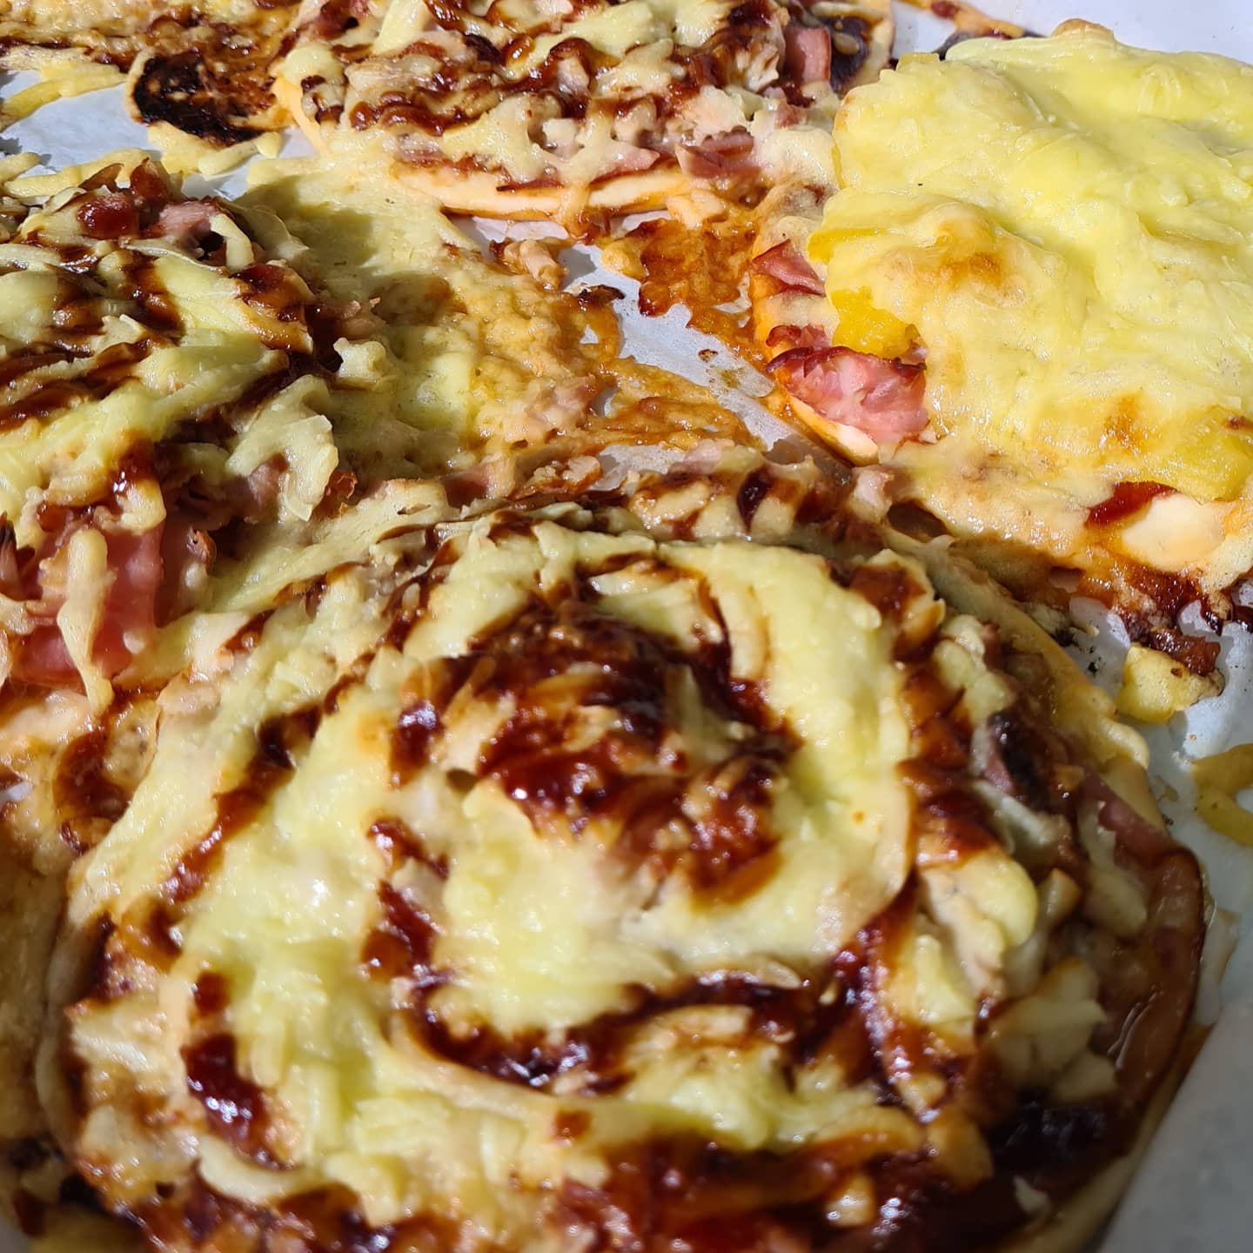

**DRINKS LIST.**

Oak Thick Shake $3

Oak Milk 600 ml $3.50

Nippy’s Milk Drink $2.50

Up n Go $2.00

Bottled Water $2.00

Prima $1.00

Hot Milo $1.50 or $2.00

Quench (low sugar) $2.00

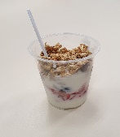

**LUNCH MENU.**

**Hot Food**

Sausage Roll CM $3.00

4n20 Sausage Roll $3.00

Hot Dog $3.50

Steamed Dim Sims $1 each

Warm Cheese Bacon Roll $3.00

Chicken Parma Roll $6.00

Nachos $5.00

Cheeseburger or with Bacon $4.00

Vege Burger $5.00

Sweet Chilli Chicken Wrap $5.00

Lasagne CM $6.00

Chicken Schnitzel lettuce and Mayo Roll $5.00

Potato Bake CM (Veg) $5.00

**Pizza $5.00 each**

1. BBQ Chicken
2. Ham and Pineapple
3. Pepperoni
4. Ham, Cheese and Tomato
5. Pumpkin and Feta (Veg)
6. Cheese and Tomato (Veg)

**Salad Roll/ Wrap $6.00**

Standard salad consists of lettuce, tomato, cucumber, carrot, beetroot and cheese with mayo, butter, salt and pepper

Ham and Salad $6.50 Chicken and Salad $6.50

**Chicken Cesar Salad Bowl $6**

**Sandwiches $4.00 or Rolls $4.50**

(Toasted extra 50c)

Ham and Cheese Egg and Lettuce

Cheese and Tomato Chicken

Cheese, Carrot and Mayo Ham

Ham, Cheese and Tomato Cheese

Cheese and Vegemite Vegemite

Egg and Lettuce

**Toasted 30 cents extra. Extra salad fillings 30 cents each.**

**Please state if mayonnaise not required.**

**No butter unless requested.**

**(Choice of white or multi grain roll, please state).**

**Sandwiches (white bread only).**

**Wraps**

Cold Meat & Salad Wrap $6.00

(Ham, Chicken or Tuna) includes mayo

Salad Wrap $5.00 includes mayo

**Sweet Chilli Chicken** Tenders Wrap with Salad $5.00

**Sweet Chilli Chicken** Tenders with lettuce & mayo $4.00

**SALADS**

Tub of Salad $6.50

Tub of Meat & Salad $7.50

(Fresh Chicken Meat, Ham or Tuna).

CM – Made in the Canteen by Cate

**RECESS.**

Warm Cheese & Bacon Rolls $3

Coffee Scrolls $3

Egg & Bacon Muffin $3

Hot Dog $3.50

Dim Sims $1

Fantastic Noodle Cups $2.50

2021

PRICE LIST

**Gluten Free**

**Options**

Toasted Sandwich $5

Or

Cup Noodles

$5

**HOT SOUP**

(Term 2 & 3 only)

Chicken & Corn,

Pumpkin, various

$3.80 small or $4.50 Large.

With

Bread Roll $5.00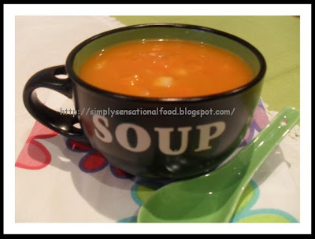

EFTPOS Available.

30c surcharge

**FRESH**

Muffins Baked Daily $2

*Fresh Fruit Salad $4

*Yoghurt fruit Muesli

Cup $3

Fresh Fruit $1.00

*Term 1 and 4

**ICE-CREAMS**

Quench Fruit Sticks 80c

Calippo 80c

Paddle Pop $1.50

Drumsticks $2.00

Frozen Yoghurts $2.00

98% Fat Free & Gluten Free Frozen Yoghurt $2.00

**KORUMBURRA SECONDARY COLLEGE CANTEEN MENU & PRICE LIST. 2021**