Help us support Greek Welfare Centre this special time of the year
by making a donation
Suggested food items include:
- Tinned tuna, salmon, sardines and ham
- Pasta sauces and pasta, rice
- Breakfast cereals, muesli bars, breakfast bars
- Biscuits, oil, lentils, beans
- Teabags, instant coffee, Milo, juice boxes
- Tinned fruit, vegetables
- Small jars of vegemite, honey and jam
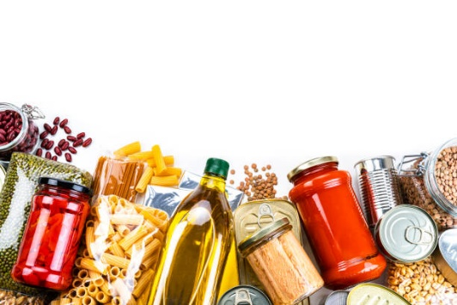
Donations can be brought to School until Monday 4 Apri 2022

