

**22/4/2024**

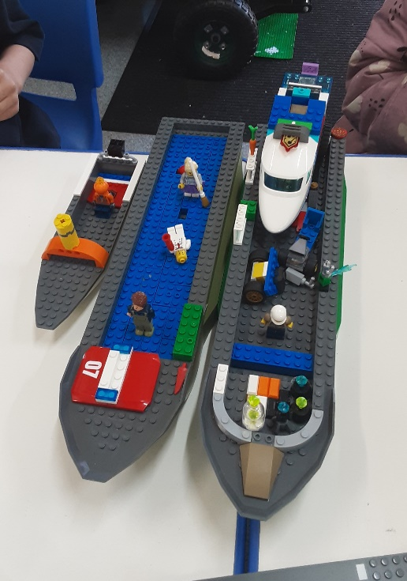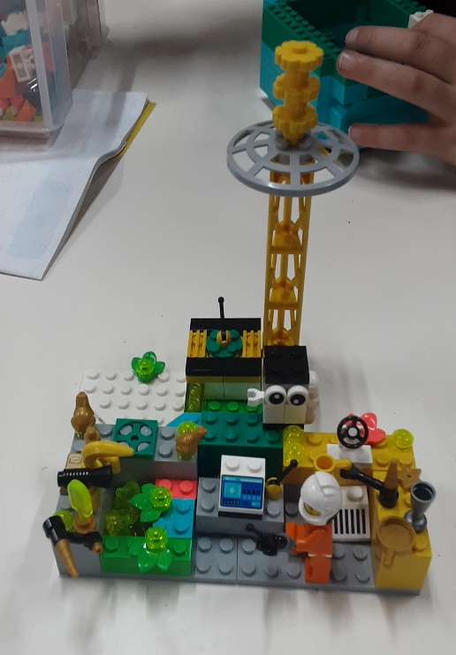[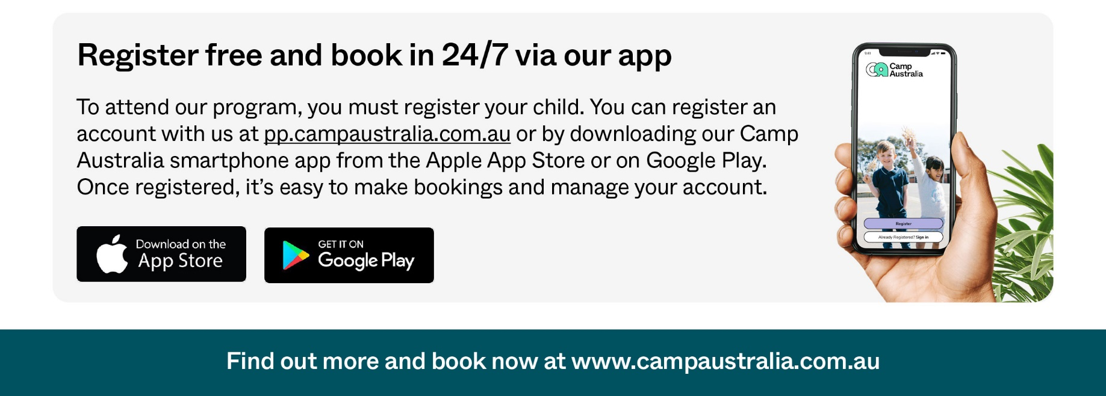](https://pp.campaustralia.com.au/)Big

**A message from your Coordinator**

We have some exciting news to share with all of you. Children can participate in Big Art Comp to win 1 of 40 exclusive LEGO packs! Children can sketch their dream creation and submit their masterpiece. More info on campaustralia.com.au/big-art-comp

**Reminder: Friday, 3rd May is student free day so make the bookings. We are open 6:45am-6:30 pm.**

* Lego Play
* Water Paintings
* Loom Bands

**Activities coming up**

Join in the fun of Outside School Hours Care activities and experiences with Your OSHC and Rocketeers.

**Make a booking**

Book now

**Oatlands Primary School OSHC**