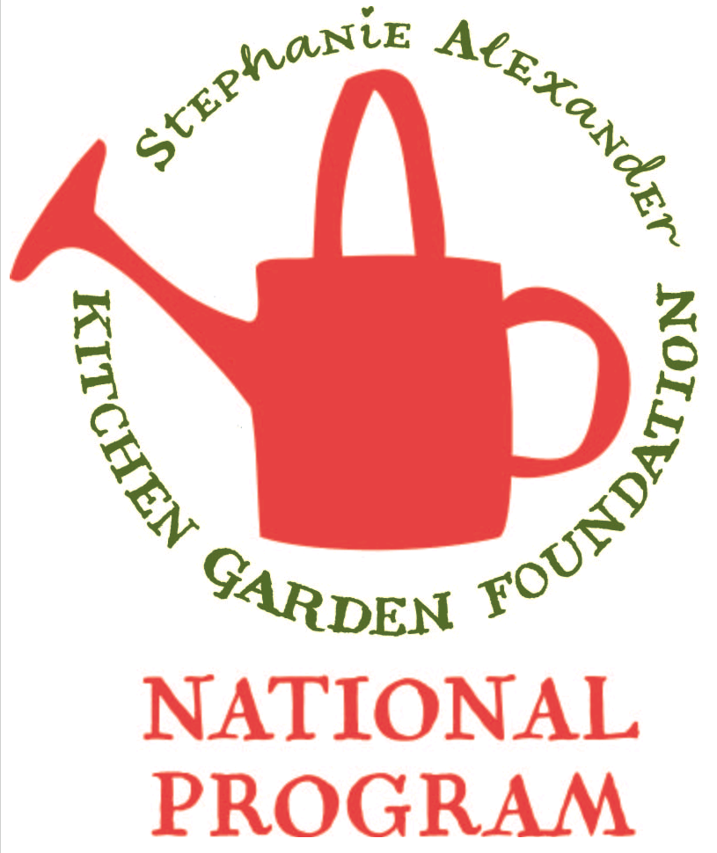
Buttermilk Pancakes

Season: Summer

Type: Bread

Difficulty: Easy

Serves: 30 tastes in classroom, 12 at home

Fresh from the garden: strawberries, lemons

Recipe source: Weight- Watchers

Volunteer Notes:

Equipment:  * mixing bowl  * measuring spoons  * sieve  * measuring cups  * whisk  * pastry brush  * frying pan  * 4 serving platters | Ingredients:  - 600mL carton buttermilk  - 2 eggs  - 2 cups self-raising flour  - 2 pinches baking powder  - 2 tablespoons caster sugar  - 25g butter to melt in frying pan

What to do:
- Step 1
Whisk buttermilk and eggs together in a bowl. Add flour, sugar and baking powder.
Whisk until just combined.
- Step 2
Heat a large non-stick frying pan over medium heat. Brush pan with butter. Using 1/4 cup mixture per pancake, cook 4 -6 pancakes for 3 to 4 minutes or until bubbles appear on surface. Turn and cook for 3 minutes or until cooked through. Transfer to a plate. Cover loosely with foil to keep warm. Repeat with remaining mixture, brushing pan with butter between batches. Serve.

Notes: Serve warm with strawberries, berries, maple syrup or lemon juice and sugar.

