Section 1: for Students and Families

Career News

23 – 30 September Going to the Show?

The Royal Show is the place to unearth hundreds of career opportunities.
Agriculture Colleges

See students from the West Australian Ag Colleges demonstrate their knowledge in sheering, tractor driving, chemical safety and welding.
Agventure Hill
Agventure Hill, helps to connect the country and the city, with everything you need to know about becoming a junior farmer and understanding agriculture.
Find details HERE.
Speak with Experts
West Australia’s best farmers want to talk with people about what they do.
By chatting to the experts, you will discover opportunities for careers across Western Australia’s booming agriculture industry.

Find out more about the Perth Royal Show HERE.

Perth Boom Time
If you have any doubt that big business is booming in WA, check out the number of cranes over the city, South Perth and Applecross.

If you can’t get served at your coffee shop, can’t get your roof repaired, can’t find a builder, it could be because 70% of growth in the mining sector has been in WA.

According to the Bankwest Curtin Economics Centre Labour Market Update, which is based on June stats:

- The mining sector, led by WA, is the fastest growing sector. It is up a whopping 40.3% since February 2020. WA accounted for around 70% of the growth in mining jobs at a national level.

- The labour market is absorbing growth in the working age population of 50,000 people every month, with little sign of demand weakening in WA. If anything, it is even tighter than in May.

- Full time jobs rose by 11,300 in WA.

You can read the full BCEC Labour Market Update HERE.

Jobs and Skills Australia Stats – Job ads up

Jobs and Skills Australia has identified that job advertisements increased again in July by 2.1% Read the report HERE.

ABS Figures for July – 14,600 more people unemployed

The latest Australian Bureau of Statistics identified a 0.2% increase in unemployment in July. That amounts to 14,600 extra people without jobs.

Hours worked were 5.2 per cent higher than in July 2022.

“The strength in hours worked over the past year, relative to employment growth, shows the demand for labour is continuing to be met, to some extent, by people working more hours,” Mr Jarvis, head of ABS labour statistics, said.

University Opportunities

23 and 30 August Curtin Pathway Support Day
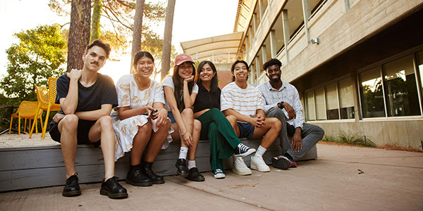
Book an appointment with Curtin Connect to chat with one of our Future Student Advisors about your pathway options, including ATAR entry, Portfolio entry, enabling pathways.

Book an appointment HERE.

23 August UWA Social Work Information Session

This information evening, available both in person and online, will introduce you to the diversity of social work careers, and the structure of UWA’s new Bachelor of Social Work (Honours) and Master of Social Work (MSW) courses, including how they prepare you for professional practice in a variety of employment settings.
5.30 – 6.30pm Get details HERE.

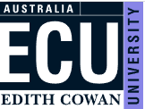
23 August Auditions for WAAPA applications open

WAAPA Applications are open and audition information can be found on the ECU “Interviews, folios and auditions page” or on the respective course page on the WAAPA website.

WAAPA applications are direct to ECU. The audition packages are comprehensive and include application deadlines, audition submission dates, application fees and other requirements.

23 August Murdoch Open Night Nursing

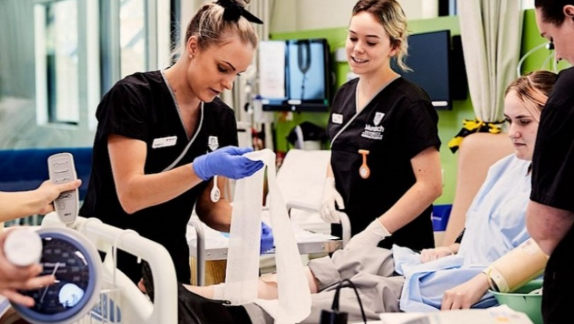
Join us at Murdoch University's South Street Campus and discover your future career in Nursing.

Gain hands-on experience as you rotate through a number of engaging activities including a tour though our state-of-the-art facilities including our Simulation Lab.
4.30pm – 8pm Find details and register HERE.

24 August Murdoch University Open Night: Sciences, Technology, Engineering and Maths

Specialist academics and industry partners design Murdoch’s degrees to ensure that our students are prepared for emerging industry and global trends.
5.30 Murdoch Campus. Find details and register HERE.

29 August Murdoch University Business, Law, Humanities, Art and Social Sciences, Education

Specialist academics and industry partners design Murdoch’s degrees to ensure that our students are prepared for emerging industry and global trends.
Time: 5.30 pm Find details and register HERE

30 August Murdoch University Health and Education

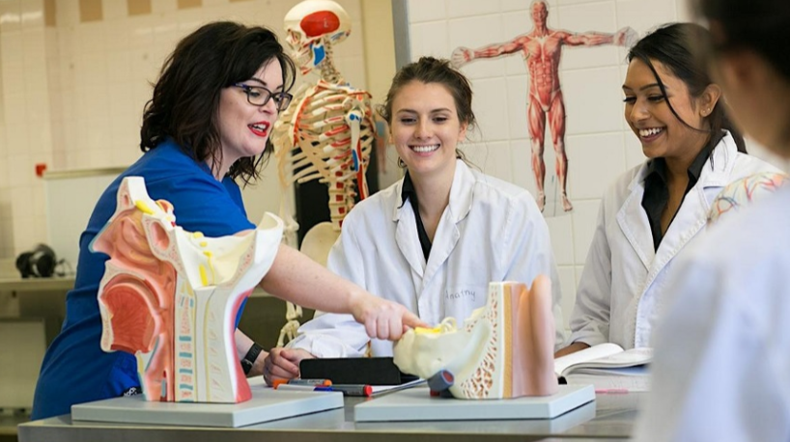
Learn how you can use your passion for sport, rehabilitation language, science, leadership and compassion to improve the lives of others.

Find details and register HERE.

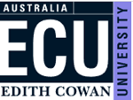
30 August WAAPA Production Tour

ECU's Western Australian Academy of Performing Arts (WAAPA) is one of the world's leading performing arts academies and we're giving you the opportunity to explore our state-of-the-art production and design facilities.
6 – 7.30 Register HERE.

1 September ECU Nursing and Midwifery Showcase
At our Nursing and Midwifery Showcase Evening you will have the opportunity to explore our state-of-the-art facilities, learn about our courses and the excellent support services you can expect as a student. You can speak to our Future Student Engagements Team about admission pathways, how to apply, fees and scholarships and flexible study options like online or part-time.
Joondalup Campus 5.30 – 7.00pm Register HERE

1 September WAAPA Applications for Bachelor of Arts (Musical Theatre) and Diploma of Musical Theatre Close

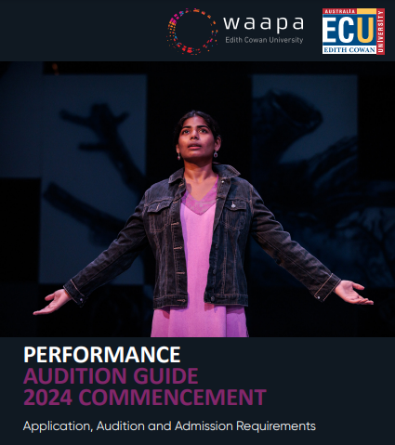
WAAPA Performing Arts Guidelines give details of key dates for applications and guidelines for auditions.
These Auditions Guide are for those applying for the:
- Bachelor of Arts (Musical Theatre) and Diploma of Musical Theatre (Applications close 1 September)
- Bachelor of Arts (Acting) and Diploma of Acting (Applications deadline 29 September).
- Bachelor of Performing Arts (Performance Making) (Applications close 29 September).
Auditions take place in November and December.
You can get a copy of the Guidelines HERE.

5 September Enabling Pathways to Murdoch Information Evening

M﻿urdoch University has an enabling program to suit any prospective students who aspire to go to University but may not be on track to achieve the required ATAR.
6pm Murdoch Campus Find more and register HERE

6 September ECU Science and Mathematics Information Evening

If you are interested in Biological Sciences, Horticulture, Physics, Maths, Data Science, Chemistry, Sustainability, Conservation Biology, Environmental Management and/or Marine and Freshwater Biology then this event is for you.
6-7.30 pm Joondalup Campus Register HERE.

8 September ECU Engineering Showcase (for Year 11 and 12s)
Discover why the engineering profession is a rewarding and exciting choice of career. Our alumni speakers will share their experiences of transitioning into industry roles, and our current students will be present to speak and answer questions about their study and learning experiences at ECU. Additionally, information will be provided on our wide range of engineering course offerings, entry requirements, scholarships, and student support services.
4.30 – 6.30 Joondalup Campus Register HERE.

12 September ECU Medical and Health Sciences Showcase Evening

Join us for this interactive event that will showcase courses offered in our major disciplines of Allied Health, Medical and Exercise Science and Public Health and Occupational Safety & Health.

6 – 7.30 pm Joondalup Campus Register HERE.

13 September Teacher Education Information Evening

Are you thinking of pursuing a career in Teacher Education? If so, our information evening is perfect for you!
6 – 7.30 pm Mt Lawley campus. Register HERE.

13 September Curtin Course Expo

This event isn’t just a showcase of our courses – it’s a hands-on exploration of all things Curtin and university study. Grab a course guide, attend an info session, join a portfolio pathway workshop and gain valuable application tips.
Curtin Campus 4 – 8 pm
Register HERE.

20 September Computing and Security Science Information Evening

Our Computing and Security programs include a broad choice of major subjects and cover dynamic areas such a computer science, cyber security, information technology, counter terrorism, security, intelligence, and software engineering.

6 – 7.30 pm. Joondalup Campus Register HERE.

25 September 2023 ATAR Revision Sessions

ECU will be delivering the ATAR revision sessions both on-campus, and online for our regional and remote students.
Sessions run between Monday 25 September and Friday 29 September 2023
 | Monday 25 September | Tuesday 26 September | Wednesday 27 September | Thursday 28 September | Friday 29 September
9.00am – 1.00pm | Computer Science | Maths Methods | Human Biology | English | Physics
2.00pm – 6.00pm |  | Biology | Maths Applications | Maths Specialist | Chemistry
Register for online www.trybooking.com/CHTPZ
Register for on campus www.trybooking.com/CHTPB

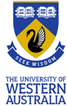
Book a tour of UWA accommodation
UWA has five residential colleges that offer tours all-year round. Tours take about 30 minutes per college, and you’ll get to check out the rooms and facilities, chat to current residents and staff and find out just how close to campus your new home will be!
Book directly with your preferred college(s):
- Trinity Residential College
- St Catherine’s College
- University Hall
- St Thomas More College
- St George’s College virtual tour

Apply Now. Volunteer for the Awesome Arts Festival

If you are 15 or over, you might like to explore careers in creative industries by volunteering at the Awesome Arts Festive.
You will get to work alongside creative professionals as you engage with the Awesome Arts Festival.
You can register HERE.

31 August Scholarships for LGBTIQ people to study at TAFE or uni
These scholarships close soon.
They are awarded for fulltime study at uni or TAFE. They provide financial support and mentoring for LGBTIQ students.

Find details HERE.

11 September Inspire in 5! Women in STEM stories.
Learn about careers in STEM from experts. Some of WA’s outstanding women in STEM will give a 5 minute presentation about their studies, career journey and day to day work life.
Venue: Mt Lawley High School. 6pm – 7.45pm. Find out more and get your ticket HERE.

Apply for a place at a US or UK University
Crimson Education helps Australian students to apply for places at universities in the US or UK. Find information about how to apply HERE.

Scholarships to study in regional australia

If you find an opportunity that you would like to take up in regional Australia, you can apply for up to $15,000 to study in regional Australia. This is available to domestic and international students.

Find details HERE.

Year 12 Opportunities

Open Now: University Applications for 2024

TISC Applications close 30 September

The closing date for university applications for 2024 is the 30 September. Offers of admission are made in the weeks following the release date of Year 12 results in mid-December.
Absolute Late Date Medicine, Surgery, Dental, Pharmacy, Podiatric Medicine
Find details HERE.
For more information Important Dates for 2023 go HERE.
December 22: Main round offers will be available online and emailed.

Open Now: ECU Women in STEM Scholarship Applications close 31 August
There are up to 500 scholarships to support more women in STEM.

You can find details HERE.

2 September Deadline Curtin Medicine Casper Test

If you will be applying to Curtin University Medicine this year, apart from the UCAT, applicants will also need to register and complete the Casper Test. This is a newly introduced admission step for Curtin University (Bachelor of Medicine, Bachelor of Surgery (MBBS).
Please refer to the Acuity Insights website (acuityinsights.app), which explains the test in detail and sets out the procedures for registration including the fees payable, test day procedures and regulations.

Find details from Curtin HERE.

So many scholarships

There are so many scholarships, and they are not just for the academic superstars. There are scholarships for jewellery makers, agriculture scholarships and the Westpac Young Technologists Scholarship.

- Check your chosen industry scholarships online.

- Also check your local government website. They may have a scholarship for you to go for, or they may list scholarships from local organisations like the Chamber of Commerce or a local bank.

- Check the website of your chosen university or TAFE college for scholarships that are available to you.

- Contact the career advisor services at your university/TAFE and ask what scholarships you can go for.

- Register with the Good Universities Guide to get news about scholarships as they become available.

New Equity Scholarship for Murdoch Engineering

This new scholarship may not be listed in handbooks yet. It will support students who are Aboriginal and Torres Strait Islander, students from regional and remote areas, females wanting to study STEM, students who are ‘first generation’ to attend university, students experiencing financial hardship, students who are LGBTQIA, and others who have experienced hardship.

For information go HERE.

Year 12 Information Handbooks

The School Curriculum and Standards Authority (SCSA) is responsible for West Australian education standards and reporting.
Each year it puts out two booklets to help year 12s.

Part I Information for Students
This information from the SCSA identifies:
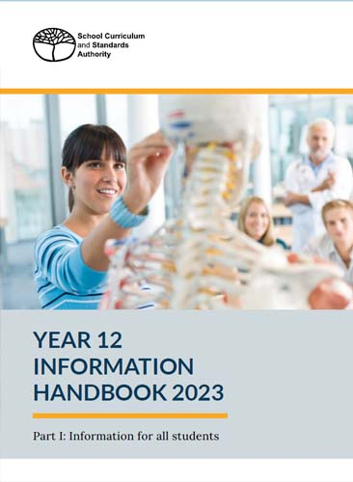
- key dates that are important for you this year
- what is involved in the WA Statement of Student Achievement and the WACE
- the student portal and the WACE Checker
- equivalences and how they can count towards your WACE
- school-based assessment and how it works.

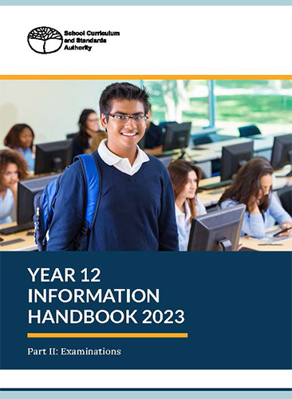
You can download a copy HERE.

Part II Examinations
Part II of the Year 12 Information Handbook focuses on examinations and is relevant to students sitting the Australian Tertiary Admission Rank (ATAR) course examinations.

It identifies key dates for exams and key information like what to do if you are sick during exams, how you are required to behave in exams and information about practical exams.
You can find it HERE.
Defence Opportunities

27 August Applications Close Defence Navy Work Experience
Naval Gazing Navy Careers Experience - October Job Ref - WEP/09395/22  - 2 - 4 October  - HMAS Stirling  - Navy  Information Pack Word Document Information Pack PDF | - Start New Application  - Access Existing Application  - Preview Application Form

1 October Applications close for Navy Work Experience
Naval Gazing Navy Careers Experience - November Job Ref - WEP/09396/22  - 13 - 15 November  - HMAS Stirling  - Navy  Information Pack Word Document Information Pack PDF Document | - Start New Application  - Access Existing Application  - Preview Application Form  - Email A Friend

1 October Applications close Air Force Careers Day
An Aerial View: Air Force Careers Day (14 November 2022) Job Ref - WEP/01117/23  - 14th November 2023  - RAAF Base Pearce Great Northern Highway, Bullsbrook WA 6084  - Air Force  Information Pack Word Document Information Pack PDF Document | - Start New Application  - Access Existing Application  - Preview Application Form  - Email A Friend

15 October Applications close for A day in the life
Day in the life of a Soldier - WEP - (23rd November 2023) Job Ref - WEP/02601/23  - 23rd November 2023  - Irwin Barracks  - Army  Information Pack Word Document Information Pack PDF Document | - Start New Application  - Access Existing Application  - Preview Application Form  - Email A Friend

Women in Defence Industry Scholarship – Last intake February 2024

Fully funded scholarship places will be available for women who have just finished school.
At the SkillsWest Expo I was told that the 2024 scholarship will be the final Women in Defence Industry offered.
Students will be able to study two qualifications at the same time over six months:
- Certificate II Electronics
- Certificate III Engineering – Technical.

Details will be published HERE.

Student Pathways into Defence Careers

There are a range of pathways and scholarships available for students who want to go into the defence forces.
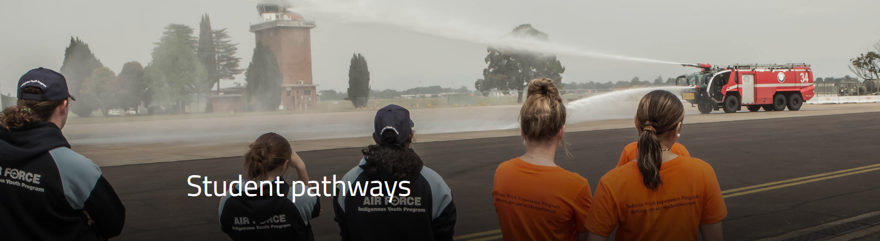
Find out about the various pathways into defence jobs HERE.

RRR Opportunities

24 August Curtin Kalgoorlie Open Day

Are you in high school and looking at going to university or a pathway to university? Or maybe you're looking for a career change? Then join us at the Curtin Kalgoorlie Open Day and find out more.
Find details HERE.

25 August Murdoch University RRR online information session
Attend our Online Regional & Remote Student Q & A Session and find out everything you need to know about making the transition to uni and studying as an undergraduate at Murdoch.
You’ll have the opportunity to explore the wide range of courses we offer and hear the real experiences and support from our staff and students.
You'll also have the opportunity to ask our staff and student advisers any questions you might have about studying, student experience, accommodation, support and much more. To be reminded of the event please register now.

1 September Busselton Innovators Tea Party

Learn about careers in Science, Technology, Engineering and Maths from the experts!

Join us for a free series of presentations from some of WA's Women in STEM Mentors to learn about the endless opportunities a career in STEM can offer. You will hear firsthand what it’s like to work at the frontlines of innovation.
Find details HERE.

6 September South West Medical & Health Sciences Information Session

Join us for this online session and learn about courses offered in the Medical and Health Science discipline including Allied Health, Medical and Exercise Science and Public Health and Occupational Safety and Health.

6-7.30pm online. Register HERE

6-7 September Newdegate Machinery Field Days

With more than 300 exhibitors and Machinery, technology and research, animals and livestock, outdoor and camping exhibits, arts, fashion, show bags, food and wine, local produce and live entertainment, there is a lot to see at the Newdegate Field Day

Find details HERE.

15 September Narrogin Agriculture College Open Day

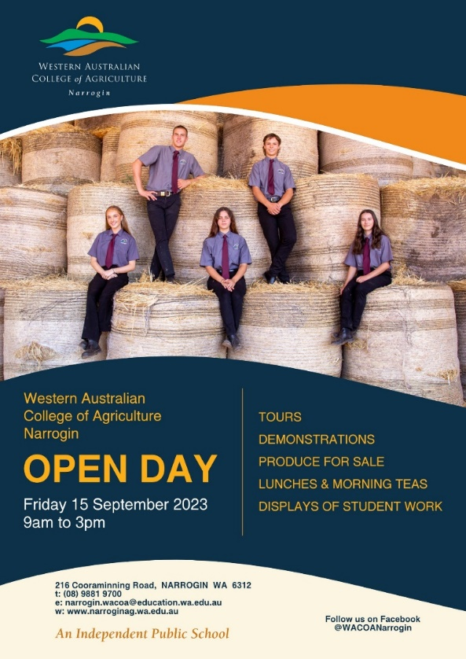
Senior school students can enrol at an agriculture college for their final years of school.

You can tour one of Western Australia’s top agricultural schools at Narrogin Agricultural College on 15 September 9am – 3pm.

Find details HERE.

Relocation scholarships for regional students

Students who need to relocate more than 90 minutes to study, need to apply for a Regional Scholarship to help with their relocation payments.
You can apply for up to $18,000 to undertake studies from Cert IV to PhD at any eligible Australian institution.

For details go HERE.

Grants to support for education, training and jobs through Country Education Foundation

$500 to $5,000 per student per year is available through the Country Education Foundation, to help buy textbooks and laptops for uni students, purchase tools and equipment for apprentices and assists rural and regional youth to relocate to take up career opportunities.
The Country Education Foundation also provides mentor support for students.
Find details HERE.

UWA Accommodation Scholarship
The UWA Convocation Accommodation Scholarship of $5000 assists eligible regional or remote students with the cost of accommodation at University Hall.
Find details HERE.

Regional universities WA
Students in regional Western Australia can undertake degrees at regional universities.
Curtin University | Kalgoorlie, Margaret River,
Edith Cowan University | Bunbury
Murdoch University | Peel
University of Notre Dame Australia | Broome
University of Western Australia | Albany
Geraldton Universities Centre | Geraldton
Great Southern Universities Centre | Albany & Denmark

Aboriginal and Torres Strait Islander

15 September – Applications close for ECU Bilang Bilang Taste of University Program
This is a free program for Aboriginal and Torres Strait Islander highs school students to get a taste of university life at ECU.
Dates: Monday 2– Wednesday 4 October 2023. Please be aware this program is a residential camp, and there are overnight components.
For further information or queries, please contact Kurongkurl Katitjin's Engagement team on the details below:
Kurongkurl Katitjin Engagement Team Email: kkengagements@ecu.edu.au
Phone: 08 6304 6664

17 September Applications close for army work experience

IYP- Indigenous Army Careers Day - WEP/02599/23 (26th October 2023) Job Ref - WEP/02599/23  - 26th October 2023  - Irwin Barracks  - Army  Information Pack Word Document Information Pack PDF Document | 17-Sep-2023  11:30 PM (AEST) | - Start New Application  - Access Existing Application  - Preview Application Form  - Email A Friend

New Indigenous Engineering Scholarship at Murdoch
Murdoch University has created 5 scholarships for Aboriginal and Torres Strait Islander school leavers who go into engineering.
Find details HERE.

Students with Disability

25 - 26 August Disability Connections Expo
More than 250 service providers under one roof, participants, their families and carers can exercise greater choice and control over their care.
Find details HERE.

School of Special Education Needs

The School of Special Education Needs is an Education Department service designed to support students with medical and mental health issues.

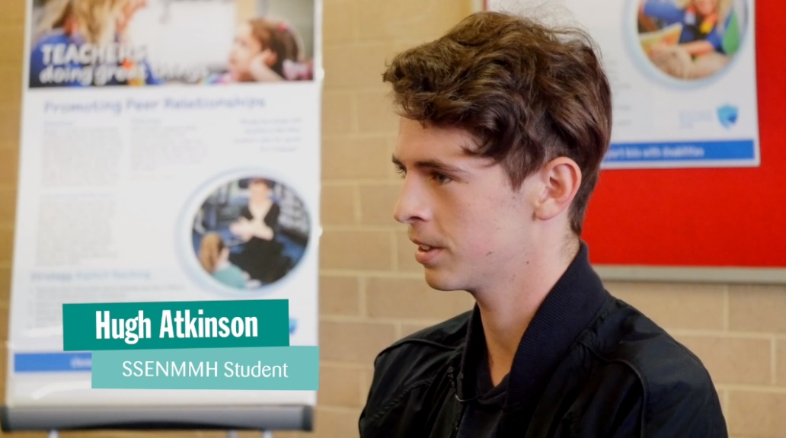
It provides teaching programs and specialist educational support for primary and secondary students who are in hospitals. It also provides outpatient liaison programs through hospital and referrals to assist students with ongoing health needs to improve their engagement in learning or return to school.
To find out more go HERE.

Career support for 8 – 25 year old students who have responsibility as carers
Student who are responsible for caring for someone, usually a family member, experience barriers to launching their own career independent of their caring responsibilities.
Carers WA provides a range of support services to people aged 8-25 who provide unpaid care and support to family members and friends who live with a disability, mental illness, chronic condition, terminal illness, an alcohol or other drug issue or who are frail aged.
Services include:
- Career Action Plans: Setting goals and pathing the way to brighter futures.
- Job Search Support: Identifying carer friendly employers and jobs that fit around you!
- Resume Development: Packaging your skills and abilities in the best possible way.
- Training information: Wondering what the next step of your education journey might be? Let us help you.
For more information, please call 1300 227 377 or contact youngcarers@carerswa.asn.au

Canteen Support
Canteen can help to support people with cancer or those who have a family member with cancer.
They have a robots program for young people who are unable to attend school due to a diagnosis or being in treatment, there is a counselling service and school support.
Services are free.
If you have a student impacted by cancer who would benefit from any of the above services or would benefit from speaking with the education and career consultant about navigating their career and study goals, please send us a referral or contact the WA team on 1800 226 833.

International Student Opportunities

International student scholarships for universities in Western Australia
There are scholarships for super smart students, scholarships for those whose families studied here, scholarships for those with refugee like backgrounds. I even found a Welcome to Western Australia scholarship.

If you are an international student planning to study in Western Australia, check out the scholarships that are available to you:
- Curtin University
- Notre Dame
- Murdoch University
- University of Western Australia
- Edith Cowan University

Multicultural Services Centre
Multicultural Services Centre of Western Australia provides community services and programs to culturally and linguistically diverse (CaLD) Western Australians.
If you need help finding the right course, or scholarships or applying for a job, check out the help you can get from the Multicultural Services Centres.
To find your local Centre go HERE.

Study Perth services to international students
Study Perth provides support to international students in Perth.
They have information on courses, scholarships, jobs and how to apply, accommodation and living in Perth.
It has an office in the Flux building at 191 St Georges Ter Perth You can contact them HERE..

Blog Posts

Leaving Year 12? There are adventures to be had. Try these gap Year Ideas in 2024
If you don’t want to go to uni or TAFE next year have fantastic opportunities for adventures and to meet interesting people in 2024 through these Gap Year ideas.

CBH Summer harvest jobs

