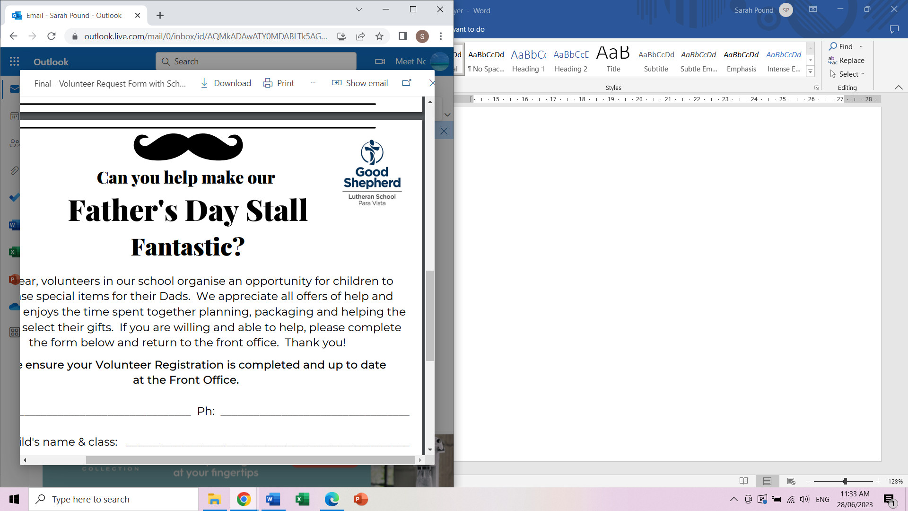Can you help make our

Father’s Day Stall

Fantastic?

Each year, volunteers in our school organise an opportunity for children to purchase special items for their Dads. We appreciate all offers of help and are seeking volunteers for setting up, supporting the children with their buying and/or packing up of the Father’s Day Stall. **Note - new times of the stall, running over 2 full days.** Please complete the form below and return to the front office. Thank you!

Name Phone

Oldest child’s name & class

We will collate all offers of help and confirm your day/time closer to the stall.

I can help:

Wednesday 28th August 11.05am – 12.25pm

Wednesday 28th August 1.50 – 2.55pm

Thursday 29th August 8.50 – 10.40am

Thursday 29th August 11.05am – 12.25pm

Thursday 29th August 1.25 – 2.55pm

RSVP Friday 16th August (week 4)

For more information, please contact the Front Office or Sarah Pound 0431156318.

Thank you for helping to make this a wonderful celebration.

**Please ensure your Volunteer Registration is complete and up to date at the Front Office. Thank you.**

Can you help make our

Father’s Day Stall

Fantastic?

Each year, volunteers in our school organise an opportunity for children to purchase special items for their Dads. We appreciate all offers of help and are seeking volunteers for setting up, supporting the children with their buying and/or packing up of the Father’s Day Stall. **Note - new times of the stall, running over 2 full days.** Please complete the form below and return to the front office. Thank you!

Name Phone

Oldest child’s name & class

We will collate all offers of help and confirm your day/time closer to the stall.

I can help:

Wednesday 28th August 11.05am – 12.25pm

Wednesday 28th August 1.50 – 2.55pm

Thursday 29th August 8.50 – 10.40am

Thursday 29th August 11.05am – 12.25pm

Thursday 29th August 1.25 – 2.55pm

RSVP Friday 16th August (week 4)

For more information, please contact the Front Office or Sarah Pound 0431156318.

Thank you for helping to make this a wonderful celebration.

**Please ensure your Volunteer Registration is complete and up to date at the Front Office. Thank you.**