YMCA St Joseph’s Cobram
Weekly Program - Term 2 Week 8
Service Name | Date
St Joseph’s Cobram | 3rd - 7th June 2024

 | Monday | Tuesday | Wednesday | Thursday | Friday
Planned Activities  (all activities are planned based on children’s interests and are available throughout the week) | Animal Homes in the Sandpit  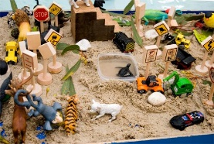  Farm? Zoo? Ocean? What home will you build for your animals? | Stamp Art  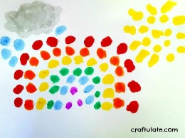  New rainbow dotting stamps. So much fun! | Corn Flour Slime  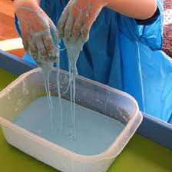  Liquid and a solid at the same time, it’s slime and science. | AFL Drills  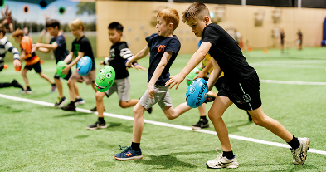  Tom has drills planned for our up can coming AFL stars. | Shop Set Up  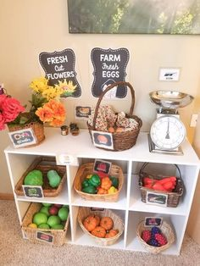  Our home corner is becoming a shop. What will it sell?
Yarning Circle Discussion Topics | Acknowledgement of country  Different wording of Acknowledgement of Country

Interest Areas
These areas and resources are available always for the children to extend on their interests and curiousness.
Crafty Creations | Dramatic Play |  | Super Sports
This area is always available for children to be creative and explore and extend on their imagination. Using textas, coloured paper, beads, glitter, recycled materials and more!  Stamps and Stickers  LO:4 (ALL), LO5.1, LO2.4, LO5.3 | This area is always available for children to imitate and connect to their home life . This includes kitchen, food, babies, dress-ups and jewellery .  Shop  MTOP: LO1.1, LO1.2, LO, 2.2, LO5.2 |  | Children are encouraged to be participate in active play. This supports the development of their fine and gross motor skills, coordination and social skills  AFL  MTOP: LO1.4, LO3.1, LO3.2, LO2.3, LO5.1
Construction Capital |  | Games Galore
Children utilising our construction and imaginary play space, think and create independently, working collaboratively, problem solve and enhance their fine motor skills. Resources include, Lego, Cars and Trucks, Trains, Connector Blocks, Dolls, play food and more!  Cogs  MTOP: LO4 (all), LO5.1, LO3.1 |  | In our Games Galore area, we have a variety of engaging and interactive board games, where children continue to develop their thinking, problem solving and language skills. They also have the opportunity to learn how to work in teams or individually and understanding the importance of fairness.  Scrabble  MTOP:4.1, LO5.1, LO3.1

Bookings now open for Pupil Free Day 11th June
Give Lara a call on 0477336657, if you need help enrolling your child.

