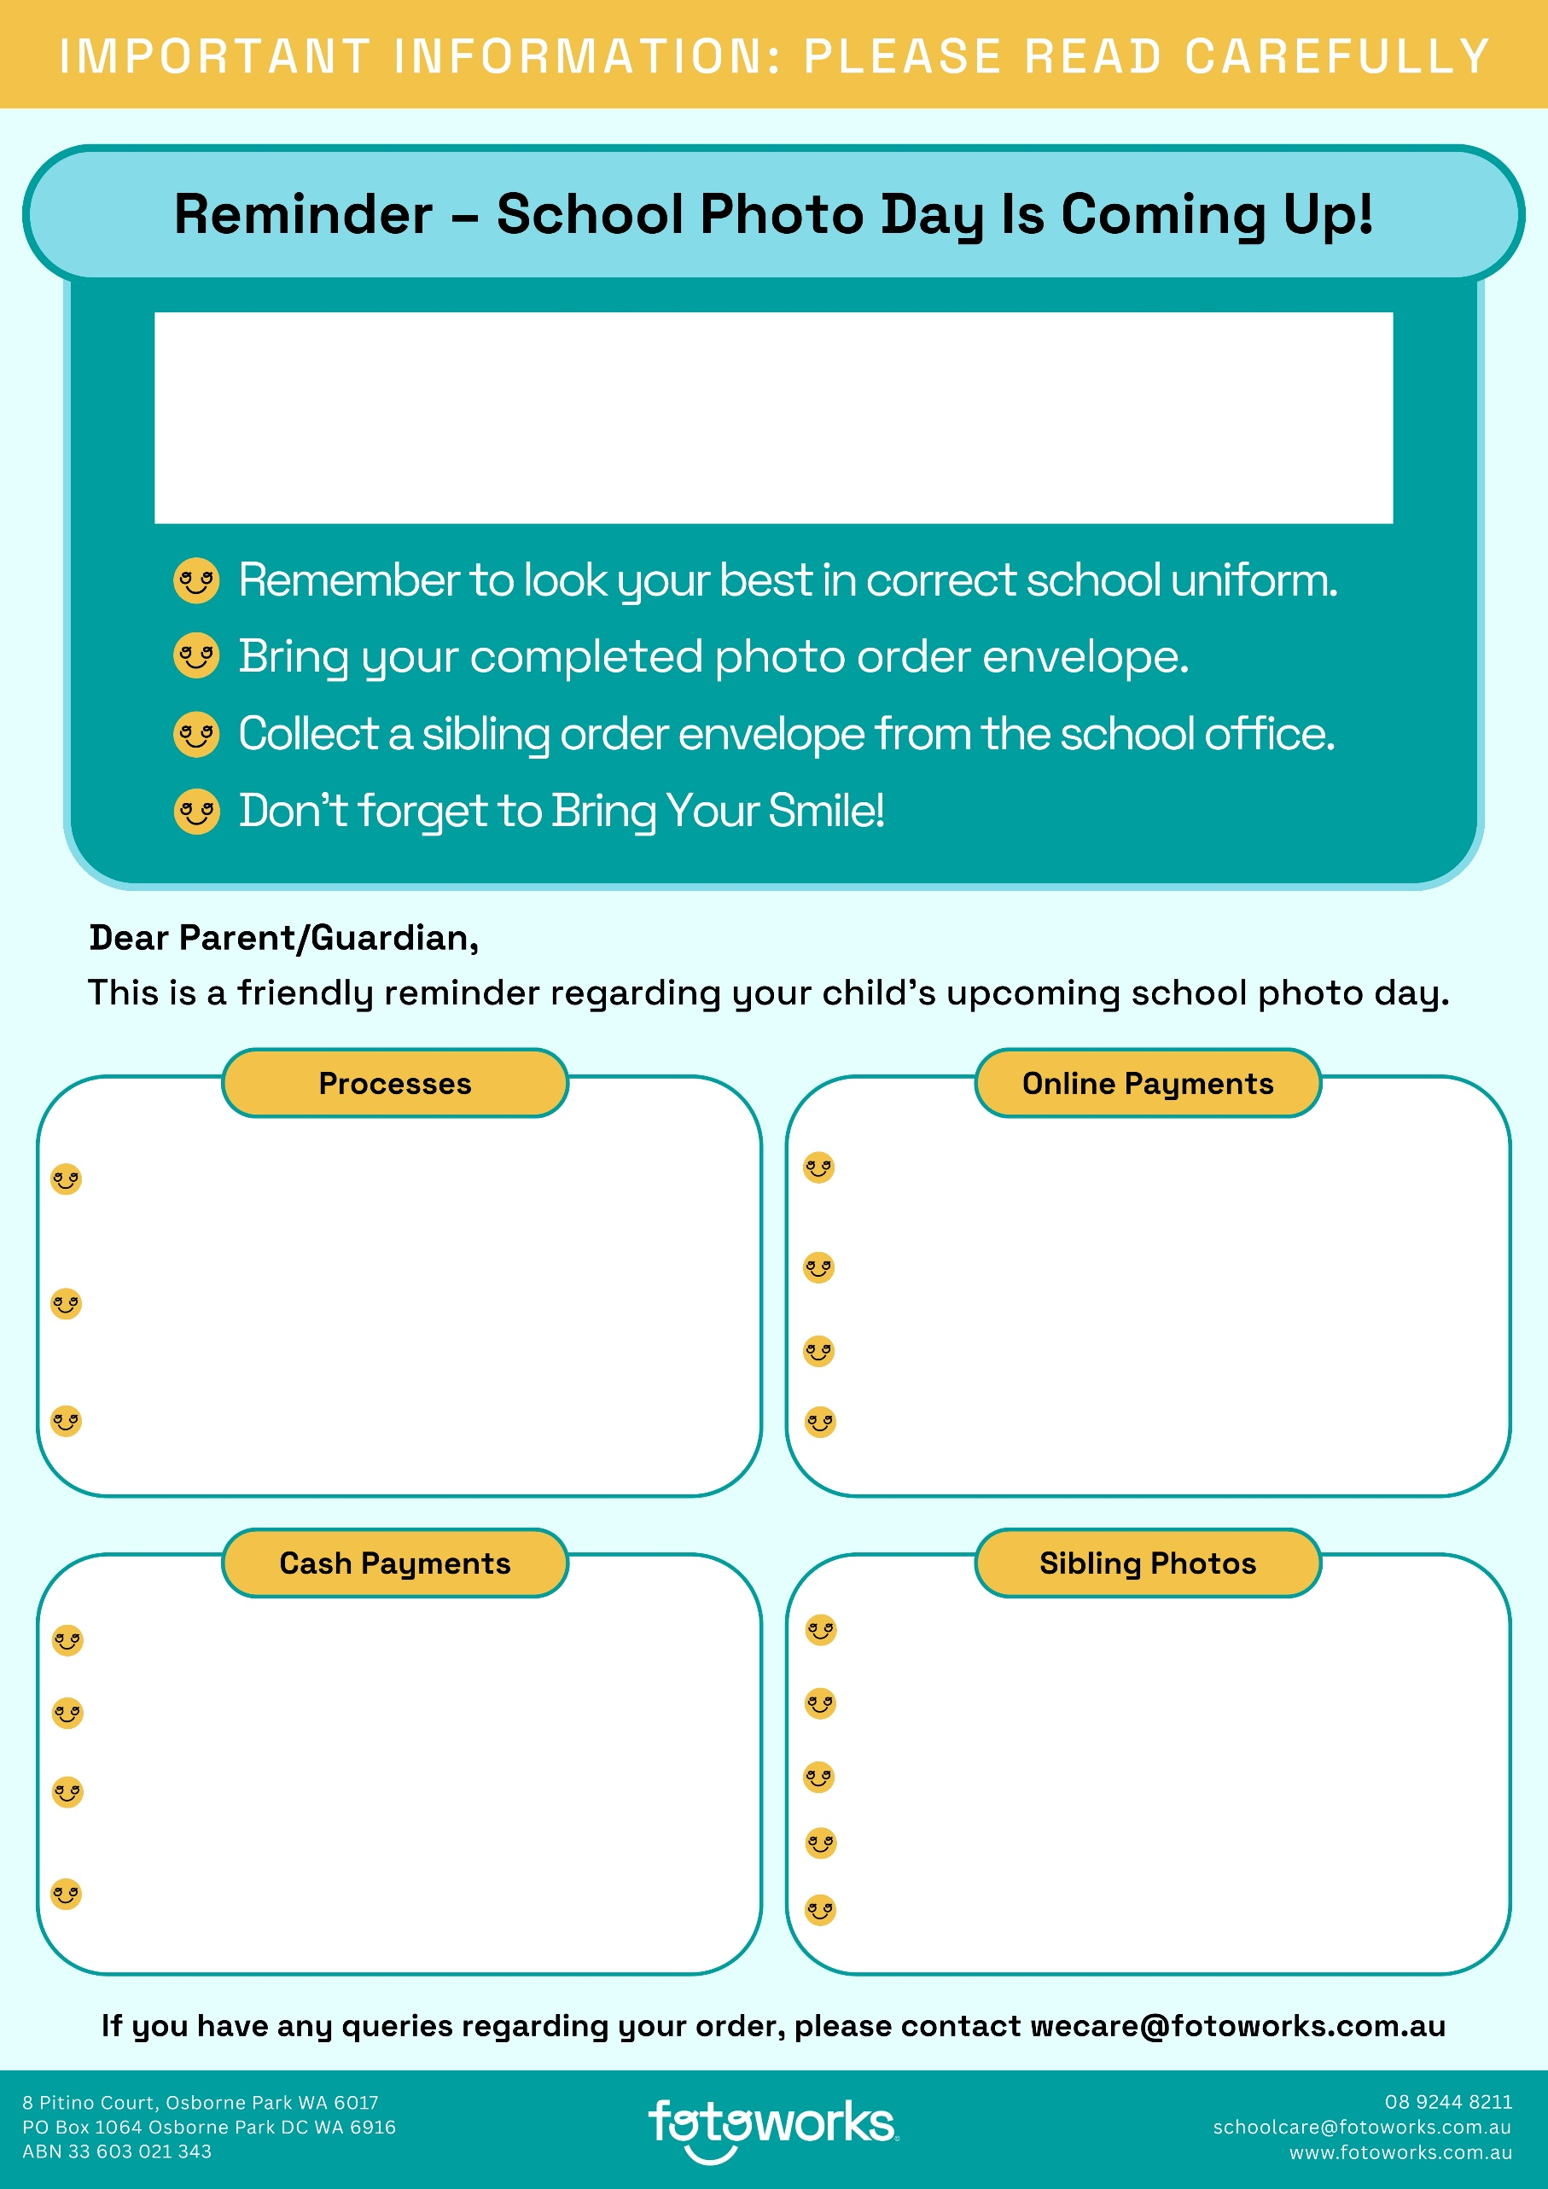
Wednesday 12 August 2026
Please collect a sibling order envelope from the school office.
Enter the sibling access key provided on the envelope.
Fill out the details and follow the prompts to place your order.
The last day to order sibling photos online is: 9 September 2026
If no photos are purchased on photo day the envelope will be returned to the student to give the parent a second chance to order online prior to the cut-off date.
Scan the QR code on your order envelope or go to https://online.fotoworks.com.au/ordering/access
Enter your child’s 2026 Access Key - provided on the order envelope (please note each child has a unique access key).
Follow the prompts to place your order.
The last day to order online is: 9 September 2026

Make sure the student has their completed envelope with them on photo day.
If paying by cash, please ensure that the exact amount is sealed inside of the envelope as no change can be given.
Tick your order on the reverse side of the envelope.
Browse our packages listed on the envelope.
Approximately two weeks before photo day each student will be given an envelope to take home so that parents can purchase their child’s school photos.
Once you have placed your individual orders online, click next and then click order for another.
Each student will need to bring their personalised order envelope on photo day even if no photos are purchased.

