
Vegetable Sushi rolls
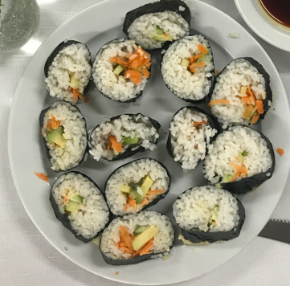
Makes approx. 20 rolls. GF
Recipe from Mount Eliza Primary School
Equipment:  Medium sized saucepan with tight fitting lid  Measuring cups  Spoon measures  Large baking dish  Cutting boards  Cutting knives  Graters  Sushi rolling mats (bamboo or plastic)  Small bowl of water for fingers  Platters, small bowls and teaspoons for serving | Ingredients:
  For the rice:
  4 cups sushi rice
  6 cups water
  8 tablespoons rice vinegar
  4 tablespoons sugar
  1 teaspoon salt
  Fillings:
  1 carrots- grated
  2 Lebanese cucumbers
  1 avocados
  Optional Japanese mayonnaise
  For wrapping:
  1 packet Nori seaweed sheets (10)
  Soy sauce for serving (or coconut aminos)
What to do:
To make the rice
- Measure the rice and place into the saucepan with the water. Give the rice a quick stir, then leave it to heat on the stove until just starts to bubble. Put the lid on and turn the heat to its lowest setting. Cook for 12 minutes. Turn off the heat and let the pot sit for another 10 minutes. Do not open the lid at any time as the steam will be released and will stop the cooking process!
- Whilst the rice is cooking, mix together the rice vinegar, sugar and salt. Stir until sugar and salt is dissolved.
- After the rice has rested for 10 minutes, scoop out into the base of the baking dish. Drizzle over the vinegar mixture and using a fork, gently stir through. Continue to fork through the mixture for about 5 minutes until the rice has cooled. Cover with a damp cloth until ready to use. IMPORTANT: If not using the rice straight away, place the rice into the refrigerator.

To create the filling
- Prepare the filling ingredients. Peel and grate the carrots and put into a small bowl. Slice the cucumber in half and then into thin strips and place onto a plate.
- Cut the avocado in half and remove the skin and centre seed. Slice into long strips and place onto a plate.

To assemble:
- Lay a piece of the seaweed sheet (shiny side down and longest width going across) onto the sushi rolling mat. Scoop out some of the rice with a spoon and using fingers press a thin layer of rice across the sheet but leave a 2 cm space at top end. Use the bowl of water to dip your fingers into. This will help to stop the rice from sticking to your fingers.
- If using mayonnaise, carefully squirt a line of mayonnaise across the rice. On top of that, lay a small strip of grated carrot, topped with a strip of cucumber and then a strip of avocado across the rice.
- Starting from the bottom end, roll up the sushi tightly using the mat as you roll. When you get to the end, let the rolling mat go and dab a little water across the top seaweed strip. Continue to roll completely until you have a tight log. Place on a plate.
- Repeat the process until all the sheets have been used
- To serve, slice each roll into 6 even pieces and place onto platters. Serve with a small side bowl of soy sauce or coconut aminos.

