Wellbeing Support for students

OPTION ONE  Physical Health & movement | OPTION TWO  Cognitive, Mind & Self  Spiritual, Community & school Values | OPTON THREE  Creativity
Walking for 20-30 minutes each day.  If it is cold, rug up, if it is drizzling take an umbrella. If it is too unreasonable to go outside look from the list below. | Journaling – complete each week.  Appendix 1 self-esteem | Time capsule – Make a time capsule of this time to be opened in 10 years  “Your 2021 experience so far”
Walk- with someone or a pet for 20-30 minutes  Practice social distancing – 1.5 metres | Get organizing- Organize your room & workspace | Make a Play list – Make a list of 10 songs that make you happy.
Yoga-  Yoga for the classroom with Adriene 10 min  https://www.youtube.com/watch?v=Td6zFtZPkJ4&t=44s  https://www.youtube.com/watch?v=Td6zFtZPkJ4&list=PLui6Eyny-Uzx96yT2Ok7l6SGcxSxXigUI  Yoga with Adriene 17 min  https://www.youtube.com/watch?v=dF7O6-QabIo  Yoga for Teens with Adriene 20 min  https://www.youtube.com/watch?v=7kgZnJqzNaU&t=33s  Chair Yoga for Beginners 4 min  https://www.youtube.com/watch?v=CJJnMvM6eDA  Chair Yoga for Slowing down 10 mins  https://www.youtube.com/watch?v=x9X4Y47DBdI  Chair Yoga for better balance 10 min  https://www.youtube.com/watch?v=x9X4Y47DBdI  Chair Yoga to regulate mood and emotions 9 min  https://www.youtube.com/watch?v=M76x26Fj1To | Mindfulness-  - Smiling Mind App  - Stop breathe think App  - Calm App  Find some:  - Spot the difference  - Colouring  - Mindfulness walk  - Mindfulness mazes  Research the following:  What is Mindfulness?  - Mindfulness Meditation  - Grounding techniques  - Progressive Muscle Relaxation script  Clip:What are the benefits of Mindfulness? students perspectives 5 min  https://www.youtube.com/watch?v=cOGM_-zKPTE  Mindful meditation Clip with Adriene  https://www.youtube.com/watch?v=vYQy8-7Ut1E  Mindful breathing 5 min  https://www.youtube.com/watch?v=SEfs5TJZ6Nk  Classroom meditation – Grounding & relaxation 5 min  https://www.youtube.com/watch?v=eYm9FkWQc0Q  Relaxing music 2 hours  https://www.youtube.com/watch?v=zQtfnPTlFFE | 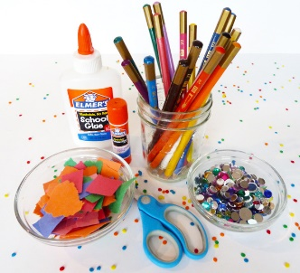  Arts and crafts – Have a look through the existing arts/crafts materials you might have at home. Make pressed flower cards, a collage, dreamcatchers, bracelets, necklaces, wall décor, collect quotes that inspire you.  Make a collage  - About me  - Favourite Celebrity  - 2021  - Things I found on my walk  - My family  - My favourite food
Skipping – create your own 2-3 minute routine  Basic to Advanced skills Clips:  https://www.youtube.com/watch?v=_g05NZ3rro8  https://www.youtube.com/watch?v=PUCQ2pvnyW4 | Unplug hour – Ensure one hour a day without accessing your phone, device or laptop. Use this as learning, reading or relaxing time.  Pets – It’s a great time to spend time with your pets | Cook up a feast-  Egg and Lettuce flying saucers  https://www.taste.com.au/recipes/egg-lettuce-mayonnaise-flying-saucer-sandwiches/Qq3DP2g3?r=recipes/kidshealthyrecipes&c=a91da572-616c-44a6-bc76-05f675fabedc/Kids%20healthy%20recipes  Ham and 3 cheese muffins  https://www.taste.com.au/recipes/ham-3-cheese-muffins/RtXTDH2a?r=recipes/kidshealthyrecipes&c=a91da572-616c-44a6-bc76-05f675fabedc/Kids%20healthy%20recipes  Chicken Nuggets  https://www.kidspot.com.au/kitchen/recipes/healthy-chicken-nuggets-recipe/a3eqoxyw  Lemonade Scones  https://www.kidspot.com.au/kitchen/recipes/traditional-lemonade-scones/wukc6bcx?r=sweets&c=qd5kvbtx/5%20ingredient%20dessert%20recipes&h=sweets  Please be cautious and avoid ingredients you are allergic to.
Balloon volleyball - Blow up a balloon and clear some space for a competitive game of balloon volleyball. If you don't have anyone to play with, see how many times you can hit the balloon into the air without it touching the ground  Think of some other games you can play | Audiobooks – Listen to your favourite book through Audible (https://www.audible.com.au/) or download apps such as “Open Culture,” “Lit2Go”, “Loyal Books”. | Think to the future- Write a bucket list of 5-10 things you would like to do in the future  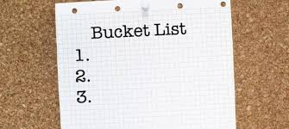
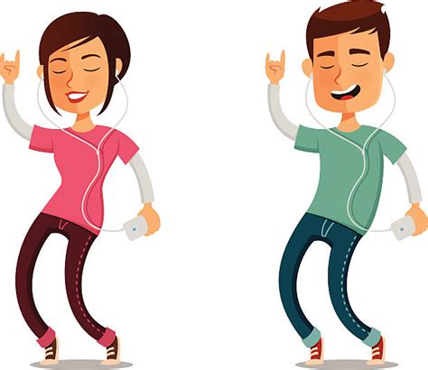  Music – Listen to your favourite music, make a playlist. Dance around to fun beats too, whether oldies-but-goodies or something new, it's a great way to have everyone relax, laugh and get moving. Here are 100 songs that can uplift you during this time: https://www.usatoday.com/story/entertainment/music/2020/03/20/coronavirus-100-songs-listen-while-youre-stuck-at-home/2882725001/ | Board games – Play board games and trivia with your family. Bring out your old games you used to love when you were younger! Or you can purchase more online to be delivered to your house.  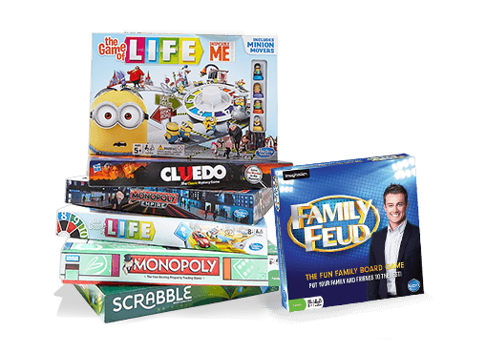 | Gaming Creativity- Create a cover for a PS or XBOX game  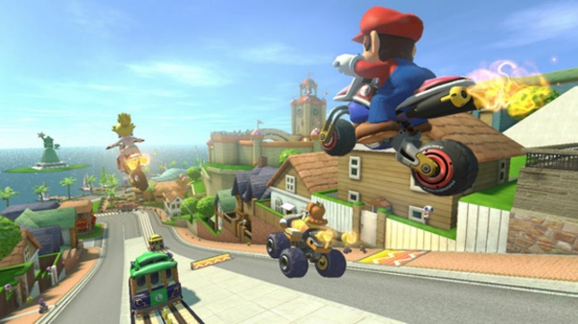
Step Challenge-How many steps are you doing in a day? Challenge yourself to achieve 10,000 steps per day or set your own target. | 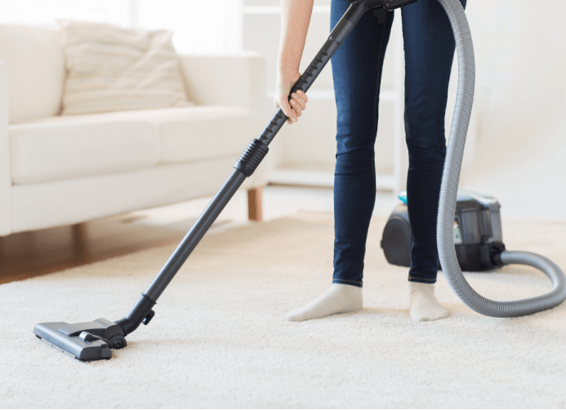  Chores – Help your parents/carers by assisting with a designated chore list, ticking off different chores each day. Take care of each other. | 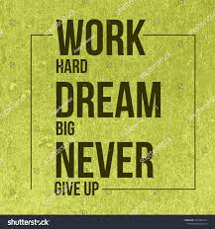  Inspirational quotes – Choose one or two that you love and create a poster for your room
Go outside – Head into your backyard, kick the footy/soccer ball, play basketball, jump on the trampoline, lift small weights, jog around the yard | Charades – Play charades with your family: https://ourpastimes.com/charade-ideas-teenagers-8725678.html | Build a Lego city - Find your Lego blocks and create a whole city. Use your family dog or cat as the oversized villain. Film your pet destroying the city. Or play Lego online: https://kids.poki.com/en/lego  30 day Lego Challenge
Circuit training  Home Fitness Circuit with stations - basic exercises  https://www.youtube.com/watch?v=PYNbM9N7alI  Caution do not do the stair activities  Circuit – You can set up a circuit, for yourself or with the family  https://www.sportaus.gov.au/findyour30/challenge/cards  Circuit – clip follow the instructions  https://youtu.be/g3L556EpRuo  Low impact workout for 10 min  https://www.youtube.com/watch?v=g-D7ncAC9rQ  Kids, Teens & beginner HIIT 10 min  https://www.youtube.com/watch?v=-ytpqZniZIw  Kids workout at home 12 min  https://www.youtube.com/watch?v=8uUawnM-FD8 | Movie night - Host a movie night with your family. Rotate each family member’s favourite movies or watch a new movie. Now is the perfect time to catch up on those really long movies you have avoided. Create a Google document of the movies you’ve watched and share it with friends.  Watch uplifting or hopeful movies, such as these movies: https://www.crosswalk.com/culture/features/hope-filled-movies-to-while-youre-stuck-in-the-house.html | Musical Reflection- Play your favourite song and write down how it makes you feel.
Have fun moving- Dance like no one is watching  Learn a new Dance genre | Podcasts - Sit together and listen to podcasts, pick a few to listen to that you can learn from, be inspired by or relax to. Share with your friends.  Mindfulness in 8 Weeks – 15 minute guided mindfulness sessions  https://www.podbean.com/podcast-detail/ivapj-41c93/Mindfulness-in-8-Weeks-20-Minutes-a-Day-Program-Podcast  Morning Mindfulness– Wake up right with morning mindfulness  https://podtail.com/en/podcast/wake-me-up-guided-morning-mindfulness-meditation-a/ | 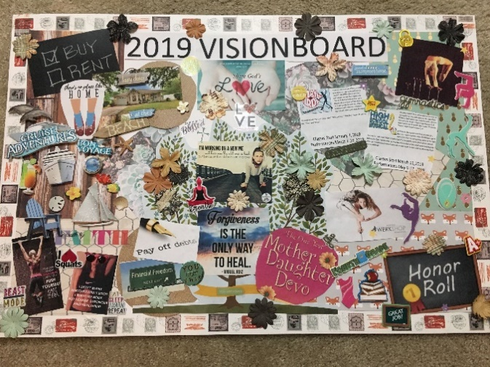  Vision Board – create a vision board with your favourite quotes and goals you’d like to achieve.
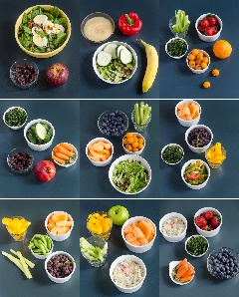  Eat Right – Try eating 5 serves of vegetables a day and 2 serves of fruit | Play instruments – Practice your flute, piano, trumpet, guitar etc. | Slime – Learn how to make your own slime at home with your family: https://www.bbcgoodfood.com/howto/guide/how-make-slime
Sleep Right- Aim for 8 hours a night of sleep. Try to avoid napping through the day and drinking caffeine in the afternoon. | Puzzles – Complete puzzles together as a family or by yourself. Purchase puzzles online or even complete puzzles online: https://thejigsawpuzzles.com/ | Video – Put together a video of your favourite family videos and photos.
Routines- Stick to your normal routines  Eating  Sleeping go to bed around the same time and get up at the same time you would as if you are coming to school.  Exercise in the morning if you can. Make time during the day. Teachers will give you time.  Meals have regular meals and healthy snacks  Personal hygiene Showering frequently  Technology Limit your time and take breaks in between classes. Choose an activity from the Grid and just relax when you need to.  Classes should only go for up to 35 minutes. You need to work on your wellbeing for the remainder of each session.  Tidy your room | Zoo – Go to the Melbourne Zoo, online! https://www.zoo.org.au/animal-house/  Or you could try the San Diego Zoo: https://animals.sandiegozoo.org/live-cams  Or visit the Online Zoo: http://theonlinezoo.com/ | 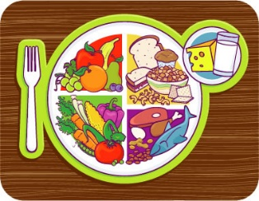  Weekly Menu – Help your parents/carer setup a weekly menu of what you can eat/cook for the week and how you can help
Hula hoop try using a hula hoop and improve your fitness at the same time  Hula Hoop for beginners:  https://www.youtube.com/watch?v=0visc3p6uAA  Beginner Hoop tricks  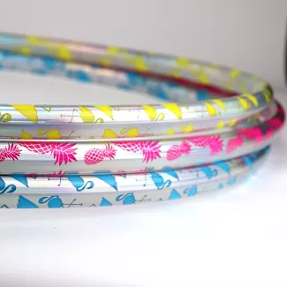  https://www.youtube.com/watch?v=H-k0uhlM3_c  Make your own routine to music | 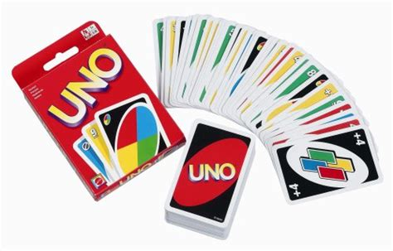  Uno – Play with your family, or play online: https://www.crazygames.com/game/uno-online | DIY Projects for Teens:  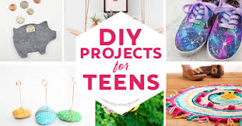  https://diyprojectsforteens.com/

Instructions:
Students have 3 activities that are highlighted in grey and are the first item in each category on the grid that are strongly recommended to do:
- Walking for 20-30minutes each day
- Journaling to be completed each week Appendix 1
- Time capsule and you will get instructions from your Learning for Life teacher
We actively encourage you and family members to engage in as many Wellbeing activities as possible. All other activities are optional and you can do them after your set work in each class.

