FIRST READING

A reading from the prophet Isaiah
22:19-23

Thus says the Lord of hosts to Shebna, the master of the palace: I dismiss you from your office, I remove you from your post, and the same day I call on my servant Eliakim son of Hilkiah. I invest him with your robe, gird him with your sash, entrust him with your authority; and he shall be a father to the inhabitants of Jerusalem and to the House of Judah.
I place the key of the House of David on his shoulder; should he open, no one shall close, should he close, no one shall open. I drive him like a peg into a firm place; he will become a throne of glory for his father's house.

RESPONSORIAL PSALM

R/ Lord, your love is eternal;
do not forsake the work of your hands.

SECOND READING

A reading from the letter of St Paul to the Romans 11:33-36

How rich are the depths of God – how deep his wisdom and knowledge – and how impossible to penetrate his motives or understand his methods! Who could ever know the mind of the Lord? Who could ever be his counsellor? Who could ever give him anything or lend him anything? All that exists comes from him; all is by him and for him. To him be glory for ever! Amen.

GOSPEL ACCLAMATION

Alleluia, Alleluia!
You are Peter,
the rock on which I will build my Church;
the gates of hell will not hold out against it.
Alleluia!

GOSPEL READING

A reading from the holy Gospel according to Matthew 16:13-20

When Jesus came to the region of Caesarea Philippi he put this question to his disciples, ‘Who do people say the Son of Man is?’ And they said, ‘Some say he is John the Baptist, some Elijah, and others Jeremiah or one of the prophets.’ ‘But you,’ he said ‘who do you say I am?’ Then Simon Peter spoke up, ‘You are the Christ,’ he said, ‘the Son of the living God.’ Jesus replied, ‘Simon son of Jonah, you are a happy man! Because it was not flesh and blood that revealed this to you but my Father in heaven. So I now say to you: You are Peter and on this rock I will build my Church. And the gates of the underworld can never hold out against it. I will give you the keys of the kingdom of heaven: whatever you bind on earth shall be considered bound in heaven; whatever you loose on earth shall be considered loosed in heaven.’ Then he gave the disciples strict orders not to tell anyone that he was the Christ.

 | Christ Our Light  Catholic Parish  Highett / Cheltenham  Parish Office:  9 Centre Dandenong Road,  Cheltenham, VIC. 3192 | Our Lady of the Assumption Church  9 Centre Dandenong Road, Cheltenham  St Agnes’ Church  25 Spring Road, Highett  Telephone: (03) 9583 6161  Email: col@cam.org.au  Website: www.olacheltenham.org.au

TWENTY-FIRST SUNDAY IN ORDINARY TIME – YEAR A
22nd / 23rd AUGUST, 2026

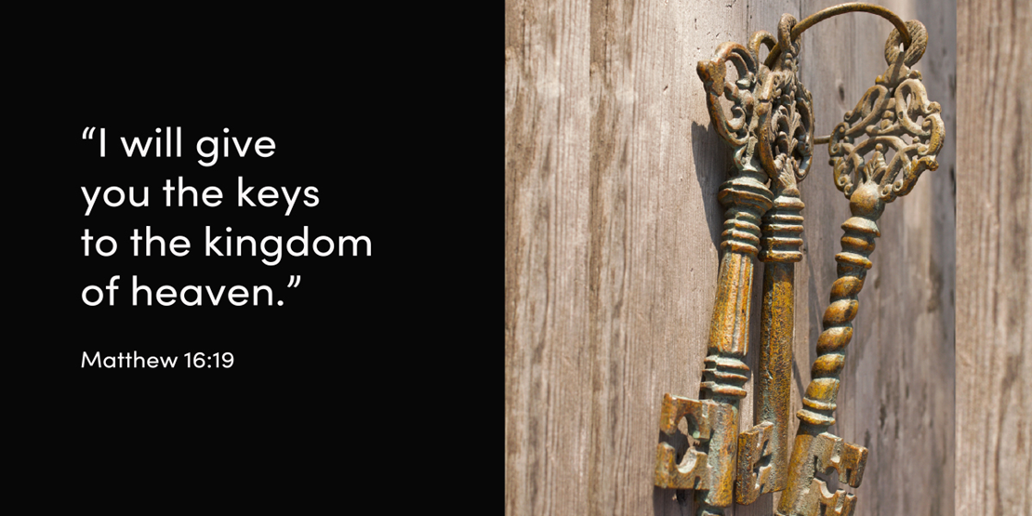

In today’s gospel Jesus questions the disciples about his identity. The disciples cite rumours that Jesus is a reincarnated prophet, namely John the Baptist, Elijah or Jeremiah. It is Simon Peter who recognises Jesus’ true identity: “You are the Christ, the Son of the living God.” Jesus responds by appointing Peter ‘the rock’ on which the church is to be built. As Eliakim was given keys of the house of David, so Peter is given keys to the kingdom of heaven! By the time the gospels are being written – some thirty to seventy years after Jesus’ death and resurrection – it is clear to Christians that Jesus had officially commissioned Peter to be the leader of the church, and Peter effectively took on this role for some thirty years. Some people like playing around with Jesus’ use of the word ‘rock’ to nominate Peter’s role in the infant church. Does it mean Jesus thought Peter was a bit thick in line with Marullus in Shakespeare’s Julius Caesar: “You blocks, you stones, you worse than senseless things”? Clearly this is not Jesus’ reasoning, as he will have been quite aware that the Psalms praise God as my ‘rock’, ‘fortress’, ‘shield’ and ‘my place of safety’. Despite Peter’s weaknesses – denying Christ three times and running away from Jesus’ crucifixion – God gave him the grace to be dependable, committed and a support for others with their different gifts. Peter’s rule was not one of craving or hanging onto power, but the rule of one who eventually learnt from his master that to rule is to serve.

Gerard Hall SM
Source: www.majellan.media

PARISH PRIEST:
Fr Alan Fox BH: 9583 6161 / AH: 9532 1794
Email: Alan.Fox@cam.org.au

PARISH OFFICE HOURS: 9583 6161
Monday - Friday 9am – 3pm
Secretary:
Accountant: Maureen Ryan

OUR SCHOOLS:

Our Lady of the Assumption PS 9584 9488
Principal: Mr Richard Jacques
Email: principal@olacheltenham.catholic.edu.au

St Agnes’ Primary School 9532 0344
Principal: Mr Thomas Hartney
Email: principal@sahighett.catholic.edu.au

MASS TIMES – CHELTENHAM & HIGHETT

SATURDAY VIGIL & SUNDAY MASSES:
Saturday [St Agnes Church] 6:00 pm
Sunday [OLA] 9:00 am, 11:00 am

WEEKDAY MASS TIMES:
Tuesday [St Agnes Church] 9.00 am
Tuesday [OLA Church] 6.00 pm
Wednesday [OLA Church] 9.15 am
Thursday [OLA Church] 9.15 am
Friday [St Agnes Church] 9.00 am
Saturday [OLA Church] 9.00 am

COMMUNION SERVICE (except Public Holidays)
Monday [OLA Church] 9.15 am

SACRAMENT OF RECONCILIATION: Wednesday [OLA Church] 9:45 am
Saturday [OLA Church] 9.30 am

BAPTISMS: Contact Parish Office: 9583 6161.

WEDDINGS: By appointment, 6 months’ notice required. Saturdays or weekdays (not Sundays).

The clergy, employees and volunteers of our parish are committed to upholding a duty of care to all children, young people and vulnerable adults, taking all reasonable steps to protect children, young people and vulnerable adults from all forms of abuse and harm and commit to safeguard their health and well-being.

TWENTY-FIRST SUNDAY-Year A
22nd / 23rd AUGUST, 2026

PRAYING FOR:

Kevin Curran, Oswald Rosso,

and all who have died recently.

WE ALSO PRAY FOR:

Rocco Tripodi, William Rigby, Maria Dib, Pina Gori, Carolina Ramirez,
Snow Seymour, Andrew Borg,
Janet Lanigan, Rosie De Gregorio,
Stan Smith, Gaetano Lomacchio,
Daniel Braganza, Molly Taylor,
Liam Chadwick, Renee Herft

and all who we remember at this time.

…as we also keep in our prayers
all those who are currently unwell.

Readings for this liturgical year from Advent 2025 to Christ the King 2026 are taken from Year A in the Lectionary cycle.
Should you wish to view the Scripture Readings for Daily Mass (Australian Liturgical Calendar) please visit: universalis.com/australia.melbourne/1000/Mass

VOLUNTEERS: Please make sure that your WWCC/POLICE CHECK documents are current, that is, have not expired, and copies made available to the Parish Office.

PARISH STEWARDSHIP: Thank you to all parishioners who continue to generously support our parish i.e., through their contributions to both our Thanksgiving and Presbytery collections. With the assistance of the Archdiocese, we are currently working on refining the facility for parishioners to contribute to Christ Our Light Parish via an online portal.

MELBOURNE SYNOD 2026
We’re invited to answer the call to deepen our understanding of synodality in parish life. For more information please visit:
melbournecatholic.org/synod2026

SYNOD CORNER: Synodality and the Eucharist The Eucharist is the heart of synodality. Around one table, many are gathered as one Body. What we celebrate sacramentally must shape how we live communally.

WELCOME BACK to Fr Alan after a well-deserved holiday and a BIG THANK YOU to Fr Laurie for his support to our Parish over the past month.

PARISH STEWARDSHIP. New boxed sets of Envelopes for Thanksgiving / Presbytery Giving are available in each church foyer. Thank you.


PARISH SOCIAL LUNCH. Thursday 27th August, 12noon. Venue: Highett RSL. All welcome. RSVP by Tuesday 25th August: Tricia Hickey on 0421 275 853 or Adrian Foley: 0497 780 233

THE ARCHBISHOP’S CAMPAIGN
Please consider a one time or monthly pledge to support the vital ministries of our Archdiocese. Brochures with more information can be found at the church. Online (direct debit or credit card) donations are the most secure and preferred method and can be made via the QR code above.
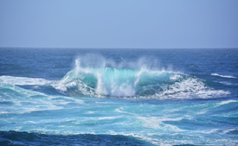
IGNATIAN OCEAN RETREAT ONLINE FOR SEASON OF CREATION 2026 Tuesdays 8th, 15th, 22nd & 29th September 2026. 6.30pm - 8.30pm AEST. $80.00 for all four sessions, including retreat facilitation and prayer materials. Facilitated by Jesuit & Ignatian Spirituality Australia, Being with God in Nature Ministry. For further information visit:
https://jisa.org.au/retreat/ignatian-ocean-retreat-online-for-season-of-creation-2026/


FETE DONATIONS can be dropped off to:
9 Centre Dandenong Rd, Cheltenham, by the 2nd October 2026.
For more information please contact:
fete@olacheltenham.catholic.edu.au

RCIA LEADERS GATHERING: NAVIGATING PASTORAL REALITIES. Wednesday 26 August 2026, 7.30pm-9pm, Online. The session will explore how to welcome enquirers including holding meaningful first conversations, responding to canonical issues and Sherry Weddell’s Thresholds of Faith. We encourage whole RCIA teams to attend together. Register here:
www.trybooking.com/events/landing/1623167

