Help us support Ronald McDonald House
by making a donation
Suggested food items include:
- Tinned tuna, salmon, sardines and ham
- Pasta sauces and pasta, rice
- Breakfast cereals, muesli bars, breakfast bars
- Biscuits, oil, lentils, beans
- Teabags, instant coffee, Milo, juice boxes
- Tinned fruit, vegetables
- Small jars of vegemite, honey and jam
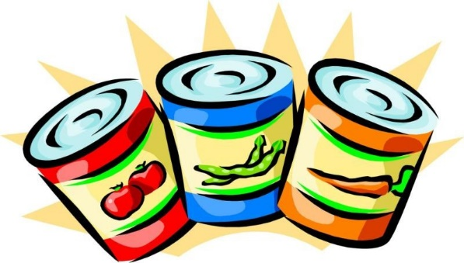
Suggested brand new toys include:
- Reading books
- Coloured pencils
- Colouring books
- Board games (packed)
- Balls
- Stuffed animals (packed)
- Small toys (packed)
- Dressing up costumes (packed)
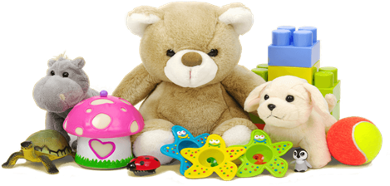
Donations can be brought to School until Friday 27 August 2021!

