

**21/02/2025**

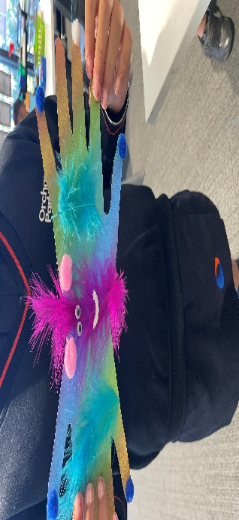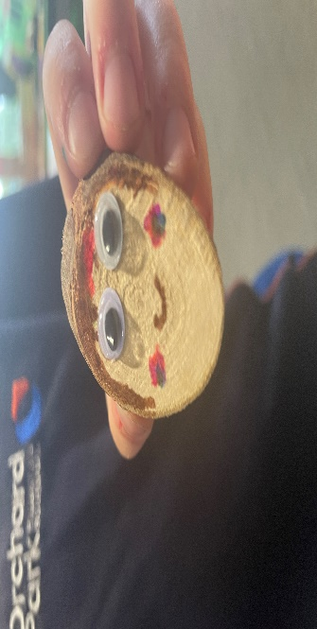[](https://pp.campaustralia.com.au/)

We celebrated kindness week, a special time dedicated to exploring and promoting the importance of kindness within our community. During circle time, the children enthusiastically engaged in discussion about what kindness means to them, sharing ideas and experiences that highlighted the value of caring for one another.

The week was filled with creative and meaningful activities. Such as Kindness kites, 100 acts of kindness, kindness rocks…etc.

Great news! We are open on the upcoming pupil free day 5-3-2025 to provide a fun and engaging day for the kids.

Kindness week was a resounding success, fostering an environment of empathy, creativity, and unity. We look forward to continuing this wonderful journey of kindness together.

* Clay animal
* Tape heart painting
* Friday Disco

**Activities coming up**

Join in the fun of Outside School Hours Care activities and experiences with Your OSHC and Rocketeers.

**Make a booking**

Book now

**Orchard Park Primary School**