
Treating and controlling headlice
OFFICIAL

While children are at school many families will have contact with head lice. The information contained here will help you treat and control head lice.

Catching head lice
Head lice have been around for many thousands of years. Anyone can get head lice.
Head lice are small, wingless, blood sucking insects. Head lice only survive on humans. If isolated from the head, they die very quickly (usually within 24 hours). They do not generally carry or transmit diseases.
People get head lice from direct hair to hair contact with another person who has head lice. They do not have wings or jumping legs so they cannot fly or jump from head to head. They can only crawl.

Finding head lice
Many lice do not cause an itch, so you have to look carefully to find them.
Head lice are found on the hair itself and move to the scalp to feed. They have six legs which end in a claw, and they rarely fall from the head. Louse eggs (also called nits) are laid within 1.5 cm of the scalp and are firmly attached to the hair. They resemble dandruff but can’t be brushed off.
Lice can crawl and hide. The easiest and most effective way to find them is to follow these steps:
Step 1: Comb any type of hair conditioner on to dry, brushed (detangled) hair. This stuns the lice and makes it difficult for them to grip the hair or crawl around.
Step 2: Comb sections of the hair with a fine-tooth head lice comb.
Step 3: Wipe the conditioner from the comb onto a paper towel or tissue.
Step 4: Look on the tissue and the comb for lice and eggs.
Step 5: Repeat the combing for every part of the head at least four or five times.
If lice or eggs are found, the hair should be treated.
If the person has been treated recently and you only find empty hatched eggs, you may not need to treat, as the empty eggs could be from a previous episode.

Head lice eggs
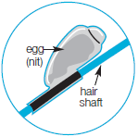
Head lice eggs are small (the size of a pinhead) and oval. A live egg will ‘pop’ when squashed between fingernails.
Dead eggs have crumpled sides and hatched eggs look like tiny boiled eggs with their tops cut off.

Treating head lice
Treating head lice involves removing lice and eggs from the hair. There are two ways you can do this.
- Buying and using a head lice lotion or shampoo that has an insecticide in it. (Also see the section below called Insecticide resistance.)
- Using the conditioner and comb method (described above in the section Finding head lice) every second day until there have been no live lice found for ten days.
If you choose to use a head lice product always carefully read and follow the product instructions. The following points may also be helpful:
- Head lice products must be applied to all parts of the hair and scalp.
- No insecticide treatment kills all the eggs so treatment must involve at least two applications, seven days apart. The first treatment kills all lice; the second treatment kills the lice that may have hatched from eggs not killed by the first treatment.
- Cover the person’s eyes while the treatment is being applied. A towel is a good way to do this.
- If you are using a lotion, apply the product to dry hair.
- If you are using a shampoo, wet the hair, but use the least amount of water possible.
- Apply the treatment near the scalp, using an ordinary comb to cover the hair from root to tip. Repeat this several times until all the hair is covered.
There is no need to treat the whole family – unless they also have head lice.
Concentrate on the head – there is no need to clean the house or the classroom. Only the pillowcase requires washing – either wash it in hot water (at least 60ºC) or dry it using a clothes dryer on the hot or warm setting.

Insecticide resistance
Insecticide resistance is common, so you need to check that the lice you comb out during a treatment are dead. If the insecticide has worked, the lice will be dead within 20 minutes. If they are, treat again in seven days using the same product. If the lice are not dead, the treatment has not worked and the lice may be resistant to the product and all products containing the same active compound. Wash off the product and treat as soon as possible using either a product containing a different active compound or the conditioner and comb method.
The active compounds in head lice products are:
- pyrethrins
- synthetic pyrethroids (permethrin, bioallethrin)
- organophosphates (maldison or malathion)
- herbal, with or without natural (non-chemical) pyrethrins.
Any head lice product can cause a reaction and should be used with care by women who are pregnant or breastfeeding, children less than 12 months old and people with allergies, asthma or open wounds on the scalp. If you are unsure, please check with your pharmacist or doctor.

Preventing head lice
There is no product available that prevents ‘catching’ head lice. However, tying long hair back and checking weekly for lice, using the conditioner and comb method, can help prevent the spread.

Regulations
According to the Public Health and Wellbeing Regulations 2019, children with head lice can be readmitted to school or children’s service centres after treatment has commenced.
The department recommends a child with head lice can be treated one evening and return to school or children’s service centres the next day, even if there are still some eggs present. There is no need to miss school or childcare because of head lice.

The life cycle of head lice
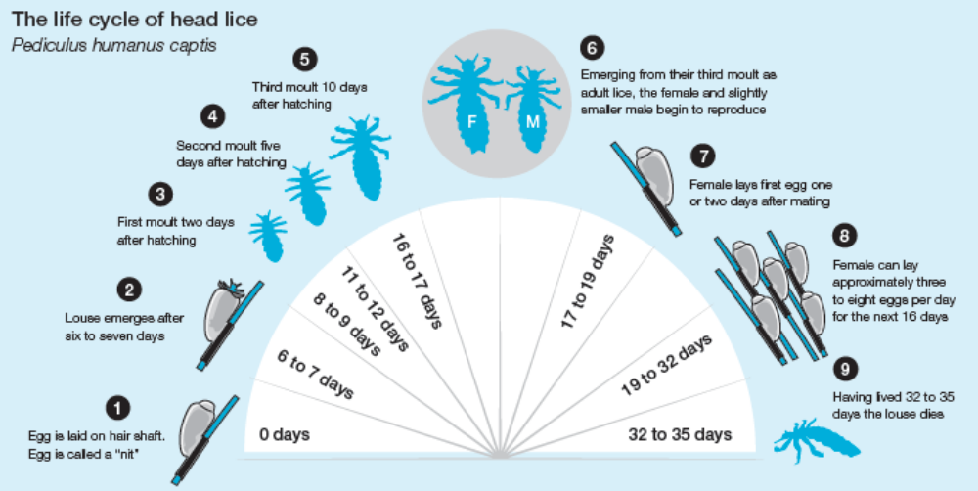
The diagram above shows the phases of a head louse’s life cycle. These include the following:
Phase 1. An egg is laid on a hair shaft. The egg is called a ‘nit’.
Phase 2. A louse emerges after six to seven days.
Phase 3. The first moult occurs two days after hatching – 8 to 9 days in their life cycle.
Phase 4. The second moult occurs five days after hatching – 11 to 12 days into their life cycle.
Phase 5. A third moult occurs ten days after hatching – 16 to 17 days into their lifecycle.
Phase 6. Following the third moult, the louse emerges as an adult. The female and slightly smaller male begin to reproduce.
Phase 7. Females lay their first eggs one or two days after mating – 17 to 19 days into their lifecycle.
Phase 8. Females can lay approximately three to eight eggs per day for the next 16 days – 19 to 32 days into their lifecycle.
Phase 9. Having lived 32 to 35 days the adult louse dies.
To receive this document in another format, phone 1300 651 160 using the National Relay Service 13 36 77 if required, or email the Communicable Disease Section <infectious.diseases@dhhs.vic.gov.au>.
Authorised and published by the Victorian Government, 1 Treasury Place, Melbourne.
© State of Victoria, Australia, Department of Health, September 2023.
Available at <https://www.health.vic.gov.au/infectious-diseases/about-head-lice>

