[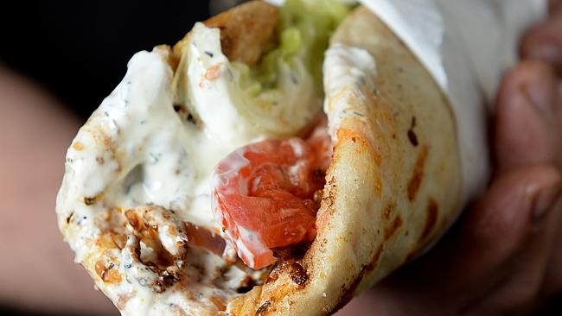](http://www.google.com.au/url?sa=i&rct=j&q=clipart+onlineYIROS&source=images&cd=&ved=0CAcQjRw&url=http://www.adelaidenow.com.au/messenger/city/my-top-3-spots-in-adelaides-cbd-for-great-food-and-a-hangover-cure/story-fni9lkxa-1227362636238&ei=blpuVdWQH5Lt8gWdx4CYDg&bvm=bv.94911696,d.dGc&psig=AFQjCNFMoKMOtYpvMKQMUHCIhA7TAE0NLg&ust=1433381853144207) **LARGS BAY SCHOOL CANTEEN**

**SPECIAL LUNCH ORDER**

**YIROS DAYS – WEEK 9**

Wednesday 20th September – Rooms 3, 4, 5, 5A, 13, 14, 16, 17, 19, 20, 22, 23

Thursday 21st September – Rooms 10, 11, 26, 27, 29, 30, 31, 32, 33

**MONEY AND ORDERS MUST BE RETURNED TO THE CANTEEN**

**BY THE MORNING OF WEDNESDAY 13th September**

******NO LATE ORDERS WILL BE ACCEPTED******



**OPTION 1 $6.00**

½ Chicken Yiros 🞏

(please tick)

Lettuce 🞏

Tomato 🞏

Tzatziki Sauce 🞏

Cookie included

(Please tick one)

390ml Water 🞏

Fruitbox Apple 🞏

Fruitbox Orange 🞏

Fruitbox Blackcurrant 🞏

**OPTION 2 $8.00**

Full Chicken Yiros 🞏

(please tick)

Lettuce 🞏

Tomato 🞏

Tzatziki Sauce 🞏

Cookie included

(Please tick one)

390ml Water 🞏

Fruitbox Apple 🞏

Fruitbox Orange 🞏

Fruitbox Blackcurrant 🞏

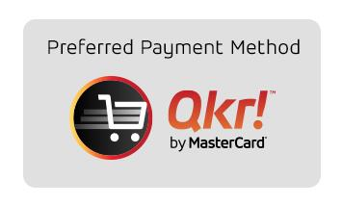

**STUDENT NAME:**________________________________________

**ROOM NO:**______________

**AMOUNT ENCLOSED:**____________________

….. ORDER USING OUR **QKR APP** OR BY RETURNING YOUR ORDER FORM WITH PAYMENT …..