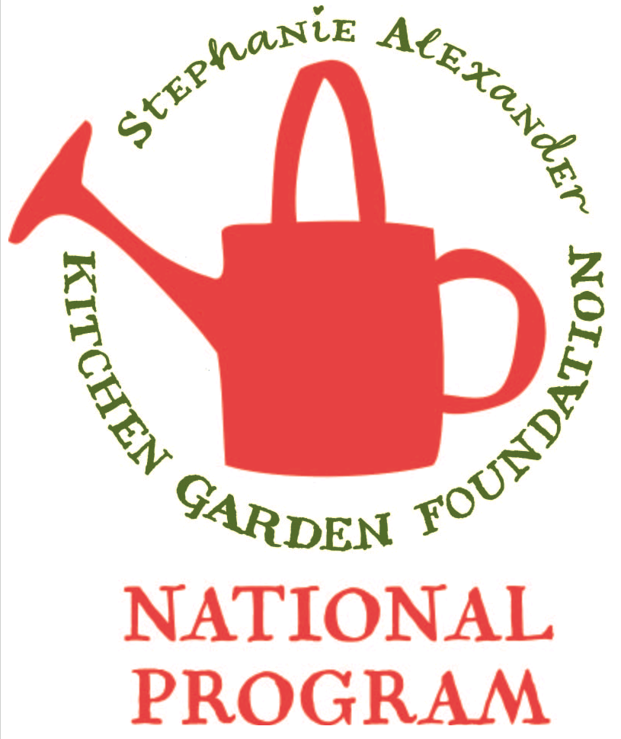
Hot Cross Buns

Season: Autumn

Type: Bread

Difficulty: Easy

Serves: 30 tastes in classroom , 12 at home

Fresh from the garden:

Recipe source: Woolworths Fresh magazine April 2017

Equipment:  * mixing bowl  * measuring spoons  * sieve  * measuring cups  * whisk  * pastry brush  * 4 serving platters | Ingredients:  - 4 cups plain flour  - 21 grams dried yeast (3 sachets)  - 1/2 cup brown sugar  - 1 ½ teaspoons mixed spice OR ½ tsp cinnamon and ½ tsp nutmeg  - ½ tsp bicarb soda and ½ tsp baking powder  - ½ cup sultanas  - ½ cup raisins  - 60g butter  - 300ml/ 1 ¼ cups milk  - 2 eggs, lightly beaten  - Pinch salt  - FLOUR PASTE  - ½ cup plain flour  - 4 to 5 tablespoons water  - GLAZE  - ¼ cup boiling water cup water  - ¼ golden syrup  - Butter, to serve

What to do:
- Combine flour, yeast, sugar, spices, salt, bicarb soda and dried fruit in a large bowl.
- Melt butter in a small saucepan over medium heat. Add milk. Heat for 1 minute, or until lukewarm.
- Add warm milk mixture and eggs to sultana mixture. Use a flat-bladed knife to mix until dough almost comes together. Use clean hands to finish mixing to form a soft dough.
- Step 2
Turn dough out onto a floured surface.
Knead for 10 minutes, or until dough is smooth. Place into a lightly oiled bowl. Cover with plastic wrap.
Set aside in a warm, draught-free place for 1 to 1 1/2 hours, or until dough doubles in size.

- Step 3
Line a large baking tray with non-stick baking paper. Punch dough down to its original size. Knead for 30 seconds on a lightly floured surface until smooth. Divide into 12 even portions. Shape each portion into a ball. Place balls onto lined tray, about 1cm apart. Cover with plastic wrap. Set aside in a warm, draught-free place for 30 minutes, or until buns double in size. Preheat oven to 190°C or 170˚C fan-force.
- Step 4
Make flour paste: Mix flour and water together in a small bowl until smooth, adding a little more water if paste is too thick. Spoon into a small snap-lock bag. Snip off 1 corner of bag. Pipe flour paste over tops of buns to form crosses. Bake for 20 to 25 minutes, or until buns are cooked through.
- Step 5
Make glaze: Place water and sugar into a small saucepan over low heat. Stir until sugar dissolves. Bring to the boil. Boil for 3-4 minutes.
Brush warm glaze over warm hot cross buns. Serve warm or at room temperature

