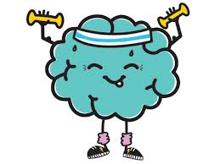

**Strong Minds Group** is a 10-Week group program for young people who are experiencing some symptoms of depression and anxiety. This group is aimed at improving their understanding of their mental health, developing their emotion regulation and adaptive coping skills to improve mood and reduce anxiety.

Strong Minds Group is primarily based in cognitive behaviour therapy principles, though also includes some dialectical behaviour therapy skills and has a strong emphasis on the effectiveness of mindfulness practice.

**Strong Minds Group**

* **Session 1**: Orientation and group formation
* **Session 2**: Understanding my emotions
* **Session 3**: Thinking errors
* **Session 4**: Challenging and changing unhelpful thinking
* **Session 5**: DOING what matters
* **Session 6**: Identifying anxiety provoking situations & helpful strategies
* **Session 7**: Dealing with worries (prediction testing)
* **Session 8**: Structured problem solving
* **Session 9**: Interpersonal effectiveness skills
* **Session 10**: Sleep Hygiene and program reflection

**Program Overview**

**“Every day may not be good, but there is something good in every day”.**