Thursday
Specialists Day
FA

Thursday is the Specialists Day.

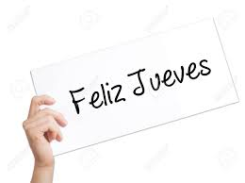

Thursday is a fun day!

In the morning, I line up at my classroom. Raúl takes FA inside to put our bags away in a locker. We are doing Physical Education!

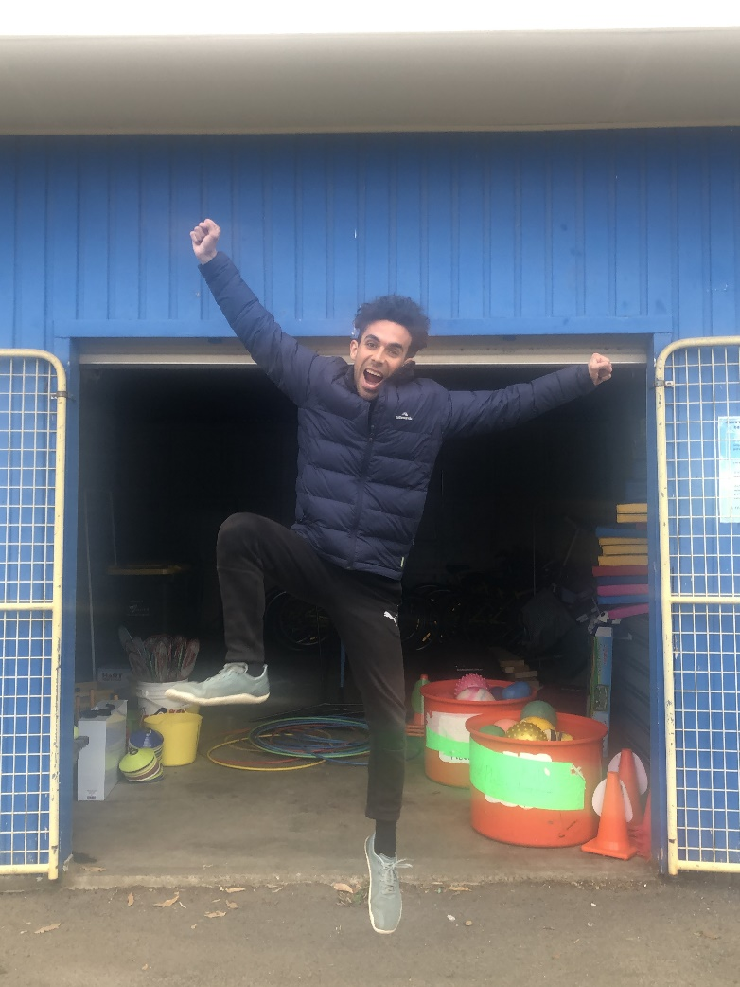

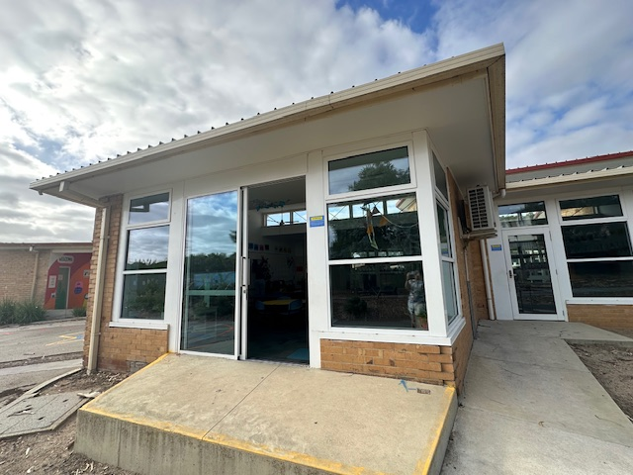

Then, I wear my hat and put sunscreen on.

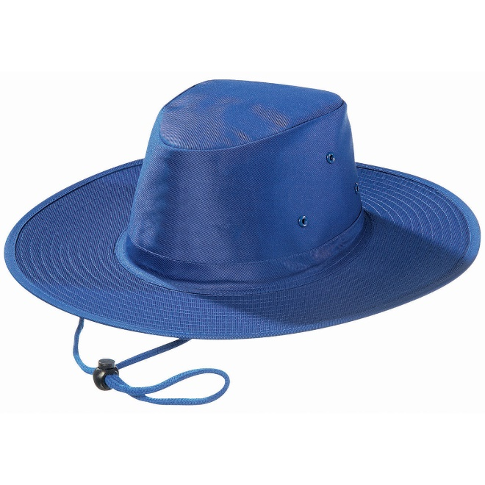
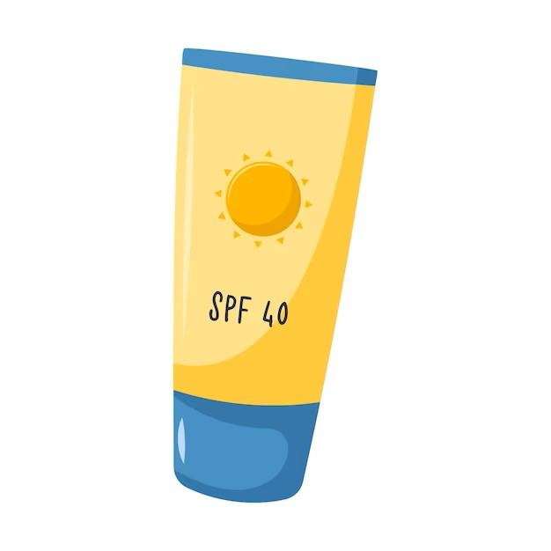

Most of the time, Raúl takes us to the gym to play games. Other times, he can take us to the bottom oval. I have a great time with my new friends playing inside the gym and in nature. When I feel tired, I can drink some water and rest.

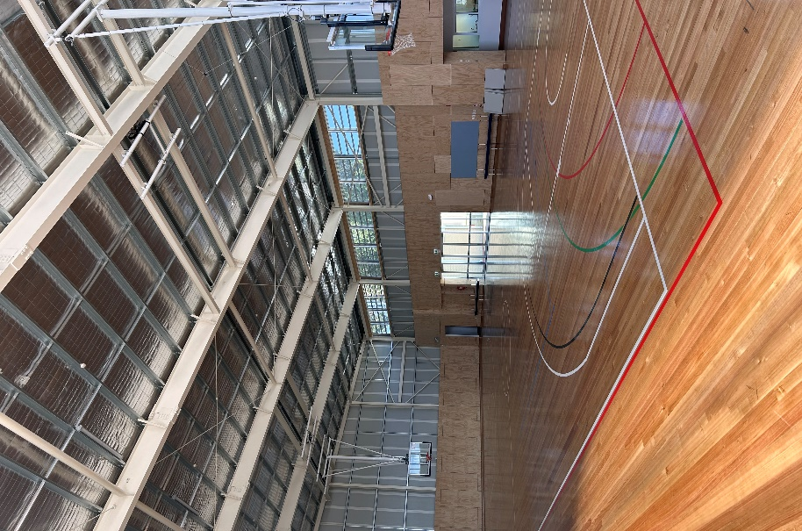
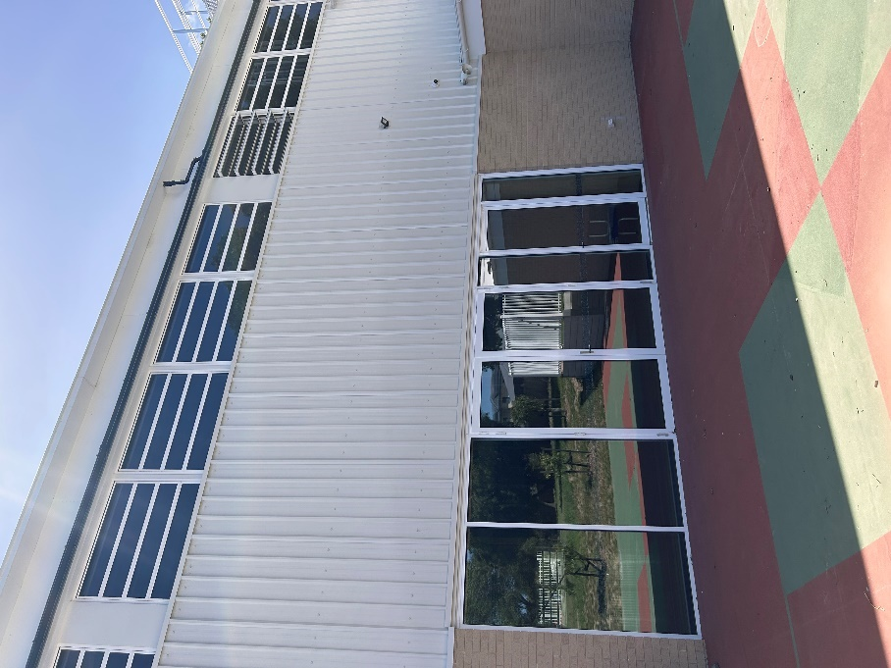

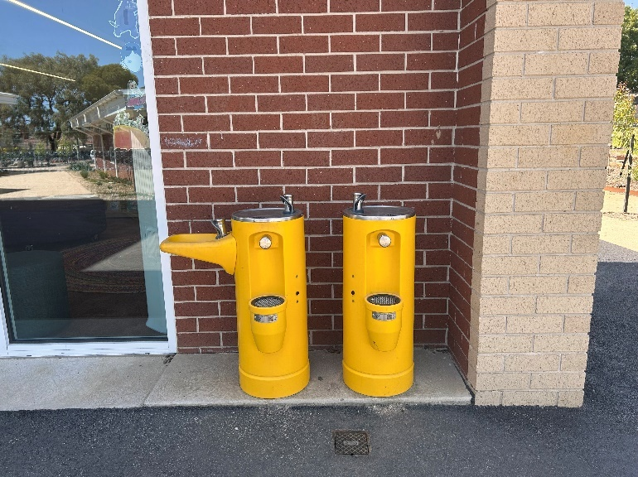

When we finish Physical Education with Raúl, we have a fruit snack in the classroom. I don’t share food with my friends.
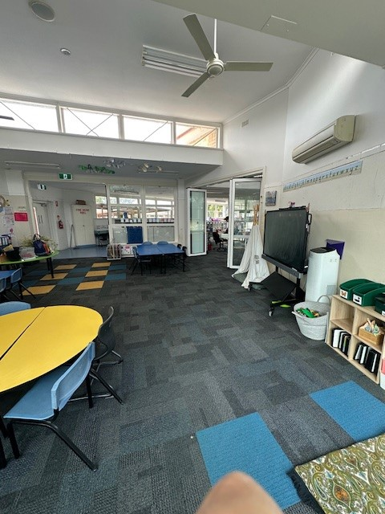
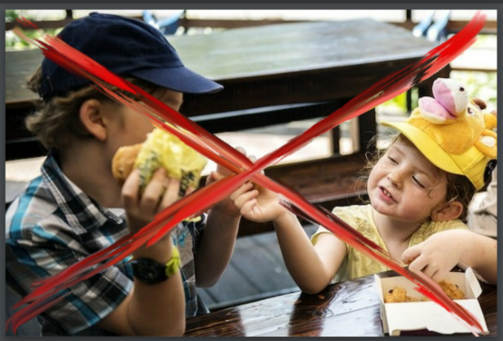
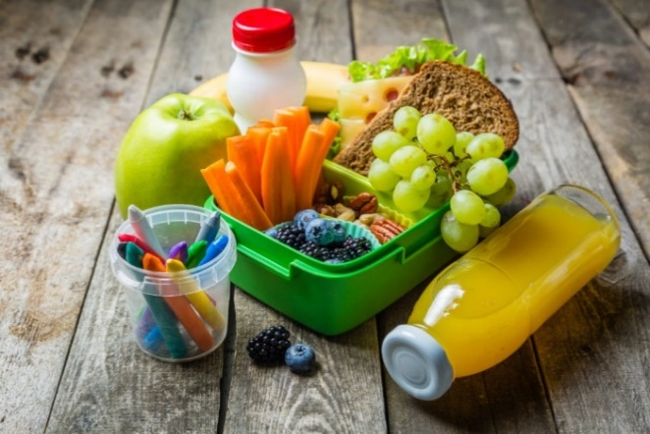

After the snack, we do Music and Performing Arts with Felipe.
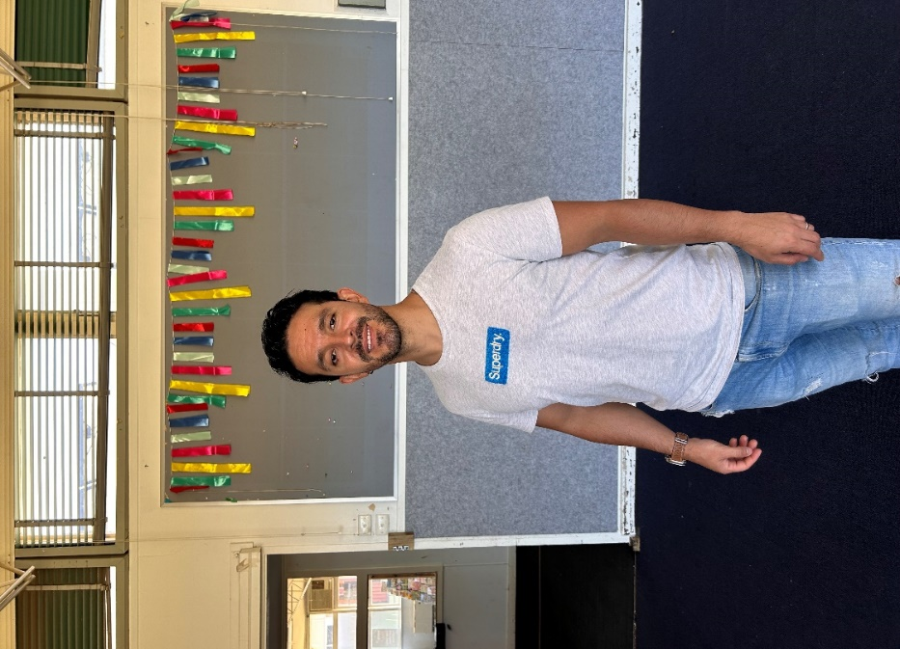

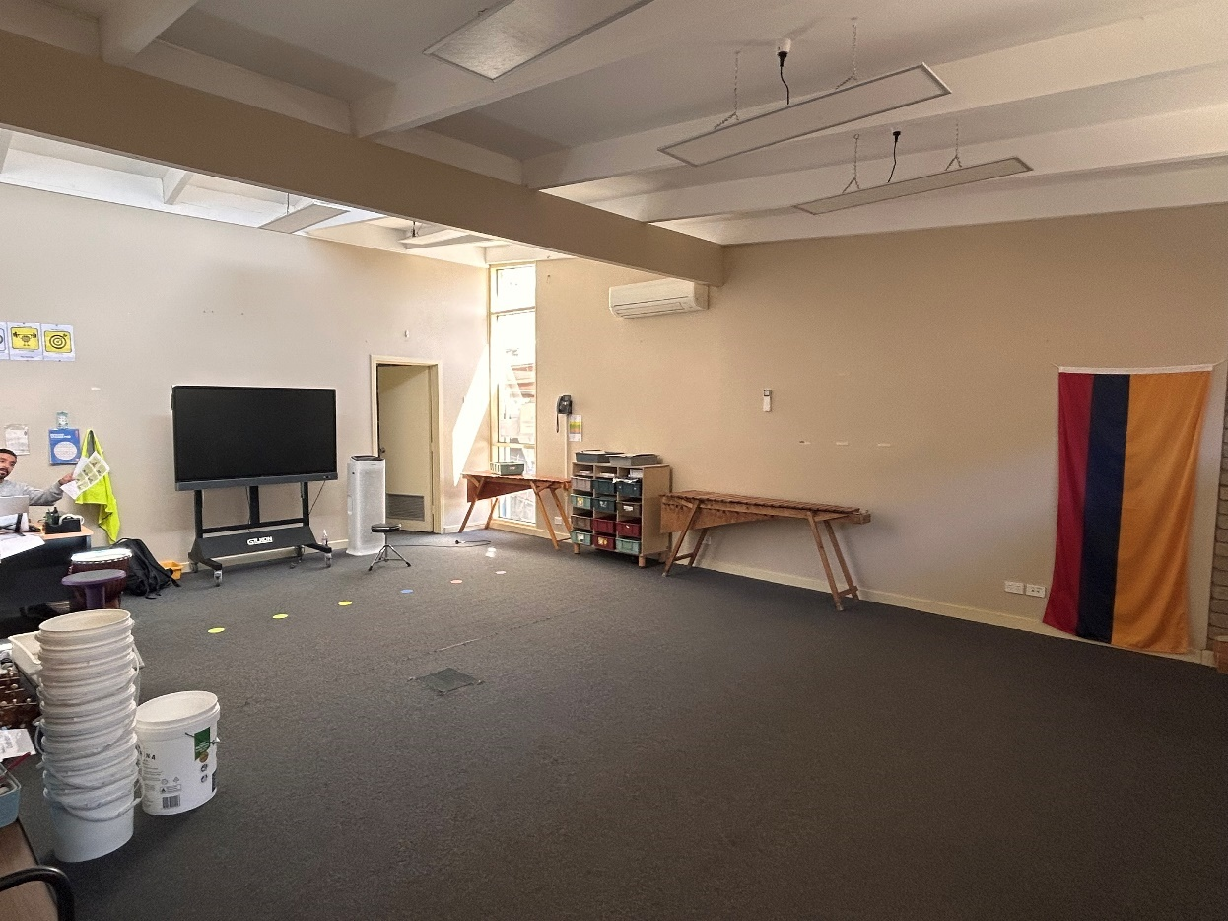

In Performing Arts and Music, I sing and dance.

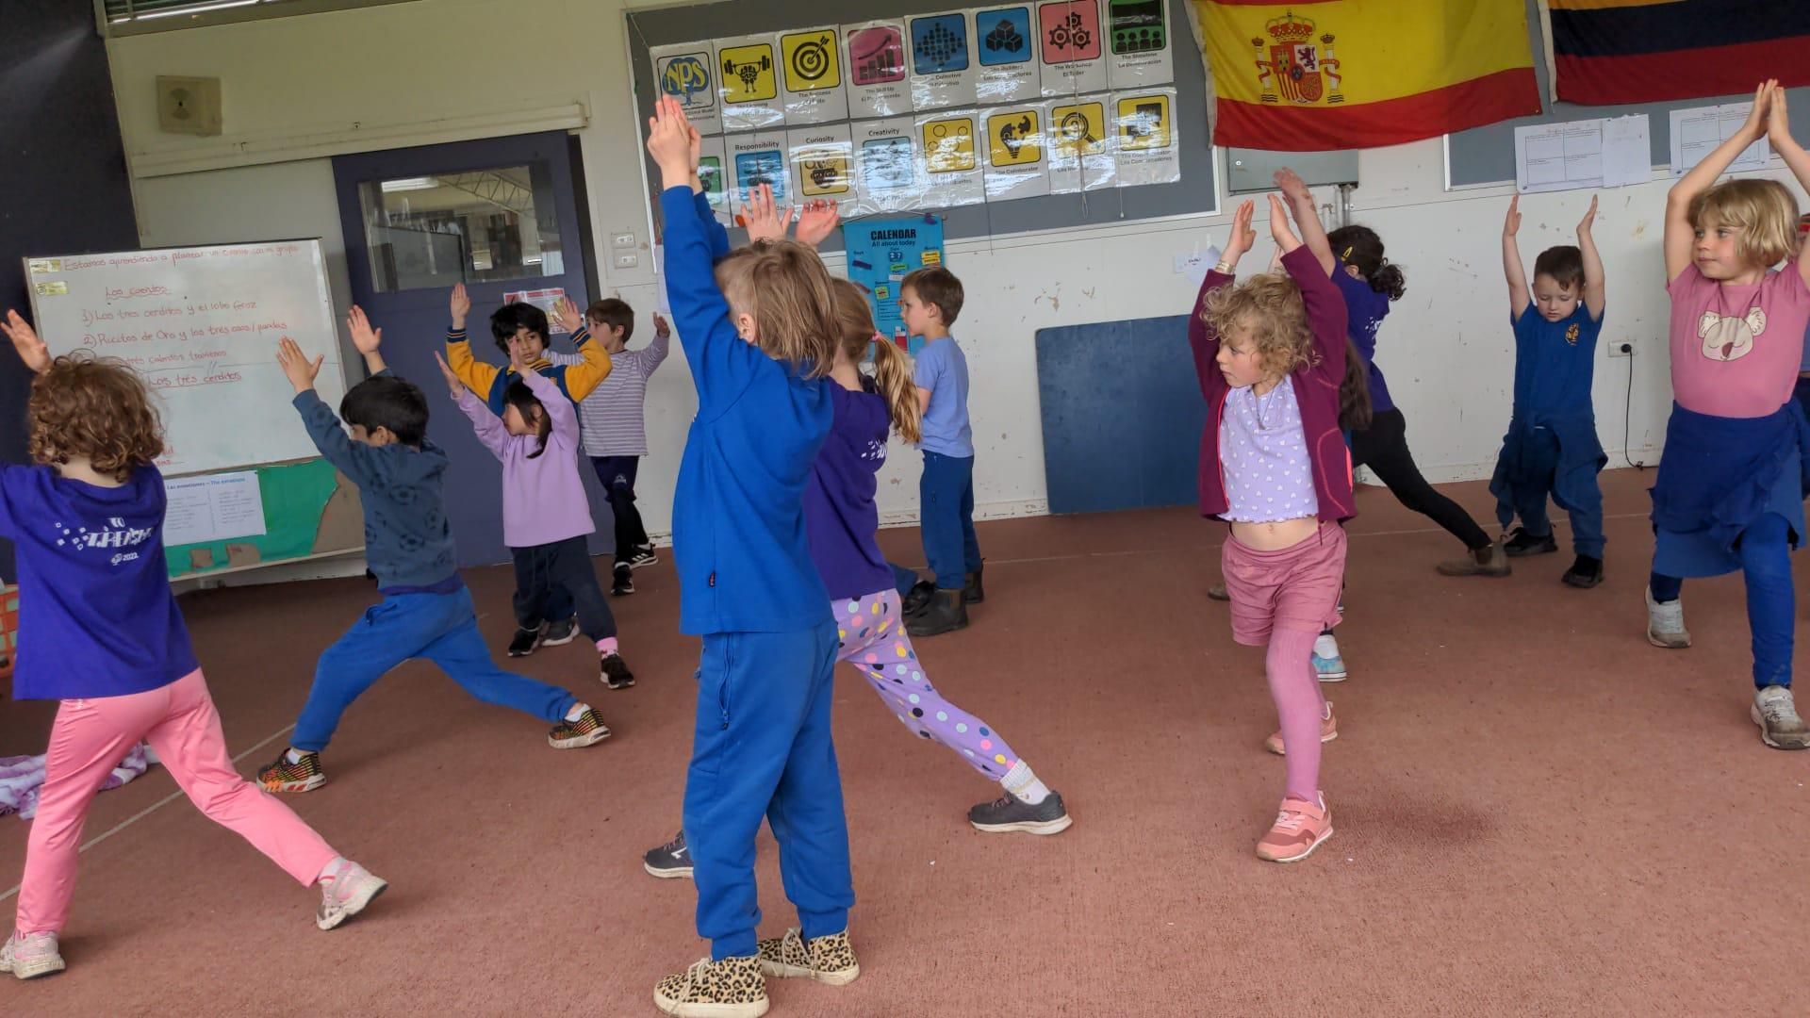

Also, I play musical instruments. It can get noisy during Performing Arts and Music lessons.

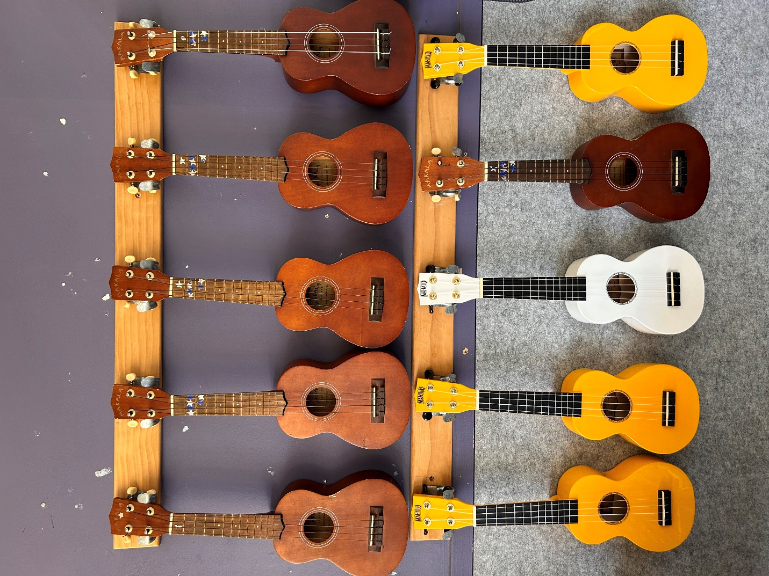

When we finish Music and the bell goes, I go outside to play.

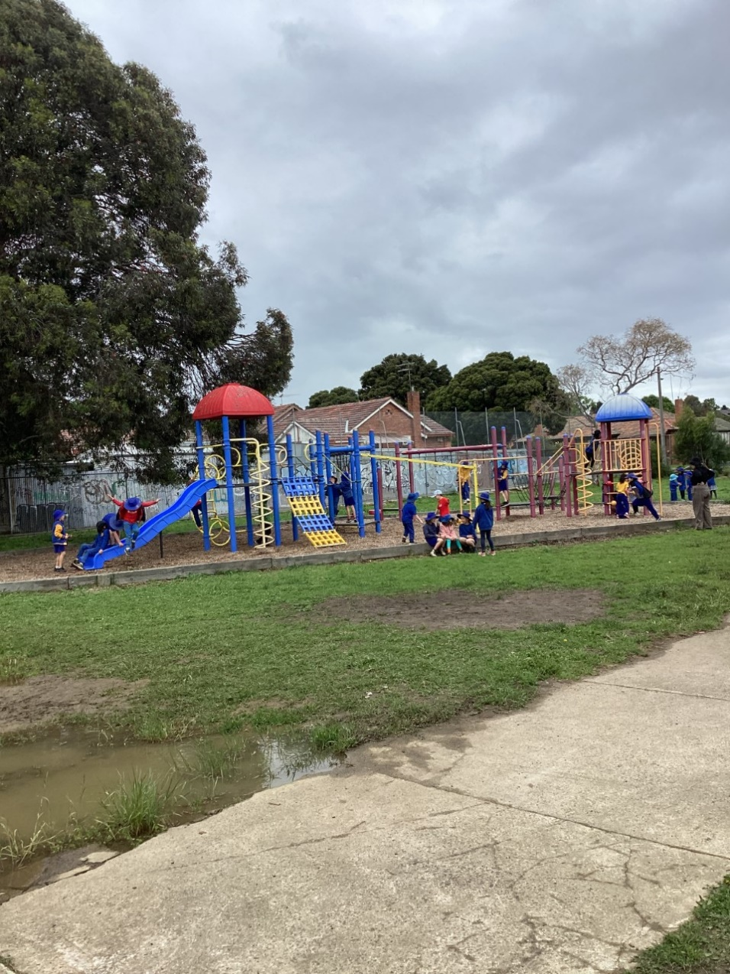

When the music rings, I line up at my room. Katherine and Paula takes FA and FB inside to eat lunch. I don’t share food with my friends.
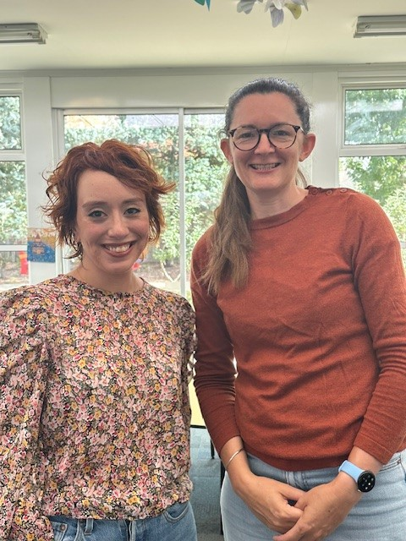

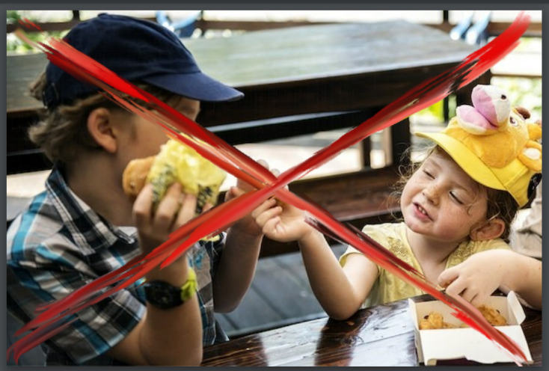
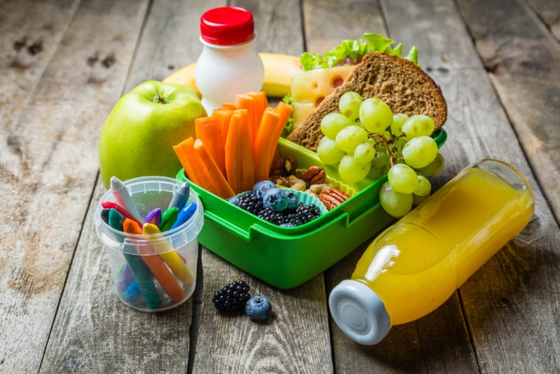

I spend the rest of the day with Katherine and Paula and we do really fun activities! Yay!

