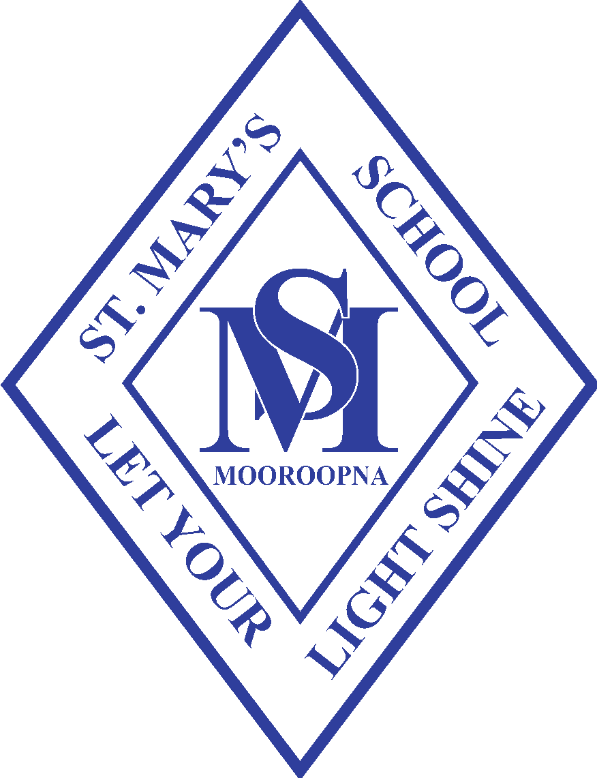
ST. MARY’S SCHOOL

McLennan Street, Mooroopna. 3629. Phone: (03) 5825 2858. Fax: (03) 5825 4026

“Let your light shine”

St. Mary’s Primary School Statement of Commitment to Child Safety

Reviewed: Term 2 2020
Ratified by School Board: TBA
NEXT REVIEW 2022

Commitment to Child Safety

All students enrolled, and any child visiting, have the right to feel safe and be safe in all school environments and outside of school hours. The wellbeing of children in our care will always be our first priority and we have zero tolerance to child abuse. We aim to create a child safe and child friendly environment where children feel safe and are free to enjoy life to the full without any concern for their safety.

The Statement is intended to provide the central focus for child safety at our School.
Our school sets out to be a school for the human person and of human persons. ‘The person of each individual human being, in his or her material and spiritual needs, is at the heart of Christ’s teaching: that is why the promotion of the human person is the goal of the school’. (Congregation for Catholic education 1997, par. 9)
St. Mary’s School holds the care, safety and wellbeing of children and young people as a central and fundamental responsibility of Catholic education. This commitment is drawn from and inherent to the teaching and mission of Jesus Christ, with love, justice and the sanctity of each human person at the heart of the Gospel.
Our School has a collective expectation for the protection of children. We are strongly committed to ensuring that all those engaged in our school promote the dignity of children and young people and their fundamental right to be respected and nurtured in a safe school environment. This is particularly so for the most vulnerable children, including Aboriginal and Torres Strait Islander children, children from culturally and/or linguistically diverse backgrounds, and children with a disability.
We believe we have a moral, legal and mission-driven responsibility to create nurturing school environment where children and young people are respected, their voices are heard and where they are safe and feel safe.
When allegations of abuse concerning children and young people are raised, our School will take prompt action to have these appropriately referred and investigated.
All Staff will strive for continual improvement that is responsive to emerging thinking, evidence and practice, so as to eliminate the possibility of abuse occurring in the first place.
We understand that creating child-safe school environments is a dynamic process that involves active participation and responsibility by our school, families and community We acknowledge it is marked by collaboration, vigilance and proactive approaches across policies, procedures, curriculum and practices.
Every Staff member has the responsibility to understand the important and specific role he/she plays individually and collectively to ensure that the wellbeing and safety of all children and young people is at the forefront of all they do and every decision they make.
We strive to provide a safe and nurturing culture for all children and young people in our school ( As defined by the Victorian Government Special Gazette No. 2 (2016), ‘children and young people’ in this document refers to those children and young people enrolled as students in Catholic schools in Victoria. Catholic Education )
We commit to providing a safe and nurturing culture for all children and young people by:
- Upholding the importance of the safety and wellbeing of children and young people.
- At all times, the ongoing safety and wellbeing of all children and young people will be the primary focus of care and decision-making, with particular attention paid to the cultural safety of Aboriginal and Torres Strait Islander children and children from culturally and/or linguistically diverse backgrounds, as well as the safety of children with a disability.
- Creating and maintaining a safe and nurturing culture, our School will actively and continually develop and review all policies, processes and practices, informed by emerging thinking and evidence.
- Empowering families, children, young people and staff to have a voice and raise concerns.
- Our School, in partnership with families, will ensure children and young people, are engaged and active participants in decision-making processes, particularly those that have an impact on their safety. This means that the views of staff, children, young people and families are taken seriously and their concerns are addressed in a just and timely manner. Children and young people are also provided with the necessary skills and knowledge to understand and maintain their personal safety and wellbeing. Implementing rigorous risk-management and employment practices.
- Our Leadership Team / Staff will systematically and continually identify and assess risks to child safety and will eliminate (where possible) or reduce all potential sources of harm.
- We will promote effective risk management which will be embedded in school life through effective, transparent and well-understood policies, procedures and practices.
- St. Mary’s School will employ highly competent and professional staff who are formed and challenged to maintain the safety of all students. The high-quality of staff appointments will be upheld through rigorous employment and staff review processes and practices.
- We will be guided by the directives of Catholic Education Victoria and will stay abreast of current legislation and will meet our legislative duties to protect the safety and wellbeing of children and young people in our care, including the Victorian Child Safe Standards (Victorian Government 2016), mandatory reporting, grooming, failure to disclose and failure to protect requirements.

