CAREER NEWS Friday 18 September

 Dates to Diarise in Term 4
- Year 12 VTAC late applications – throughout 29 September – 30 October
- VTAC SEAS and Scholarship applications – throughout September and early October

 Reminder: VTAC 2027 Upcoming Key Dates
SEAS Applications | Friday 9 October 2026
VTAC Scholarships | Friday 9 October 2026
ATARs Released | Thursday 10 December 2026
Change of Preference (CoP) closes | Saturday 12 December 2026
December Round Offers | Wednesday 23 December 2025
January Round One Offers | Wednesday 13 January 2027
January Round Two Offers | Wednesday 27 January 2027
February Offer Rounds | Wednesday 3 February 2027 onwards

For a full list of cancelled, amended, and new courses, visit VTAC Course Updates.

The VTAC website is VTAC

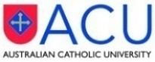 Bachelor of Educational Studies
The Bachelor of Educational Studies allows students to take their first step towards teaching or other education-related fields. This course is a pathway for students who are passionate about becoming teachers but do not meet the admission rank for their desired pre-service teacher degree.
Eligible students who successfully complete their first year of study (subject to meeting certain progression and non-academic requirements) may apply for transfer into the second year of the Bachelor of Education suite of courses.
This 3-year degree allows students to gain the necessary knowledge to pursue a career in corporate training, educational consultancy, online learning, vocational and community education, curriculum writing, youth services or adult learning, but will not lead to early childhood, primary or secondary teacher registration in Australia. Should teaching be the end goal, students who complete the Bachelor of Educational Studies can progress to a postgraduate Initial Teacher Education qualification.
Find out more at Bachelor of Educational Studies.

 Pathways into the Bachelor of Education
There’s more than one way to become a student with Monash. Students who are interested in becoming a teacher, but do not meet the entry requirements for the Bachelor of Education (Honours), Monash offers a range of pathway programs to help students achieve their goal.

There is a wide range of pathway options available, so students need to consider their reasons for completing a pathway and where they hope to end up. Students are urged to find out what pathway programs will suit your circumstances by browsing the links below.
- Diploma of Tertiary Studies (DoTS) – domestic students only
- Diploma of Higher Education Studies (DoHE) - domestic students only
- Monash College Diploma – domestic and international students

Students are encouraged to browse Pathways into the Bachelor of Education.

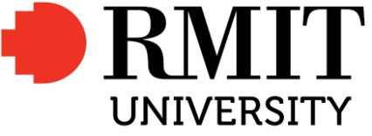 ATAR for On-Shore International Students
For any International Students who may be studying Year 12 in Australia, we now have a course search page aimed at showing them the required ATAR for their chosen study area.
RMIT has launched a very useful page where onshore International students can determine the ATAR selection rank applicable to the courses they are considering.
Visit ATAR for International Students Studying Year 12 in Australia - RMIT University.

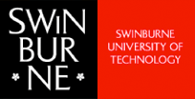 Associate Degree of Applied Technologies
The Associate Degree of Applied Technologies is an engineering and digital technologies course designed to prepare students for the profession as a para-professional engineer or technologist in the context of Industry 4.0, as well as provide a pathway for graduates to articulate into a degree course.
The course provides students with the core concepts in a range of engineering disciplines and equips them with the practical skills and in-depth knowledge to become a technical expert in sectors such as manufacturing, IT, engineering and more.
This two-year course provides an excellent pathway into the Bachelor of Engineering (Honours) with credit for units already completed.

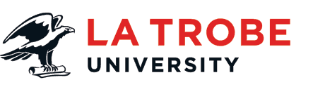Course Updates
- Sport and Exercise Science/Food and Nutrition Double Degree
Now open for 2027, this four-year double degree combines exercise physiology and nutrition science and is designed for health/science-interested students. The course includes 150+ placement hours, and also pathways to Dietetics, Exercise Physiology or Sport Analytics postgraduate studies.

Find out more at Bachelor of Sport and Exercise Science/Bachelor of Food and Nutrition.

- Diploma of Engineering Technology
La Trobe is introducing two streams within Civil and AI, providing pathway options into the Bachelor of Artificial Intelligence Engineering (Honours) and Bachelor of Civil Engineering (Honours).
Entry into this diploma is VCE: Units 3 and 4: a study score of at least 20 in any Mathematics.
Units 3 and 4: a study score of at least 25 in English (EAL) or at least 20 in English other than EAL, and no ATAR is required.
Find out more at Diploma of Engineering Technology.
- Changes to Prerequisites into Paramedicine
Students considering studying the Bachelor of Paramedic Practice with Honours should note that several prerequisite subjects for this course have been removed. From 2027, the prerequisite is: VCE: Units 3 and 4: a study score of at least 30 in English (EAL) or at least 25 in English other than EAL.

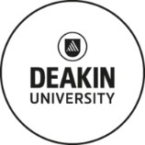 New Business Double Degrees
Deakin is introducing two new double degrees that sit alongside existing combinations such as Bachelor of Arts/Bachelor of Business and Bachelor of Criminology/Bachelor of Business, giving students even more ways to combine their interests, build a distinctive skill set and shape a career that reflects how they want to work.
- Bachelor of Business/Bachelor of Communication
This double degree combines professional business capabilities with professional communication expertise, equipping graduates with a versatile skill set valued across industries. Work integrated learning is a core part of the degree, with domestic and international internships and volunteer experiences that build meaningful professional networks, supported by research-active academics and Deakin Business School’s AACSB and EQUIS-accredited facilities, including the state-of-the-art Deakin Trading Room.
Students can choose a communications major in advertising, public relations, journalism or digital and social media, then pair it with a business major in marketing management, human resource management, project management, entrepreneurship and innovation, business management or AI and business information systems.
Find out more at Bachelor of Business/Bachelor of Communication.

- Bachelor of Design/Bachelor of Business
This double degree brings creative and commercial thinking together, designed for students who want to develop ideas that are both meaningful and commercially sound. Students build design expertise focused on understanding people, solving real problems and creating engaging solutions for audiences, alongside a solid grounding in business fundamentals.
Students choose a double major across the degree: in design, from communication design or interactive and UX design; in business, from areas including business management, AI and business information systems, entrepreneurship and innovation, human resource management, marketing management and project management. Core units, an employability sequence and electives round out this progressive double degree.

Find out more at Bachelor of Design/Bachelor of Business.

 Bachelor of Engineering Course Update
The mathematics prerequisite for all Bachelor of Engineering degrees offered at Federation University has been updated to include General Mathematics, in addition to Mathematical Methods and Specialist Mathematics. This change aligns our entry requirements with those of other universities.

This course includes the ATAR as part of its selection criteria. Applicants must have:
• Units 3 and 4: a study score of at least 20 in any English, and
• Units 3 and 4: a study score of at least 20 in Mathematics: Mathematical Methods, or
• Units 3 and 4: a study score of at least 20 in Mathematics: Specialist Mathematics, or
• Units 3 and 4: a study score of at least 20 in Mathematics: General Mathematics.

 Paramedicine Degrees in Victoria in 2026
The Good Universities Guide states that paramedics provide pre-hospital emergency care, treatment and specialised transport for patients - Good Universities Guide - Paramedic.

Working as an ambulance paramedic means that no two days are ever the same. What a paramedic does can be as varied as restarting a patient’s heart down to helping solve social welfare issues. Ambulance paramedics are called when people feel they have no other options and are suffering what feels like an emergency to them. An interesting fact to remember when applying to become a paramedic is that the majority of the workload is not lights and sirens driving to save a patient's life. This job is more about helping people in their time of need as opposed to being a hero.
Visit Ambulance Victoria - Types of Paramedics to find out more.
Students should note that to work with Ambulance Victoria, they must be a citizen of Australia or New Zealand, or be an Australian Permanent Resident, and they must also hold a full driver’s licence or have held a probationary licence as P2 for at least a year - Ambulance Victoria - Careers.
The following Victorian universities offer Paramedicine undergraduate degrees.
INSTITUTION | COURSE | VCE REQUIREMENTS | ATAR 2026
Australian Catholic University  (B) – Ballarat  (M) – Melbourne | Paramedicine | Units 3 and 4: a study score of at least 25 in English (EAL) or at least 25 in English other than EAL. | 88.10 (M)
 | Nursing/Paramedicine | Units 3 and 4: a study score of at least 25 in English (EAL) or at least 25 in English other than EAL. | 84.65 (B)
La Trobe University  (Be) – Bendigo | Paramedic Practice with Honours | Units 3 and 4: a study score of at least 30 in English (EAL) or at least 25 in English other than EAL; Units 3 and 4: a study score of at least 20 in two of Biology, Chemistry, Health And Human Development, any Mathematics, Physical Education, Physics or Psychology. | 65.25 (Be)
Monash University  (P) – Peninsula | Paramedicine | Units 3 and 4: a study score of at least 30 EAL, or at least 25 in English other than EAL. | 82.05 (P)
Victoria University  (St. A) – St. Albans  (Su) – Sunshine  (W) - Werribbee | Paramedicine | Units 3 and 4: a study score of at least 25 in English (EAL) or at least 20 in English other than EAL. | 68.05 (St. A)
 | Non-Emergency Patient Transport (Certificate) | Year 12 pass useful, 18 years old at start of course, and must hold a driver's Licence (probationary licence accepted). | N/P (Su)  N/P (W)
Visit VTAC to find out more about these courses.
 Courses offered by AIM – Melbourne Campus in 2026
The Australian Institute of Music (AIM) is a private music school totally dedicated to the pursuit of excellence in music – be it composition, performance, or even management.

AIM has campuses in Sydney and Melbourne, and courses offered in Melbourne include:
Bachelor of Arts and Entertainment Management – a 3-year course for anyone wanting to master the essentials of the music business – from marketing and artist management to music business economics and law.
Bachelor of Music (Composition) – 3-year course training students to become a composer with originality, heightened musical ability, and technical mastery. As digital media expands, so does the demand for talented composers in film, television, video games, and music.

Bachelor of Music (Performance) – a 3-year course whereby students get to refine their musicianship, develop their collaboration skills, and help them stand out as a performer. With both a contemporary and classical pathway, graduates will emerge with the skills and confidence to perform on stage and in the studio.

Bachelor of Music Theatre – a 3-year course preparing students to land leading roles, play in ensembles, and generate original theatre works as they steadily build their professional performance skills. They will build the skills to command the stage with confidence, building the ‘triple skill set’ – singing, dancing and acting.

Find out more about AIM and all its course offerings by browsing Australian Institute of Music (AIM)

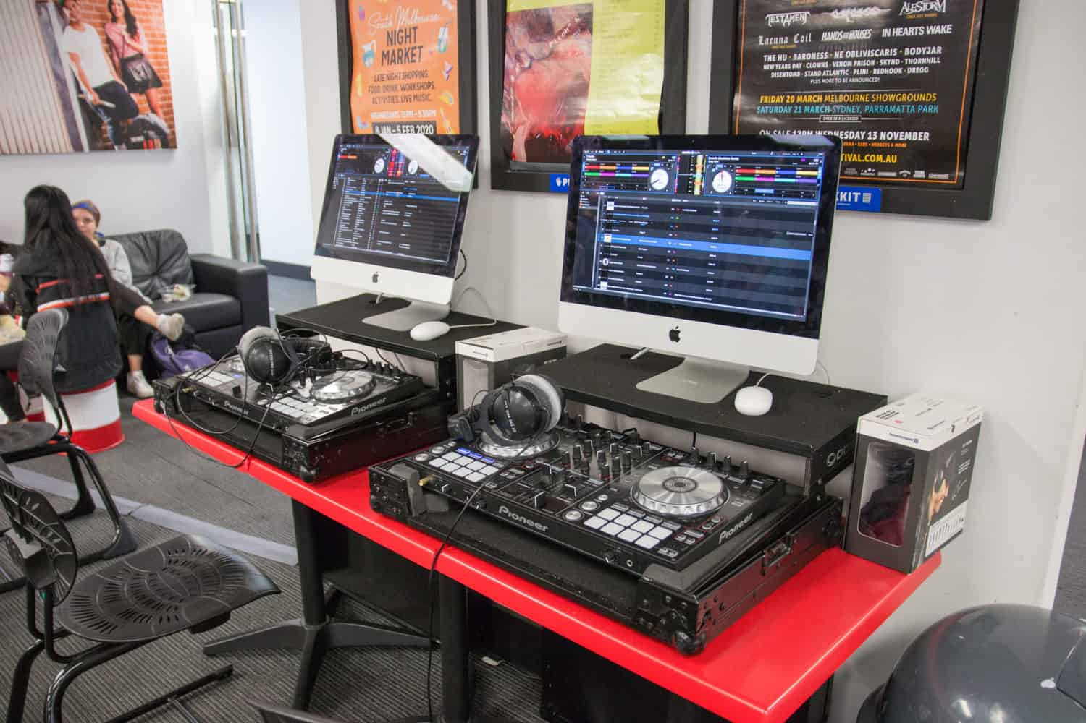
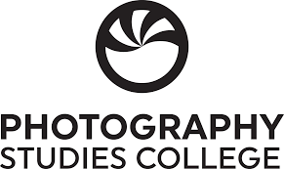 Snapshot of Photography Studies College (PSC) in 2026
- For over 40 years PSC has provided students with an environment in which to explore their creativity, see the world anew and give expression to what they see.
- PSC is a leading photography college.
- PSC offers a number of programs, some of which are designed to get students into the industry before they have completed their studies.
- The lecturers at PSC are experienced practitioners and educators with national and international profiles in the areas of documentary, photojournalism, art, commercial photography, photobook publishing, curation, and photographic theory.
- PSC offers a range of programs from full-time courses to short courses, and workshops.
- Full-time undergraduate courses on offer include -
Bachelor of Photography and Digital Imaging
Diploma of Screen and Media

Undergraduate Certificate of Digital Imaging

- There are often some part-time, short courses, and online courses on offer too.

