Okonomiyaki (Japanese Pancake)

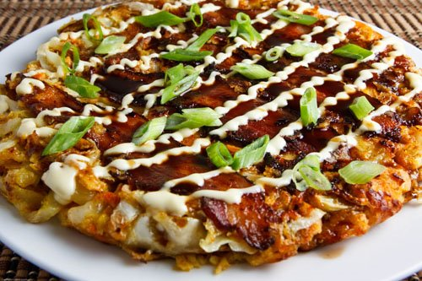

Recipe source: www.closetcooking.com

Season: All year

Type: snack

Difficulty: Easy

Serves: Serves 20 to taste

- Large bowl  - Measuring cups and spoons  - Sharp knife  - Chopping board  - Large frypan  - spatula | Ingredients  - 1 and 1/2 cups flour (whole wheat preferably)  - 1 cup dashi or beef stock  - 2 eggs  - 1/2 of a cabbage, about 3-4 cups packed, shredded very finely  - 2 carrot, grated  - 1 small zucchini, grated  - 2 green onion, sliced  - okonomiyaki sauce (or Worcestershire sauce) to taste  - Japanese mayonnaise to taste  - green onions to taste, sliced  - 4-5 slices bacon, chopped finely
  Equipment

What to do:

- Place bacon pieces in a frypan with 1 tbsp of oil. Gently fry bacon pieces until they nearly turn brown.
- Mix the flour, dashi, egg, cabbage, carrot, zucchini, cooked bacon and green onion in a large bowl.
- Heat 1 tbsp of oil in pan.
- Pour in individual tablespoons of mixture. Make enough for 1 per person in class.
- Cook on medium heat until golden brown on both sides, about 5-15 minutes per side.
- Top with okonomiyaki sauce, mayonnaise and green onion slices.

