

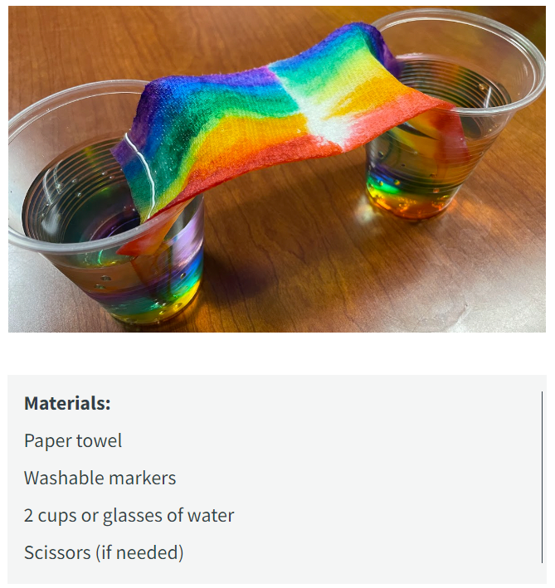 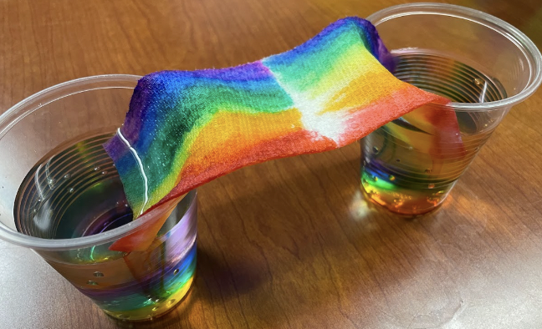

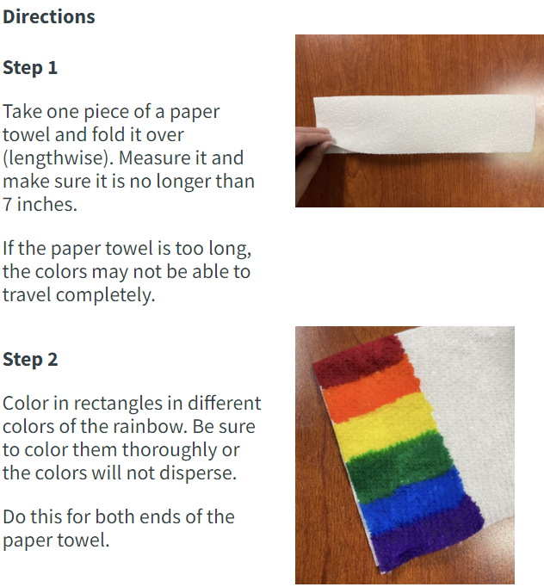

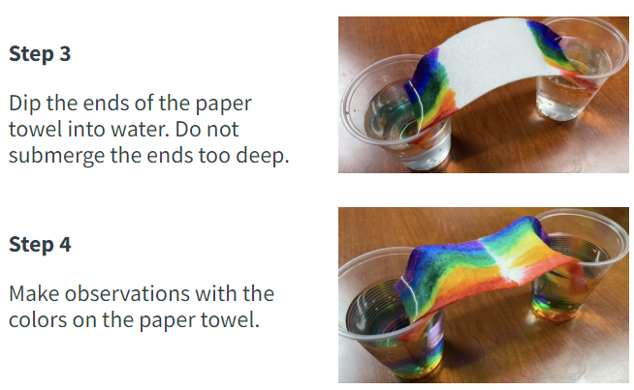

JUMPING PEPPER EXPERIMENT

**Materials:**

* Shallow bowl
* Water
* Pepper
* Liquid soap in small cup/bowl

**Procedure:**

1. Fill the bowl with about an inch of water.
2. Sprinkle pepper evenly across the surface. The pepper flakes should float, not sink, upon the surface of the water.
3. Place your finger in the water. What happens (pepper sticks to finger)
4. Place your finger in the dish soap then in the water. What happens (pepper moves away)

**Results:**

The soap makes the pepper flakes dart away. It may have looked like the soap was chasing the pepper flakes away.

**Why?**

The first question to ask is why the pepper flakes float. Why don’t they sink or dissolve in the water? Well, pepper is **hydrophobic**, meaning that water is not attracted to it. Because of that, the pepper can't dissolve in the water. But why do the flakes float on top of the water? Water molecules like to stick together. They line up in a certain way that gives the top of the water surface tension. Because pepper flakes are so light, and hydrophobic, the surface tension keeps them floating on top.

The next question to think about is why the pepper shoots to the sides when soap touches the water. Soap is able to break down the surface tension of water—that’s part of what makes soap a good cleaner. As the soap moves into the water, and the surface tension changes, the pepper no longer floats on top. But the water molecules still want to keep the surface tension going, so they pull back away from the soap, and carry the pepper along with them.

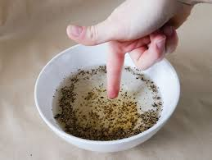 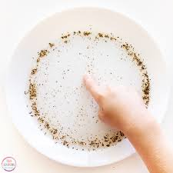

**DRY ERASE MARKER MAGIC**

 