Vegetable Macaroni Bake
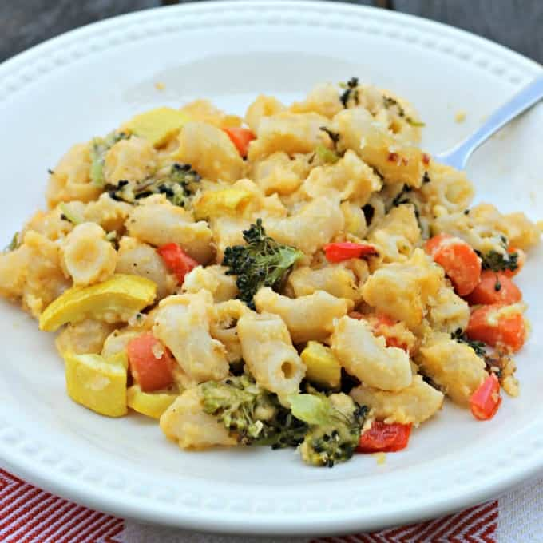

Ingredients:
250g Macaroni
70g Butter
1/3 cup plain flour
450ml Milk
100g grated cheese
¼ tsp mustard
1 Tbs garlic
½ carrot
100g mushrooms
½ red capsicum
½ zucchini
¼ broccoli (cut into small pieces)
½ tsp dried oregano

Method:
- Cook the macaroni in boiling water until tender (done for you)
- Melt half the butter in a pan, stir in the flour and cook for a minute
- Gradually add the milk and bring to a boil, stirring constantly until thickened
- Stir in just over half the cheese and mustard
- Melt the remaining butter and add the garlic and carrots
- Fry gently for 3-4 minutes then add the red capsicum to cook for 2 minutes. Add the zucchini, broccoli, seasonings and herbs and cook another 2 minutes
- Combine the macaroni and vegetables with the cheesy sauce until all the sauce is evenly mixed. Pour into 3 individual foil containers
- Sprinkle with the remaining cheese and cook in a hot oven (200 C) for 20 minutes until bubbling and brown

