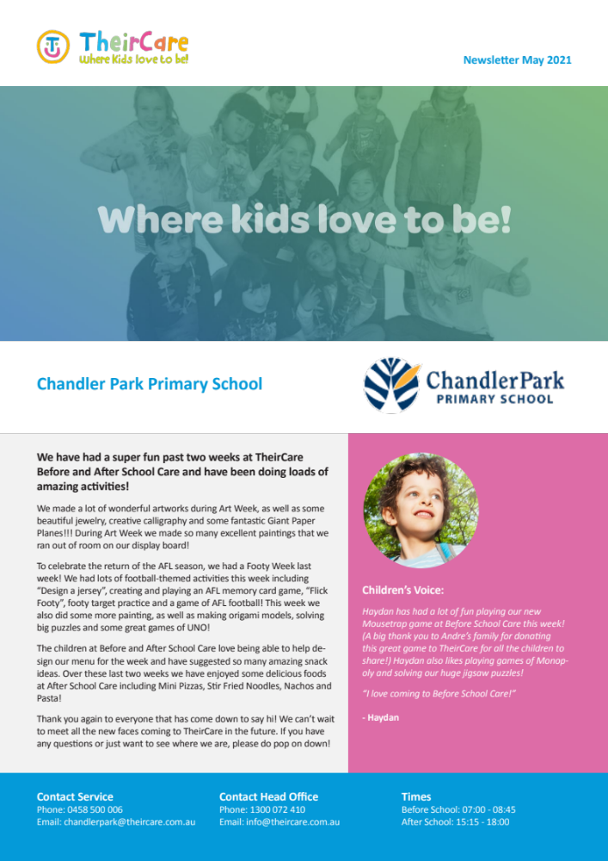

Newsletter Week 4 Term 4 2021
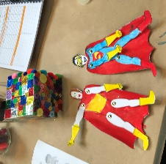
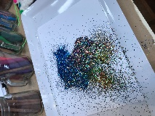
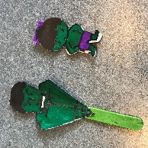
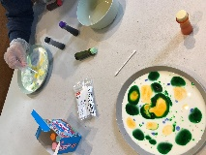
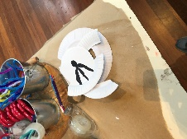
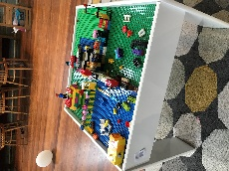
Contact Service | Contact Head Office | Times
Phone: 0475 577 404 | Phone: 1300 072 410 | Before School: 7:00am – 8:45am
Email: stmarysstkilda@theircare.com.au | Email: info@theircare.com.au | After School: 3:30pm – 6:00pm

St Marys Primary School St Kilda
Time to be a hero! Superhero Week.
Theircare celebrated the National Superhero Week from the 11th to the 15th of October (Week 2), as part of the awareness program of Muscular Dystrophy Australia. The activities were based on Arts & Crafts, and sport activities related to the topic. Superhero Hunt was popular through the week, where our children had to find the superheros hidden in the hall. They loved scavenger hunt games! Also, we did some superheros and villains puppets with paper and pipe cleaners. Lego as construction game was enjoyable during this week and our children were building houses. In addition, our children were making patterns with Glitter & Pompom Art. We had a good weather this week to do physical activity in the playground and doing some shots of basketball. A lockdown drill was done as part of the OHS plan.
Lost in Space.
During week 3, we went to the Space to celebrate the World Space Week related to science, technology, and contribution to the betterment of the human condition. The activities were focusing on science experiments, rockets challenges, astronaut and alien puppets, making our own galaxy, learning about the moon phases and planets. Our children shown their initiative with their interest of group games such as ‘Red Light, Green Light’, ‘Giant Treasure’, colouring, sensory activities such as playing with the Canadian sand, making aliens with Glitter Art, and building houses with Lego.

Coming Soon: Toy Library support to Theircare

TheirCare is pleasure to announce the support from the Toy Library, providing children opportunity to learn and engage with ‘Robotics kits’ into the service during term 4.
Implementation of Suggestion Box.

Theircare would love to hear from you! Come and give to us your feedback about our service!

Kids Art Gallery

