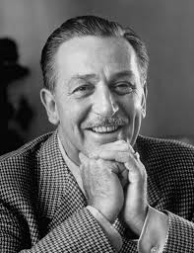Walt Disney is the creator of Disney. He was a very famous man that made cartoons that everybody loved.

Walt Disney grew up on a farm near Marcelen. He loved to draw and was very play full. When he was only seven he was selling sketches to the neighbours and ended up in the paper.

Walt had a younger sister named Ruth three brothers named Herbourt Ray and Roy a mom named Flora and a dad.

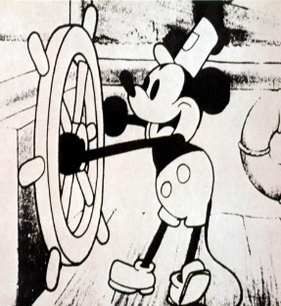

Walt worked as a artist but wanted to do something bigger so he opened his own animation studio and made kid cartoons his first show was Mickey Mouse.



He continued to make shows than opened Disney Land.

Unfortunately Walt died at 65 while working on another park.