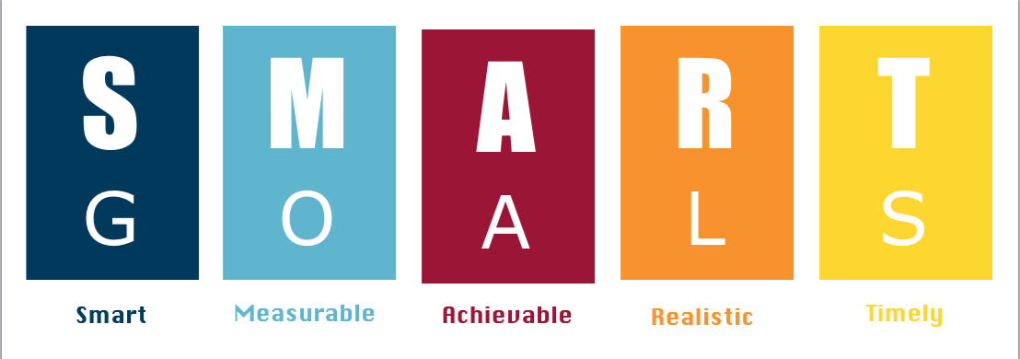
Term 2 - SMART Goals - 2022
Name:
TA:

In Term 1, I was able to demonstrate the following:
(Circle the areas you have mastered)
- I am an active listener and learner. I attempt and participate in all classroom/elective learning activities
- I am self aware, I don't just sit. I seek out by asking for help and support in class
- I show respect to my peers and my teachers during class discussion
- I am always prepared and ready to learn with my learning tools: pen, appropriate book, device, diary, laptop charged
- I'm open to feedback about my learning and my classroom behaviour
- I always complete my assessment tasks and learning by their due dates

Gratitude: In Term 1, I was able to demonstrate gratitude by:
(Colour the areas you have mastered)
- I am able to look for the things I have and what others do not have
- I aim to attempt all learning experiences no matter if it is challenging
- I aim to show an appreciation for my work, even when it might not be engaging/uninspiring
Empathy: In Term 1, I was able to demonstrate empathy by:
(Colour the areas you have mastered)
- By being respectful and only using kind words to all members at St Augustine's College
- I am able to understand how important it is to remain positive to all people, no matter the situation.
- I understand that at times, my behaviour can have an impact on my peers and my teachers
- I am able to understand the impact that my actions can have towards others at school
- I am able to develop and show empathy towards others by seeing things from a different/their perspective
- I am able to grow and learn from negative and challenging experiences by using these experiences as learning opportunities
- If I am showing red zone emotions, I attempt to use my strategies

Mindfulness: In Term 1, I was able to demonstrate mindfulness by:
(Circle the areas you have mastered)
- I rely on my teachers to help me remain and/or return to the Green zone
- I use my own strategies (such as: music, drink) when I am in the other Zones (Blue, Yellow and Red)
- I am aware of the impact screen time has on my brain and my mood
- I am aware that movement enables me to become more aware of my body, especially any form of physical education
- I am aware that my food choices could impact my thoughts/feelings

Term 2 - SMART Goals - 2022

What does academic learning mean?
Academic learning is about specific subjects or topics that you are learning about.
Am I confident with my multiplication skills?
Am I confident writing information texts?
Am I confident in spelling new vocabulary?
Am I confident reading fluently out loud?
Am I confident in completing my homework?

After reading your Term 1 report (SIMON), what successes did you experience in Term 1 2022?
1.
2.
3.

After reading your Term 1 report, what are two things you could improve on with your academic learning for this term?
1.
2.
3.

Goal 1 - Academic Learning
What do you need to work on?  (Specific) | How will you know when it is achieved?  (Measure) | List three steps you will take to achieve your goal?  (Achievable) | Why is this goal important to you?  (Realistic) | How long will it take you to achieve your goal?  (Time)
Example: Being mindful of who I am sitting with, if they are distracting me. | When Mr Poppa is not saying my name.  I am able to consistently perform the action  I am not relying on my teachers or my peers  The teachers in aren't saying my name as much | -Looking at where I am sitting.  -Taking the time to do the task well.  -Asking instead of disrupting. | So I can achieve more and get into less trouble. | 10 weeks.

Goal 2 - GEM Learning
What do you need to work on?  (Specific) | How will you know when it is achieved?  (Measure) | List three steps you will take to achieve your goal?  (Achievable) | Why is this goal important to you?  (Realistic) | How long will it take you to achieve your goal?  (Time)
Example: If I am showing red zone emotions, I attempt to use my strategies | My teachers will prompt and ask me to use my strategies and my tools | -I will feel calm  -I will be able to have an appropriate conversation | I want to feel calm when I walk into the classroom | 5 weeks.
