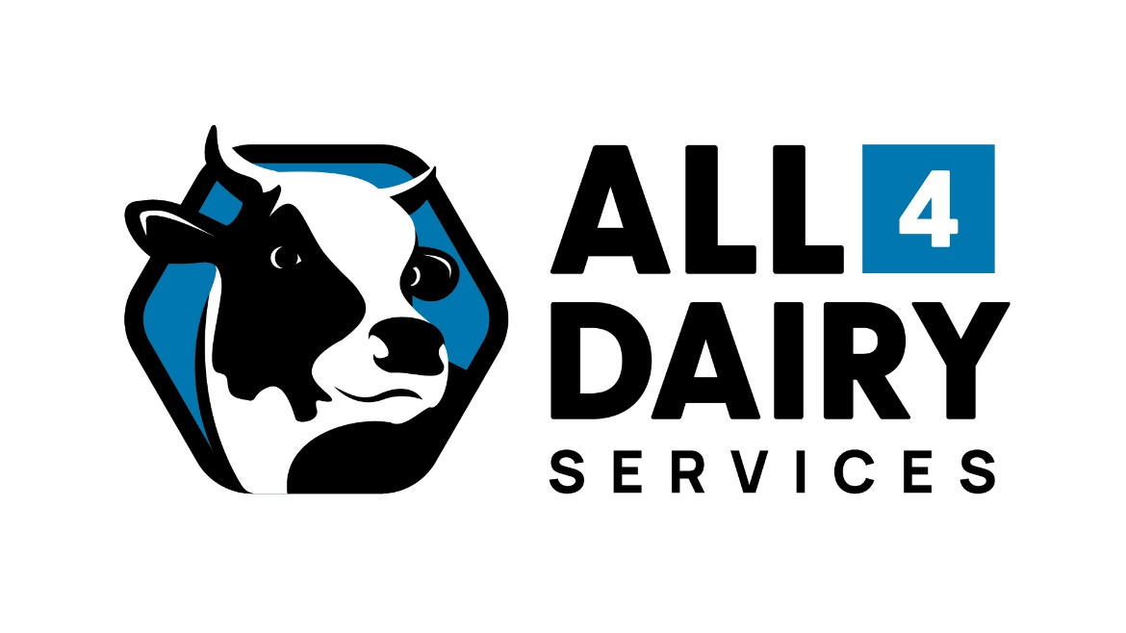

All 4 Dairy Services (an up-and-coming new local dairy business) is seeking an Apprentice to join the team. The desired applicant will be 16+ years, self-motivated, enthusiastic and punctual with a keen interest in the dairy industry and willing to work in a team environment. No experience necessary. The apprentice will attend trade school and complete a Certificate 3 in Metal Fabrication.

If this role sounds perfect for you, please email your resume and cover letter to admin@all4dairy.com.au

