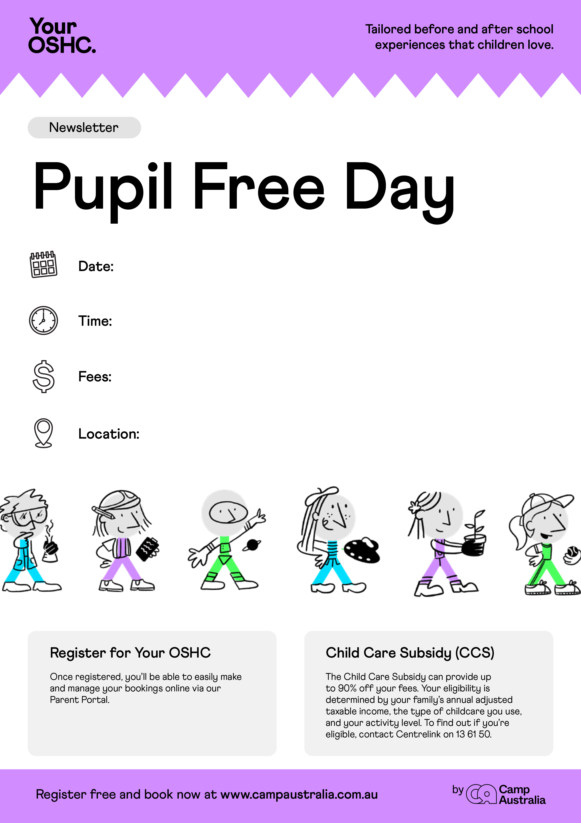[](https://pp.campaustralia.com.au/)

BAC Building (Where we normally run service)

$71-00 per day

6-45am to 6-30pm

30th January 2025