Solve:

2

9

Find x

Find Mean, Median, Mode, Range 8, 3, 5, 4, 7, 2, 2, 3, 7, 9, 3

Find the perimeter and area of the following shapes:

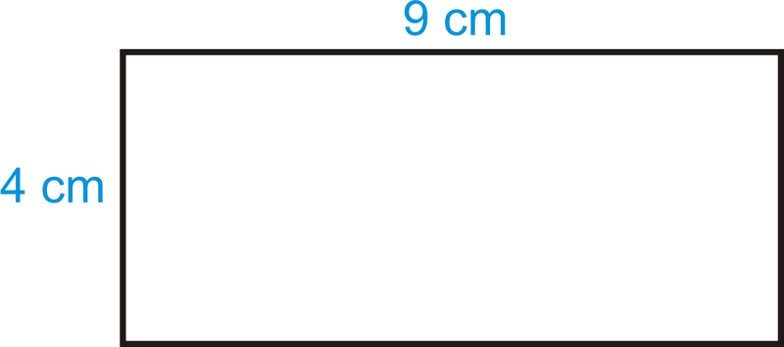

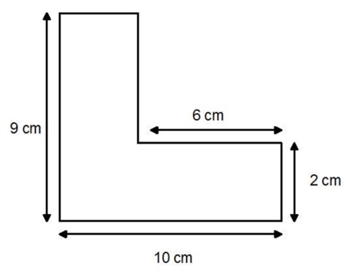

2 =208 =51

9=-

x=3 x=-5

**Mean Mode Median Range:**

Mean = 4.82

Median = 4

Mode = 3

Range = 7

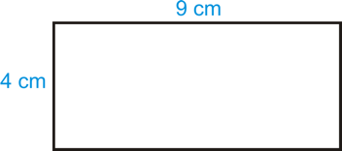

P= 12.57cm P= 2(4+9)= 26cm

A= 12.57cm2 A= 4x9=36cm2

P= 2(9+10)=38cm

A=(8x10)-(6x7)=48cm2