

Parent/Carer Newsletter
6

Child Safe Standard 6
Working together for Child Safety

‘’People working with children and young people are suitable and supported to reflect child safety and wellbeing values in practice.’’
As Catholic educators, we have a moral, mission-driven and legal responsibility to uphold and actively promote the wellbeing and safety of every student entrusted in our care. Our commitment to the protection of students involves ensuring families and community members actively participate in promoting and upholding child safety and wellbeing. Our Catholic communities develop, review and uphold robust systems, processes, and policies that support staff and volunteers to act with professionalism, integrity, and care; ensuring child safety and wellbeing are embedded in all aspects of school life.
This newsletter series provides an overview of what the Child Safe Standards are, how they are designed to help keep children and young people safe and what schools governed by Melbourne Archdiocese Catholic Schools (MACS) are doing to prioritise and achieve this.

Why is it important that all adults who work with children are suitable and supported?
Child Safe Standard 6
Child Safe Standard 6 reminds us that everyone who works with children has a responsibility to act with integrity, care, and trustworthiness.
As 1 Corinthians 4:2 teaches, “Now it is required that those who have been given a trust must prove faithful.ˮ This scripture highlights that safeguarding children is a sacred trust, and we are called to be faithful stewards of their wellbeing.
By ensuring that all staff, volunteers, and leaders are suitable, supported, and accountable, the standard helps us live out this trust every day,
creating a safe, nurturing environment where children can thrive.
Child Safe Standard 6 focuses on ensuring that adults are carefully selected, appropriately trained, and are supported to maintain high standards of child safety. It recognises that safeguarding is not just about rules, but about everyday behaviours, professional conduct, and living out our shared responsibility to protect children.

Everyone who works with or around children has a responsibility to act with integrity, care, and accountability. When staff, volunteers, leaders, and contractors are suitable, supported, and well-informed about child safety, children feel safe, valued, and able to thrive.

Schools can uphold high standards of safety and wellbeing when all adults understand their roles, follow clear expectations, and receive ongoing guidance and supervision. This shared responsibility ensures that children experience consistent, safe, and respectful interactions every day.


Working together for Child Safety

Parent/Carer Newsetter 6 2 of 2

What does this look like in a school environment?

- Recruiting safely: We ensure all staff undergo thorough screening, including thorough background checks, reference checks, and interviews, to make sure they are suitable to work with children. As part of this, we ensure that all staff hold and maintain appropriate professional qualifications and registrations, including current Working with Children Check (WWCC) or Victorian Institute of Teaching (VIT) registration, in line with the Workforce Screening and Accreditation Policy.
- Providing clear expectations: Everyone is informed about the school’s child safety policies and procedures, professional standards, code of conduct, and reporting responsibilities.
- Ongoing support and guidance: Staff and volunteers receive annual induction, professional learning, mentoring, and supervision to help them maintain safe and respectful practices.
- Accountability in practice: We encourage adults to speak up if they have concerns, follow clear reporting pathways, and model behaviours that prioritise children’s wellbeing. We also ensure that professional qualifications and registrations are maintained.

How Parents, Carers and Guardians can get involved!

Want to know more?
If you have any questions or would like to learn more about how we’re supporting child safety, please get in touch.

More information on the Child Safe Standards can be found via the Commission for Children and Young People (CCYP) website.

The Victorian Government has clear guidance around ensuring Child Safe Standard 6 is enacted in all schools, further information about how this standard to upheld and reviewed for every school can be found here.

The Federal Government developed a Child Safe Framework policy and in in May 2024 the Federal Government’s Department of Education released its updated Child Safe policy.

Child Safe Standard 6 ensures that all adults are carefully selected, appropriately trained, and supported in keeping children safe.

Families can help by:

- Knowing who works with your child: Be aware of the staff, volunteers, and other adults involved in your child’s learning and care
- Asking questions: Check that adults in your child’s life have the training and support to maintain child safety standards
- Staying informed: Read updates from the school about professional learning and child safety initiatives
- Partnering with the school: Share observations, concerns, or ideas that might help all in our community ensure interactions are safe and supportive.


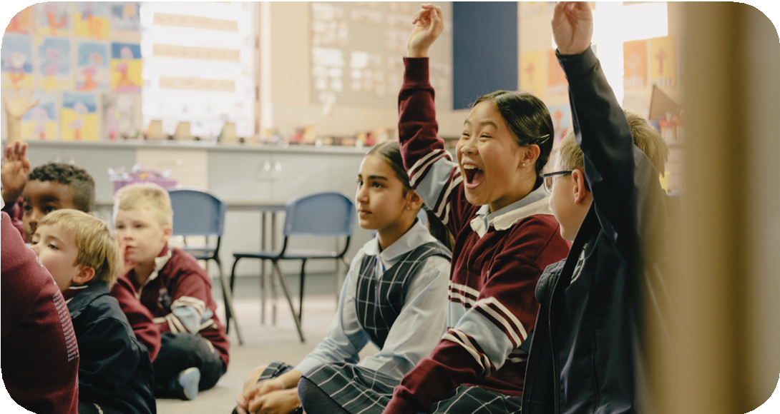

Working together for Child Safety

