This image is about the excitement that can come from starting anew and exploring.

This image makes me think of new beginnings; a place where everyone can be anyone that they that so wish.

The stars are like the calm that comes with new beginnings

‘Country’ Collage:

This image has a similar meaning to the one next to it. That there is always an opportunity for a fresh start

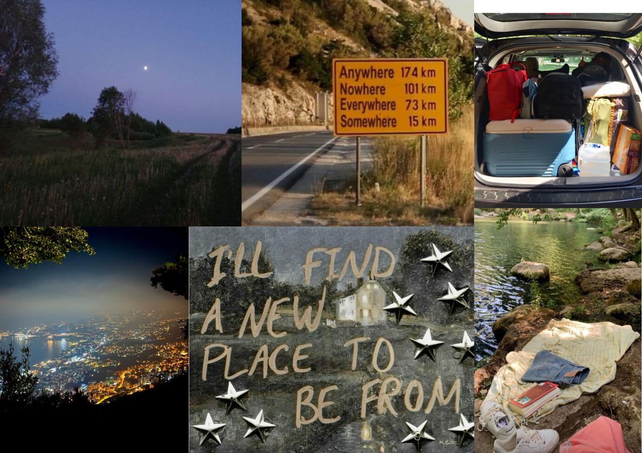

From this image I get a sense of reflections on the past whilst also living in the moment. The ability to take the time to think and to better understand ones own life, and the life of others around them.

I like this quote as it is as if the person who wrote it never gave up. When things get rough instead of giving up, continuing to pursue happiness: if not in one place than finding another.

The city lights in this image represent all of the new opportunities that come with starting fresh at an alternate place than where one once came from. That whilst it can be overwhelming at times, it can also bring a sense of reassurance and calming to oneself.