Reading is an important part of life
Children need good reading skills to be able to perform well at school and set them up for success in the future.
The student2student program may benefit your child if they need help with their reading and has helped many children take big steps forward with their reading skills.
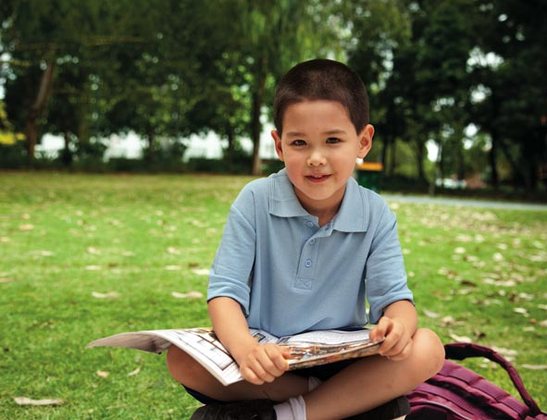
How it works
Your child will be matched with a buddy who is a student at least two years older than them.
The buddy has been trained to help others improve their reading skills and is from another school.
The student2student program runs over an 18 week period.
During this time, the buddy will ring your child 2 to 3 times a week and listen to them read for at least 20 minutes each time.

It is important to be committed to the program to get the best outcome.
To protect everyone’s privacy, you will only know each other’s first name.
The program has 3 delivery models and eligibility requirements as outlined in the Application Form attached:
- Landline
- Digital
- Mobile
When children improve their reading skills, they also improve their confidence and self-esteem.

“The best part was that a girl called in every week and helped me with my reading and I thank her so much.” Reader
“It was when I could read good books and my spelling got better. I am more confident about myself and my reading and plus I didn’t get bored at home.” Reader

How to get involved
If you would like your child to be considered for the program, please complete and return the attached Application & Consent Form.

For further information, please contact your Program Coordinator
Steve Palmer
0468 528 209 stephen.palmer@thesmithfamily.com.au

