CONGRATULATIONS!!!
HEADSTART team offer congratulations to Aisha Ashby, Alexis Watts, Georgia Prys, Payman Akbari and Omer Coruk who have successfully navigated the demands of completing their senior studies, whilst forging ahead in their chosen careers. They now transition into full time employment having established their apprenticeship with the support of the HEADSTART program. These year 12 graduates have an established pathway which is particularly important in an uncertain and unstable labour market.
As an overview, HEADSTART is an exciting program which assists students to identify their career path and then supports them into work-based learning (apprenticeship / traineeships). Students will become qualified in their chosen field whilst also completing their senior studies and be awarded their year 12 certificate. Another benefit of the program is that it allows employers an opportunity to invest in the development of young workers, by presenting students with real life work experiences.

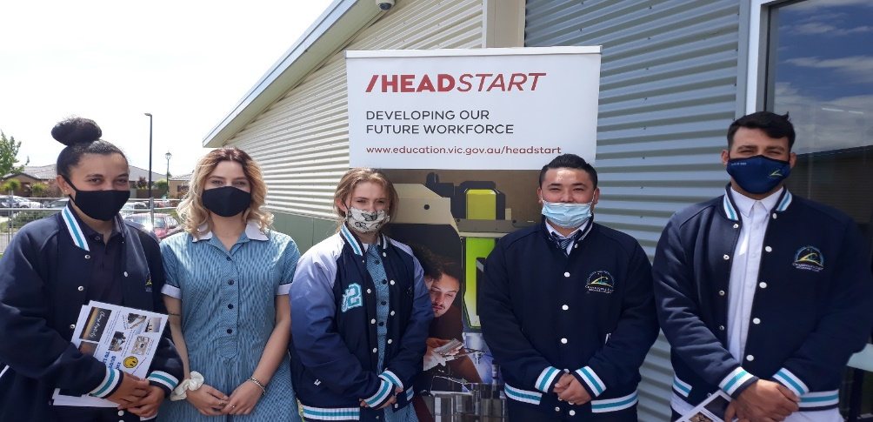
“HeadStart has offered our students an amazing opportunity. For students to be able to remain at school to complete their Year 12 Certificate and at the same time start their Apprenticeship/ Traineeship in their chosen industry. With the security of leaving school and already having a full-time employment in place they are in a very fortunate situation, especially in the current climate of rising youth unemployment. I have seen huge growth in these students both academically and personally, as they have learned to balance the competing demands of schoolwork, TAFE work and employment. Success in this program requires students to be highly motivated, have a great work ethic and have excellent organisational and communication skills; skills required for success in any future workplace. I am incredibly proud of Aisha, Alexis, Omer, Georgia and Payman and I am confident they are leaving school and continuing in pathways that will bring them well deserved success.” VCAL Leader Irene Greenwood

Any interested students or further enquires please contact Kellie-Ann Darlington on 0413 270 132 or kellie-ann.darlington@education.vic.gov.au

