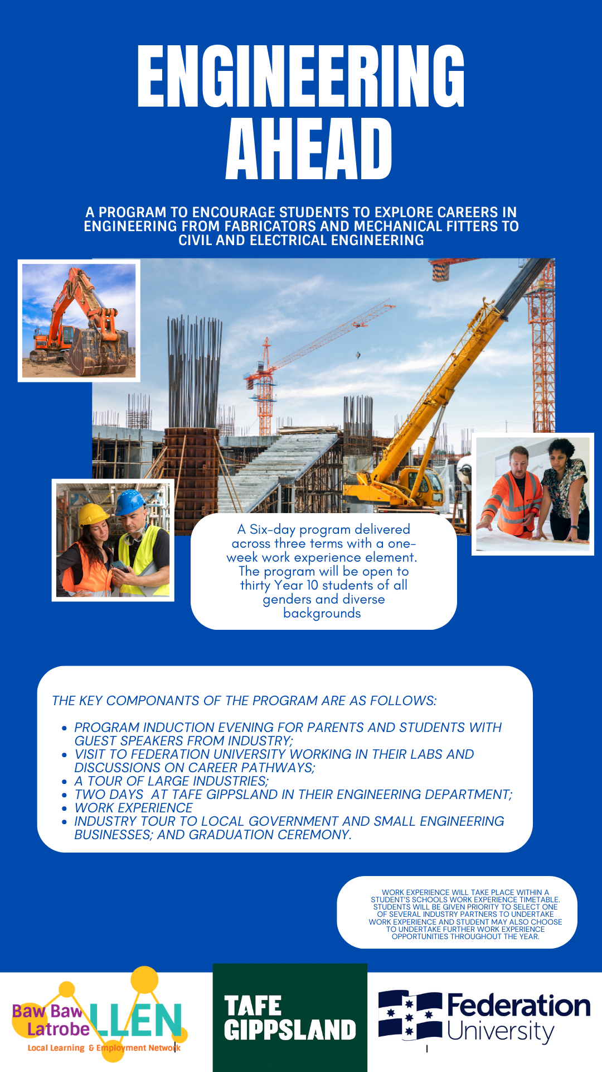
Personal Details
Surname: Given Name:
School: Year Level:
Date of Birth: _ __ / _ __ / Gender: Female / Male / Other
Address:
Suburb / Town: State: Postcode:
Home Telephone: Mobile:
Email:
CIC Card Number:

Medical history/information relevant to your program participation
Please list any current Medical Conditions (including allergies):
Please attach copy of plan |  | Do you have Ambulance Cover? | YES / NO

Why would you like to participate in this program?

What do you hope to achieve from this program?

Emergency Contacts (e.g. parent/guardian)
Emergency Contact:
Name:
Relationship:
Home Telephone: Work:
Mobile:

Emergency Contact:
Name:
Relationship:
Home Telephone: Work:
Mobile:

PHOTOGRAPHY / AUDIO / VIDEO AUTHORISATION

(To be completed by parent/guardian if the applicant is under 18 years of age)
PHOTOGRAPHY/Audio/Video
The Baw Baw Latrobe Local Learning and Employment Network (BBLLLEN) will be promoting the Engineering Ahead Program: -
Photographic footage will be taken for the purpose of building an image library to showcase education and training programs. Images selected for inclusion in the image library may be used in marketing and communication initiatives including exhibitions and displays, printed collateral, outdoor advertising campaigns and website and e-marketing promotions. Images may be shared with BBLLLEN’s education network (schools and Victorian Government Departments) for the purpose of promoting the program.
As the parent/legal guardian of the child/student named above, I agree to and provide permission for the photographic, video, audio or any other form of electronic recording of the named student for and on behalf of the BBLLLEN.
I acknowledge that ownership of any photographic, video, audio or any other form of electronic recording will be retained by the BBLLLEN.
I authorise the use or reproduction of any recording referred to above for the purposes of publishing information materials and resources which promote the Engeineering Ahead to students, teachers, parents, and the community without acknowledgment and without being entitled to remuneration or compensation. The recording may be used on the BBLLLEN and Department of Education and Early Childhood Development websites.
I understand and agree that if I wish to withdraw this authorisation, it will be my responsibility to inform BBLLLEN, on telephone (03) 5633 2868.
I understand the nature and the consequences of what is being proposed in the above paragraphs. If there has been any matter of uncertainty, I have sought clarification from the BBLLLEN, or some other person that has explained any such uncertainty to my satisfaction.
Date: _ __ / _ __ / | Signature (parent/ guardian)  X

School Endorsement
Comments to support application:

As a representative of (Name of school) , I endorse and support this student’s application.
Name (print):
Position:

